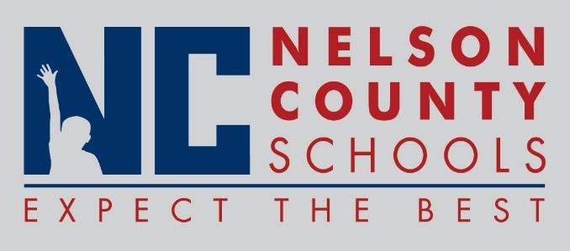

Information Paper
To: | Nelson County Board of Education
From: | Tim Beck, Director of Student Support
cc: | Dr. Anthony Orr, Superintendent
Date: | July 19, 2016
Re: | Sick Bank Information from 2015-2016

CERTIFIED
Beginning Balance as of July 1, 2015 |  | 112
New Members 2015 - 2016 |  | 17
Days Returned for 2014 -2015 |  | 0
Days Returned for 2014 -2015 (non-usage) |  | 0
Days Granted for 2015 - 2016 |  | -25
Ending Balance on June 30, 2016 | 104

CLASSIFED
Beginning Balance as of July 1, 2015 | 46
New Members for 2015 - 2016 | 12
Days Returned for 2014 - 2015 | 1
Days Returned for 2015 - 2016 for non-usage | 0
Days Granted for 2015 - 2016 | -7
Ending Balance on June 30, 2016 | 52

