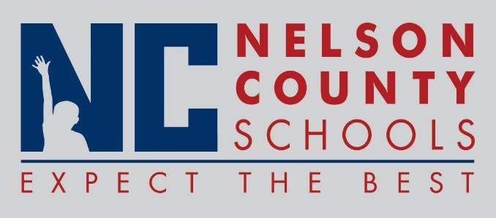

Information Paper
To: | Nelson County Board of Education
From: | Bob Morris Executive Director of Student Support
cc: | Dr. Anthony Orr, Superintendent
Date: | April 25, 2017
Re: | Personnel Notifications

New Hires: Marcy Singer Acct II CO

Transfers: None Reinstatements: None

One Year Certification: None

Classified Subs
Certified Substitute:
Student Workers: None
Non-Renewals: China Pearman Teacher CC
Erika Donahue Teacher CC
Jacklyn Stevens Teacher FH
Jessica Hutchins Teacher FH
Chris Adams Teacher FH
Lila Foster IAIII FH
Jimmy Dennis Teacher HOR
Jennifer Craig Teacher BMS
Brandon Durbin Teacher BMS
Dana Ashley IAI BMS
Stacie Vittitow IAI BMS
Derek Fields Teacher NH
Jeffrey Kisegy Teacher NH
Mary Newton Teacher NH
Judy Carmine IAI NH
Joseph Wheatley Teacher NCHS
Elizabeth Dunn Teacher NCHS
Alaina Green Teacher TNHS
Holly Smith Teacher TNHS
Jessica Kephart Teacher TNHS
Rebecca Simpson Teacher BOS
Zach Allender IAIII OKH
Dwain Burd IAIII OKH
Alicia Newton IAIII OKH
Jessica Vittitow IAIII OKH
Tara Burkhead Teacher OKH
Kaye Thetford Teacher OKH
Carolyn Goben Bus Mon TRANS
Mary Thomas Bus Mon TRANS
Chris Upton Teacher NCHS
Rachel Coleman IAIII NCHS
Rachel Hardesty IAIII NCHS

Resignation: Kelly Kapusuzoglu Teacher CC
Emil Earley Teacher SPED
Karla Kunze Teacher Hor
Kathryn Johnson Teacher TNHS
Lisa Reed Food Ser TNHS
Kurtis Howland FRYSC BOS
Dana Hines IC CO

Retirements: David Miller Bus Driver Trans
Pam Bradley Teacher BMS
Dee Wiggs Secretary BMS
Katrina Eckenfels Bus Driver Trans
Mary Mattingly IAII ELC
Susan Hey Teacher BMS
Melissa Filiatreau IAII ELC

Reprimands/Terminations: None

