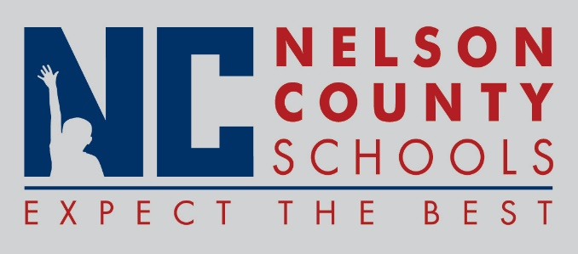

Decision Paper
To: | Nelson County Board of Education
From: | Bob Morris, Executive Director of Student Support
cc: | Tom Brown, Superintendent
Date: | January 24, 2018
Re: | Make-Up Day for Jan 8, 2018 and Jan 16, 2018

Date Missed Make-Up Day
January 08, 2018 February 19, 2018
January 16, 2018 March 9, 2018

RECOMMENDATION: I recommend the Nelson County Board of Education approve these make-up days.

RECOMMENDED MOTION: I move that the Nelson County Board of Education approve these make-up days as presented.

