Option #1

Lenovo ThinkPad L380 - 13.3" - Core i5 8250U - 8 GB RAM - 256 GB SSD

Product Details
- Core i5 8250U / 1.6 GHz
- Win 10 Pro 64-bit
- 8 GB RAM
- 256 GB SSD TCG Opal Encryption 2
- 13.3" 1366 x 768 (HD)
- UHD Graphics 620
- Wi-Fi
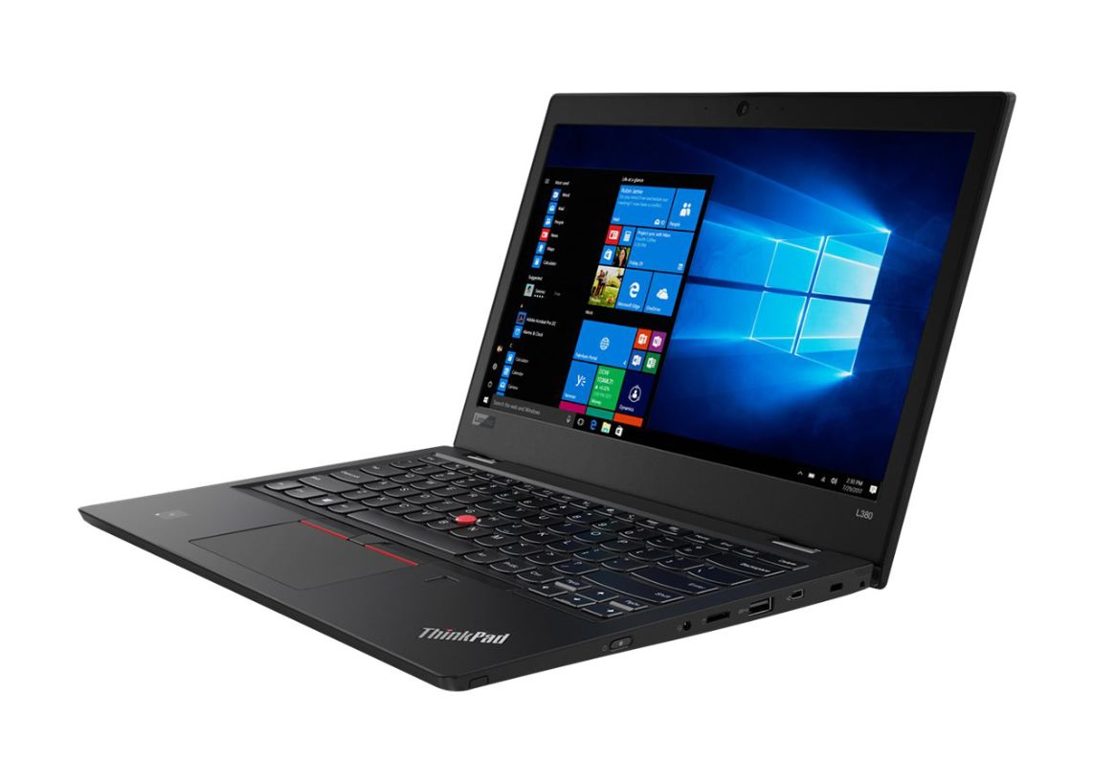

Option #2
MBAIR 13 in 1.8G 8G 128G

13-inch MacBook Air:
1.8GHz dual-core Intel Core i5, 128GB

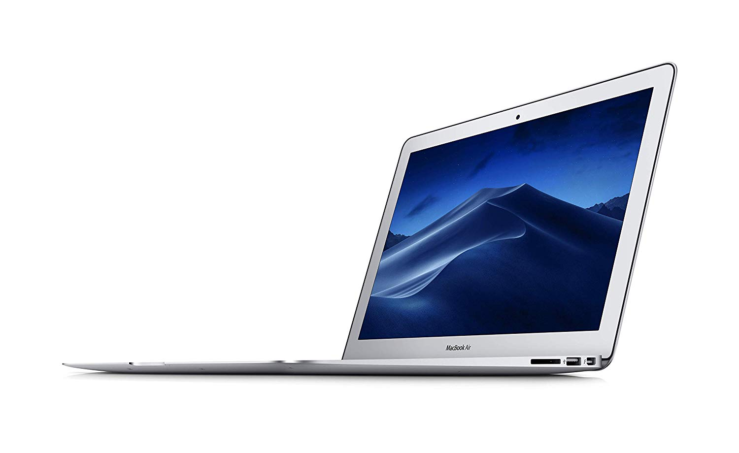

Option #3
Dell Chromebook 3380

Intel Celeron C3855 Processor with 4GB Memory and 32GB SSD

1 Year Mail in Service

