John Hardin SBDM Council
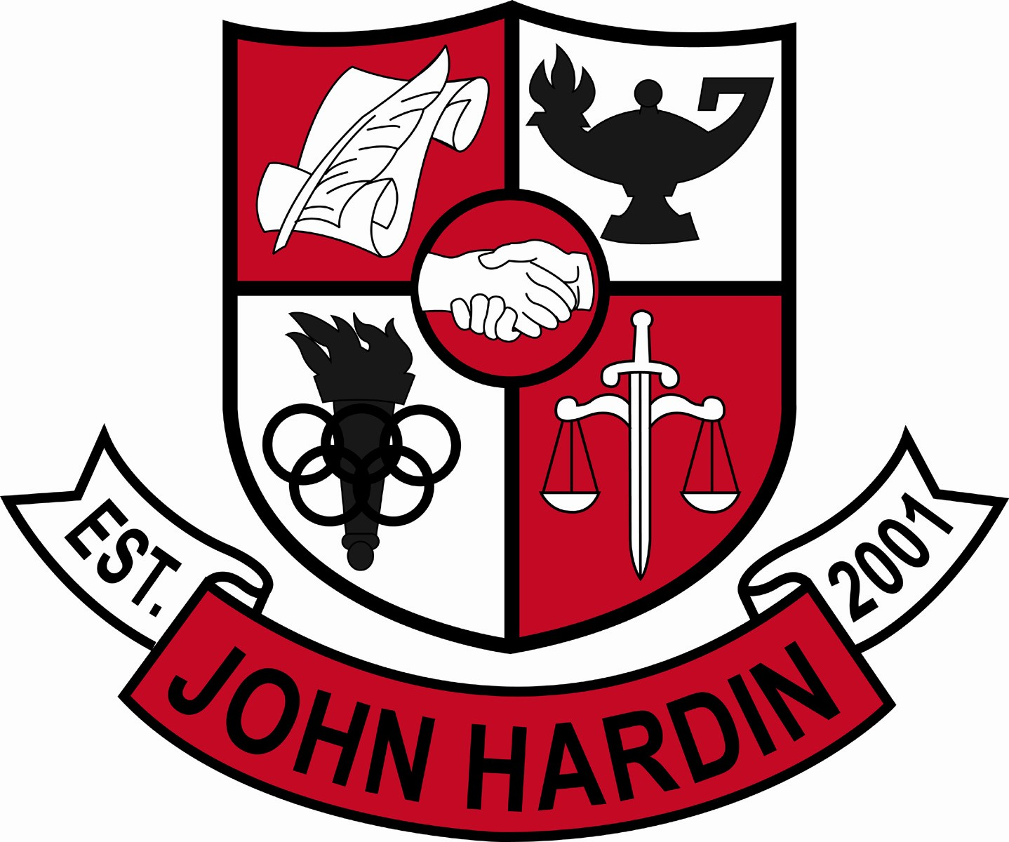
Meeting Minutes

December 8, 2016
4:00 p.m.

- Call to Order at 4:05
Members present: Jan O’Daniel, Mike Moritz, Alex Shearer, Aurora Selbe, Kelly Smith and Mark Wells.
Guest: Chris Reed
- Approval of Agenda ORDER #16-17/0029
The council approved the agenda as written.
Motion: Shearer Second: Smith
Selbe – Yes
O’Daniel – Yes
Shearer– Yes
Wells – Yes
Smith - Yes
Moritz – Yes
- Approval of Minutes ORDER #16-17/0030
The council approved the minutes as written.
Motion: Shearer Second: Smith
O’Daniel – Yes
Selbe– Yes
Wells – Yes
Shearer – Yes
Smith - Yes
Moritz – Yes
- Good News Report –
  - Veteran’s Day Ceremony – The event was lead and planned by JROTC student leaders. The ceremony was very successful.
  - Football – Our team had a great season.
- Public Comment – No comments
- Principal’s Update
  - Intervention Plan – The goal is to catch at risk students early enough that they can achieve success. Students with three zeroes and a 70 or below average are identified. The plan includes four levels of encouragement if students do not improve after an initial conference with a member of the administrative team.
  - Compass /KYOTE Plan – Students who do not meet ACT benchmarks are given additional opportunities of meeting benchmark by taking the KYOTE test at school and the Compass test at ECTC during the school day.
  - Sports Facilities – The requests were approved by the Board of Education. At this time, a work to completion timeline is not available.
- Financial Report ORDER #16-17/0031
The Financial Report for November was approved as written.
Motion: O’Daniel Second: Selbe
O’Daniel – Yes
Selbe– Yes
Wells – Yes
Shearer – Yes
Smith - Yes
Moritz – Yes
- Title IX Audit Review Report
Mr. McCune explained the Title IX Audit and presented data. Although the school is in compliance, one major area of need is gender equality of locker room space. Audits are conducted every five years and the next one is scheduled for 2021.
- Climate and Culture Committee Report
Teresa Punjack presented for the committee.
The student tailgate was successful and the weather plan was critical since the event was moved inside due to rain. Currently, the committee is working on several items such as student incentives, homecoming pep rally activities, and a military appreciation night.
The council added $3000 for Project Lead the Way.
- CSIP ORDER #16-17/0032
The Comprehensive School Improvement Plan (CSIP) was approved as written.
Motion: Shearer Second: Smith
Selbe – Yes
Shearer- Yes
O’Daniel – Yes
Moritz – Yes
Smith – Yes
Wells – Yes
- Revised 2016-2017 PPA Budget ORDER #16-17/0033
The revised PPA budget was approved as written.
Motion: Shearer Second: Selbe – Yes
Moritz – Yes
Shearer- Yes
O’Daniel – Yes
Smith – Yes
Wells – Yes
- Personnel
Hired: Walter Hampton, Freshmen Volleyball Coach-50% Stipend; Bob Hack, Asst Bowling Coach-25% Stipend
Vacancies: Freshmen Baseball Coach; Asst. Wrestling Coach, 35% Stipend; Asst. Bowling Coach, 25% Stipend
- New Business
- Agenda Items for Next Meeting
No items for next month.
- Adjourn
The meeting was adjourned at 4:41 p.m. The motion was made by Ms. Selbe and seconded by Mr. Moritz

