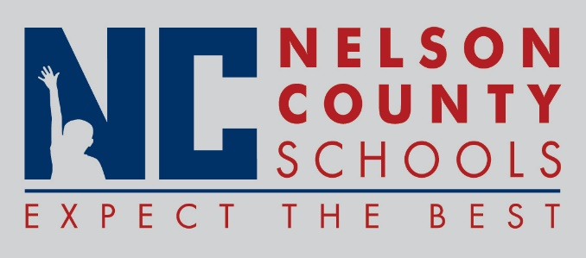

Decision Paper
To: | Nelson County Board of Education
From: | Ann Marie Williams
cc: | Dr. Anthony Orr, Superintendent
Date: | December 1, 2016
RE: | Read to Achieve (RTA) grant applications

ISSUE: BOS, FHES, BES, NH, CCES schools all wish to apply for Read to Achieve (RTA) grants sponsored by the Kentucky Department of Education. These grants are designed to support the implementation of key aspects of Kentucky Academic Standards in Reading. Each of these grant applications estimated at $50,000 amounting to $250,000 for our district.
RECOMMENDATION: Approve request for RTA Grants in the amount of $50,000 each amounting to $250,000.

RECOMMENDED MOTION: I move that the Nelson County Board of Education approve the RTA Grant applications for the following:
- Boston School
- Foster Heights Elementary
- Cox’s Creek Elementary
- New Haven School
- Bloomfield Elementary

