Regular Meeting Boone County Board of Education
September 13, 2018 7:30 PM
Ralph Rush Professional Development Center
99 Center Street
Florence, Kentucky 41042

I. CALL TO ORDER

The Regular meeting of the Boone County Schools Board of Education September 13, 2018 was called to order by Chairperson Bonnie Rickert at the Ralph Rush Staff Development Center.
Attendance Taken at 7:30 PM:

Present Board Members:
Dr. Maria Brown
Mr. Ed Massey
Mr. Matt McIntire
Ms. Bonnie Rickert

Absent Board Members:
Ms. Karen Byrd informed the board she was unable to attend.
Claire Parsons attended as Board Attorney
Karen Evans, Board Secretary, recorded the minutes.

II. NATIONAL ANTHEM
The National Anthem was presented by students from Conner Middle School.

III. PLEDGE TO THE FLAG
The Pledge to the Flag was led by students from Longbranch Elementary.

IV. STUDENT BOARD MEMBER REPRESENTATIVE REPORT
Nick Rassenfoss, Interim Student Board Representative, Conner High School, attended the meeting and updated the board on the Superintendent Student Advisory Council. Nick updated the board on the student Voice Survey from the High Schools and spoke on some of the questions that were asked such as, what is the biggest problem in you school? Results from the survey will be given in the near future. Nick reported on the Drug Free Clubs of America and the Diversity video which will be once again introduced in spring. Nick introduced the new members and the positions they held and spoke on the Leadership Activity at the last meeting.

Anna Impellitteri, the Student Board Member Representative, joined the board via a pre-recorded report from Mexico, Anna will be in Mexico for an Educational Semester.

V. GOOD NEWS
V.A. The board recognized and congratulated the September 2018 Break the Mold recipient, Mr. Mike Grout, Transportation Department.
V.B. The board will recognized and congratulated Ms. Kirby Harshbarger, of Conner Middle School, as the recipient of the 2018 Lifechanger of the Year Award.
V.C. The board will recognized and congratulated Ms. Lisa Resing, Florence Elementary Principal, selected for the prestigious BB&T 2018 National Leadership Institute.
V.D. Rhonda Whittaker presented the board with the Duke Energy STEM Check.
V.E. The board recognized and congratulated the Boone County Schools 2018 District Retirees.

Congratulations to the Boone County Schools 2018 District Retirees!
Thank you for your service to the students of the Boone County School District!
Paula Armstrong
Angela Bailie
James Baker
Brenda Baker
Joseph Barker
Janice Bell
Patrick Berry
Patricia Bond
Carol Booth
Lisa Brown
Regina Brownfield
Patricia Clark
Robert Courtney
Rebecca Cox
Carol Daniels
Dennis Davis
Michael Dawson
Sue Dugan
Sean Elkins
Shirley Evans
Lisa Ferguson
Judy Fields
Cindy Fogle
Leslie Good
Brenda Gruber
Melanie Gruner
Lesle Ham
Joseph Hamelin
Carol Hamelin
Diana Harkins
Betty Harsley
Cheryl Hensley
Timothy Hitzfield
Rebecca Hopson
Lavonne Horn
Lucretia Hulette
Richard Ingraham
Deborah Janowiecki
Tracy Johnson
Tonja Kelly
William Kidd
Elizabeth Kiser
Mary Koch
Laurie Kolkmeyer
Michael Krummen
Louise Lainhart
Michelle Lambert
Janet Lee
Jerry Lindle
Ann Lunnemann
Lonnie Lynch
Mary Maley
Deborah Martin
John Mauntel
Billie McKee
Keith Mckinley
Anita Morgan
Brenda Noll
Dana Ogden
Jennifer Parrett
Robert Perrone
Julie Peters
Christopher Peterson
Deborah Petri
Kimberly Pommier
Patricia Poweleit
Lowry Price
Louise Reynolds
E Roberta Richey
Melanie Roberts
Mary Sargent
Jerri Schulte
Julitta Setters
Charlsey Smith
Katherine Smith
Kimberly Stamper
Karen Straub
Christine Taylor
Pamela Thamann
Barbara Then
Barbara Trickel
Jeff Vonhandorf
Jennifer Wagoner
Betty Webber
Amy Wehrman
Michele Wehry
Jerry Willoughby
Vicki Wolff

VI. RECOMMENDED ACTION - CONSENT AGENDA
Dr. Randy Poe, Superintendent, recommended the following Consent Agenda items A-TTT for Board Approval, as presented.

- A motion was made by Matt McIntire, seconded by Karen Byrd, to approve the consent agenda items A-TTT, as presented. Matt McIntire, Ed Massey, Maria Brown, and Bonnie Rickert voted, “aye” MOTION: The motion passed 4-0.

VI.A. Minutes of the regular board meeting of August 9, 2018
The board approved the minutes of the regular board meeting of August 9, 2018, as presented.
VI.B. Bill List
VI.C. Treasurer's Report was given by Mrs. Linda Schild.
VI.D. Leaves of Absence
The following persons submitted leaves of absence requests were approved by the board:
Recommended by Principal/Supervisor for approval:
Anderson, Elizabeth, Teacher @ Burlington ES 9/19/2018 – 10/31/2018
Dirkes, Dana, Teacher @ New Haven ES 8/23/2018 – 4/5/2019
Duell, Nicole, Teacher @ Longbranch ES 8/13/2018 – 1/03/2019
Ellison, Katie, Speech Pathologist @ North Pointe ES 8/20/18 – 10/19/2018
Focke, Christy, Bus Driver @ Transportation 8/14/2018 – 8/25/2018
Head, Lauren, Therapist @ District Office 8/13/2018 – 9/19/2018
Isaacs, Jessica, Teacher @ Imagineering Academy 10/11/2018 – 10/26/2018
Isbill, Sarah , Teacher @ Goodridge ES 9/10/2018 – 10/17/2018
Klare, Emily, Teacher @ Collins ES 10/18/2018 – 11/14/2018
McGlasson, Kathleen, Para Educator @ Stephens ES 8/28/2018 – 10/1/2018
Haywood, Bernadette, Para Educator @ Erpenbeck ES 8/14/2018 – 1/3/2019
Knaley, Tonya, Bookkeeper @ District Office 8/22/2018 – 9/21/2018
Perry, Donna, Transportation Aide @ Transportation 8/27/2018 9/25/2018
Peters, Lisa, Teacher @ Ockerman ES 11/28/2018 – EOY
Ragan, Jennifer, Teacher @ Stephens ES 9/17/2018 – 10/26/2018
Not Recommended by Principal/Supervisor for approval:
Nothing to Report
Amended Leaves:
Kohls, James, Custodian @ Goodridge ES 6/18/2018 – 8/17/2018
Krohman, Mackenzie, Therapist @ Stephens ES-District 9/13/2018 –9/28/2018
Kuhn, Amanda, Teacher @ Goodridge ES 8/2/2018 – 10/17/2018
Stellman, Thomas, Teacher @ Conner HS 8/30/2018 – 9/17/2018
Warning, Mark, Custodian @ Yealey ES 4/23/2018 – 8/31/2018
Cancelled Leaves:
Smith, Amber, Teacher @ Thornwilde ES 8/20/2018 – 9/21/2018

VI.E. Memorandum of Agreement with ProCare Therapy
The board approved the agreement between Boone County Schools and ProCare Therapy for speech therapy services, as presented.
VI.F. NCERT October Executive Leadership Conference
The board approved Randy Poe's travel and expenses for the NCERT October Executive Leadership Conference, as presented.
VI.G. SLN Conference
The board approved the Randy Poe's travel and expenses for the SLN Conference, as presented.
VI.H. The Point/Arc of Northern KY Contract for Transition Services
The board approved the contract for Transition Services with the Point/Arc of Northern KY for the 18-19 school year, as presented.
VI.I. Kelly E. Lusk, Ph.D./ Visual Impaired Teacher
The board approved the contract for Visual Impairment Services with Kelly E. Lusk, Ph.D. for the 18-19 school year, as presented.
VI.J. DreamBox License Renewal at Mann Elementary School
The board approved the agreement between Mann Elementary School and DreamBox Learning, as presented.
VI.K. Lexia Learning and reading Plus Renewal at Mann Elementary School
The board approved the agreement between Mann Elementary School and Academic Edge for Lexia Learning and Reading Plus for the 18-19 school year, as presented.
VI.L. Executive Transportation for Longbranch Elementary
The board approved the agreement between Longbranch Elementary and Executive Transportation for a field trip to Conner Prairie, as presented.
VI.M. Queen City Transportation for Cooper High School
The board approved the agreement between Queen City Transportation and Cooper High School for a trip to the National FFA Convention in Indianapolis, Indiana, as presented.
VI.N. FY 19 Preschool Partnership Application in Collaboration with Children Inc.
The board approved the grant application in collaboration with Children Inc for the FY 19 Preschool Partnership Grant, as presented.
VI.O. FY 19 Preschool Partnership Application in Collaboration with Northern Kentucky Community Action Commission-Headstart
The board approved the grant application in collaboration with Headstart for the FY 19 Preschool Partnership Grant, as presented.
VI.P. Memorandum of Understanding Between the Family Nurturing Center and the Boone County Schools
The board approved the Memorandum of Understanding between the Family Nurturing Center and Boone County Schools for the Family nurturing Center to provide a minimum of 6 school based ANCHOR groups in the 18-19 school year, as presented.
VI.Q. Contractual Services Agreement Between The Boone County Board of Education and NECCO, Inc.
The board approved the agreement between the Boone County Board of Education and NECCO, Inc for NECCO to provide a variety of services, as presented.
VI.R. Memorandum of Agreement Between Bluegrass Behavior Health and the Boone County Schools
The board approved the memorandum of agreement between Boone County Schools and Bluegrass Behavioral Health Group for a variety of services, as presented.
VI.S. Memorandum Related to Collaborative Service Agreement Between the Children's Home of Northern Kentucky and Boone County Schools for Intensive Outpatient Programming
The board approved the Memorandum Related to Collaborative Service Agreement Between the Children's Home of Northern Kentucky and Boone County Schools for Intensive Outpatient Programming for the 18-19 school year, as presented.
VI.T. Memorandum Related to Boone County Schools and Thomas More College Dual Credit Teachers Scholarship Addendum
The board approved the Dual Credit Teacher Scholarship Addendum intended to increase the number of Boone County teachers available to teach dual credit classes, as presented.
VI.U. Interagency Agreement Between MEBS and Associates and the Boone County Schools
The board approved the interagency agreement between MEBS and Associations and Boone County Schools for a variety of services, as presented.
VI.V. Northern Kentucky Education Council Membership 2018-19
The board approved the Northern Kentucky Education Council Membership for 2018-19, as presented.
VI.W. NCERT Membership 2018-19
The board approved the NCERT Membership for 2018-2019, as presented.
VI.X. NKCES Membership 2018-19
The board approved the Northern Kentucky Cooperative for Educational Services Membership for 2018-19, as presented.
VI.Y. Memorandum of Agreement With Sign Baby Sign
The board approved the memorandum of agreement between Boone County Schools and Sign Baby Sign to offer sign language services to identified students for the 2018-19 school year, as presented.
VI.Z. Memorandum of Agreement with Kentucky Educational Collaborative State Agency Children Fund
The board approved the Memorandum of Agreement with Kentucky Educational Collaborative State Agency Children Fund, as presented.
VI. AA. Memorandum of Agreement with the University of Cincinnati
The board approved the memorandum of agreement between Boone County Schools and the University of Cincinnati to offer clinical experience for students enrolled in the Occupational Therapy Program for the 2018-19 school year, as presented.
VI.BB. Memorandum of Agreement with Movin' OM, LLC.
The board approved the memorandum of agreement between Boone County Schools and Movin' OM, LLC to offer orientation and mobility services to identified students for the 2018-19 school year, as presented.
VI.CC. Memorandum of Agreement with Commonwealth of Kentucky - Instructional Transformation Grant
The board approved the memorandum of agreement between the Commonwealth of Kentucky, Kentucky Department of Education, and Boone County Schools to establish an agreement to improve student learning and teacher effectiveness for the 2018-19 school year, as presented.
VI.DD. Memorandum of Agreement with Panorama Education, Inc.
The board approved the memorandum of agreement between Panorama Education, Inc. and Boone County Schools for license fees, as presented.
VI.EE. Conner Middle School Grant Award- Project Lead the Way
The board approved the grant awarded to Conner Middle School from Project Lead the Way, Inc for the 2018-19 school year, as presented.
VI.FF. Memorandum of Agreement Between Measured Progress, Inc. and Gray Middle School
The board approved the memorandum of agreement between Measured Progress, Inc. and Gray Middle School for STEM Gauge for a 7 year license, as presented.
VI.GG. Memorandum of Agreement with Xello
The board approved the memorandum of agreement between Xello and Boone County Schools, as presented.
VI.HH. Application Quote between MyOn LLC And Ballyshannon Middle School
The board approved the memorandum of agreement from MyOn LLC for Ballyshannon Midddle School for the 2018-19 school year, as presented.
VI.II. Bus Request- Union Pointe Academy
The board approved the bus request from Union Point Academy for use of buses to visit the Sailing Museum in Newport on September 14, 2018, as presented.
VI.JJ. US Coachways for Ryle High School Band
The board approved the agreement with US Coachways for Ryle High School on November 8, 2018 for the band to participate in the Bands of America National Championships, as presented.
VI.KK. Executive Charter for Ryle High School
The board approved the agreement with Executive Charter, Inc. for Ryle High School for 3 trips, as presented.
VI.LL. Meal Service Agreement with Children, Inc.
The board approved the Child Care Food Program Meal Service Agreement with Children, Inc. for Yealey Elementary and Erpenbeck Elementary for the 2018-19 school year, as presented.
VI.MM. Declaration of Textbooks as Surplus from Ryle High School
The board approved the declaration of surplus and approve the disposal of textbooks in accordance with Board Policy, as presented.
VI.NN. Declaration of Marching Band Uniforms as Surplus from Boone County High School
The board approved the Boone County High School Marching Band Uniforms declaration of surplus and approve the disposal in accordance with board policy, as presented.
VI.OO. Conner High School Copier/Printer Lease Agreement
The board approved the printer/copier lease agreement between Conner High School and Millennium Business Systems, as presented.
VI.PP. Use Agreement for Erpenbeck Elementary- Girl Scout Troup
The board approved the facility use agreement for Girls Scout Troop 7152 on Saturday, March 30, 2019 at Erpenbeck Elementary, as presented.
VI.QQ. Agreement with BB&T Arena
The board approved the agreement between Ryle High School and BB&T Arena for Saturday, May 4, 2019 for prom, as presented.
VI.RR. Executive Charter for Goodridge Elementary
The board approved the agreement between Executive Charter, Inc., and Goodridge Elementary for a trip to Conner Prairie, as presented.
VI.SS. Miller Transportation for Gray Middle School
The board approved the agreement between Miller Transportation and Gray Middle School for the 8th grade trip to Chicago, IL, as presented.
VI.TT. Agreement Thornwilde Elementary and Lifetouch
The board approved the Agreement Thornwilde Elementary and Lifetouch Pictures, as presented.
VI.UU. Use Agreement for Yealey Elementary- NKY School of Music
The board approved the use agreement for the Northern Kentucky School of Music for use of Yealey Elementary for the 2018-19 school year, as presented.
VI.VV. Yearbook Publication Agreement-Lifetouch
The board approved the agreement with Lifetouch for the publication of the yearbook for Yealey Elementary School, as presented.
VI.WW. Field Trips
The board approved the field trip requests, as presented.

School | Date Of Trip | Location | Reason
Camp Ernst Middle | February 8-12, 2019 | Orlando, FL | National Cheerleading Championship
Conner High School | February 8-12, 2019 | Orlando, FL | National Cheerleading Competition
Cooper High School | October 24-26, 2018 | Indianapolis, IN | National FFA Convention
Goodridge Elementary | October 3, 2018 | Conner Prairie | Educational
Gray Middle School | April 18-20, 2019 | Chicago, IL | Educational
Longbranch Elementary | September 27, 2018 | Fisher’s, IN | Educational
Ryle High School | September 7-8, 2018* | Elizabethtown | Soccer Tournament
Ryle High School | October 22-November 3, 2018 | TBD | Possible State Girls Soccer Tournament
Ryle High School | October 26, 2018 | Louisville | Possible State Volleyball State Tournament
Ryle High School | October 10, 2018 | Lexington | Educational
Ryle High School | October 18, 2018 | Mammoth Cave | Educational
Ryle High School | November 8, 2018 | Indianapolis, IN | Bands of American Championships
Ryle High School | October 16, 2018 | Harrodsburg | Educational
Ryle High School | October 23-November 3, 2018 | Louisville | Possible State Boys Soccer Tournament
- All travel by commercial carrier is due to schedule/cost.

*Preapproved by Board Chairperson

VI.XX. Sales Campaign Approval
The board approved the request for sales campaigns, as presented.
VI.YY. Agreement between Ballyshannon Middle School and adidas America, Inc
The board approved the agreement between Ballyshannon Middle School and adidas America, Inc, as presented.
VI.ZZ. Agreement between Ryle High School and Pepsi
The board approved the agreement between Ryle High School and Pepsi, as presented.
VI.AAA. Agreement between Ockerman Elementary and Schoolhouse Photos
The board approved the agreement between Ockerman Elementary and Schoolhouse Photos for the 18-19 school year, as presented.
VI.BBB. Agreement between Conner High School and Lifetouch School Portraits and Yearbooks
The board approved the agreement between Conner High School and Lifetouch School Portraits and Yearbooks, as presented.
VI.CCC. Agreement between Cooper High School and Wilson Electronic Displays
The board approved the agreement between Cooper High School and Wilson Electronic Displays for a two year service warranty, as presented.
VI.DDD. Agreement between Ballyshannon Middle School and Kickboard
The board approved the agreement between Ballyshannon Middle School and Kickboard, as presented.
VI.EEE. Use Agreement between Thornwilde Elementary and YMCA
The board approved the Use Agreement between Thornwilde Elementary and YMCA, as presented.
VI.FFF. Thornwilde Elementary School Grant Award Project Lead the Way
The board approved the Thornwilde Elementary School Grant Award Project Lead the Way, as presented.
VI.GGG. Job Description Modification -Director of Student Engagement
The board approved the Job Description Modification -Director of Student Engagement, as presented.
VI.HHH. New Classified Job Description - IDEA/Medicaid Budgeting and Reporting Specialist
The board approved the New Classified Job Description - IDEA/Medicaid Budgeting and Reporting Specialist, as presented.
VI.III. Job Description Modifications -Occupational Therapist and Physical Therapist
The board approved the Job Description Modifications -Occupational Therapist and Physical Therapist, as presented.
VI.JJJ. Children's Theatre Performance Contract-Ockerman Elementary
The board approved the Children's Theatre Performance Contract for Ockerman Elementary, as presented.
VI.KKK. Chromebook Purchases
The board approved the Chromebook Purchases, as presented.
VI.LLL. Family Resource and Youth Service Centers School District Assurance Certification FY's 19-20
The board approved the Family Resource and Youth Service Centers School District Assurance Certification FY's 19-20, as presented.
VI.MMM. Facilities Use Agreement Conner High School and NKY Bandits Football
The board approved the Facilities Use Agreement Conner High School and NKY Bandits Football, as presented.
VI.NNN. Facilities Use Agreement for Collins Elementary- Girl Scouts
The board approved the Facilities Use Agreement for Collins Elementary with the Girl Scouts, as presented.
VI.OOO. Facility Use Agreement Collins Elementary for Union Raiders Cheerleaders
The board approved the Facility Use Agreement Collins Elementary for Union Raiders Cheerleaders, as presented.
VI.PPP. Scientific Learning Corp. Research Study
The board approved the Scientific Learning Corp. Research Study, as presented.
VI.QQQ. BG-1 Application Steeplechase
The board approved the BG-1 Application Steeplechase, as presented.
VI.RRR. Cooper High School and Party Pleasers DJ Agreement
The board approved the Cooper High School and Party Pleasers DJ Agreement, as presented.
VI.SSS. Executive Transportation for Ryle High School
The board approved the Executive Transportation for Ryle High School on Sept. 7, 2018 to Elizabethtown for the Soccer Tournament, as presented.
VI.TTT. Memorandum of Understanding with Boone County Cooperative Extension Office for Newcomer Academy
The board approved the Memorandum of Understanding with Boone County Cooperative Extension Office for Newcomer Academy, as presented.

VII. RECOMMENDED ACTION - OLD BUSINESS
VII.A. 08.113 Board Policy Update Graduation Requirements - Second Reading
Dr. Randy Poe Superintendent, recommended the board to approve the 08.113 Board Policy Update Graduation Requirements - Second Reading, as presented.

- A motion was made by Maria Brown, seconded by Matt McIntire, to approve the recommended second reading of the 08.113 Board Policy Update Graduation Requirements, as presented. Matt McIntire, Maria Brown, and Bonnie Rickert voted, “aye” MOTION: The motion passed 4-0.

VIII. RECOMMENDED ACTION - NEW BUSINESS

VIII.A. Working Budget for 2019 Fiscal Year
Dr. Randy Poe, Superintendent, recommended the board approve the Working Budget for 2019 Fiscal Year, as presented.

- A motion was made by Maria Brown, seconded by Matt McIntire, to approve the recommended Working Budget for 2019 Fiscal Year, as presented. Ed Massey, Matt McIntire, Maria Brown, and Bonnie Rickert voted, “aye” MOTION: The motion passed 4-0.

VIII.B. District Funding Assurances FY 2019
Dr. Randy Poe, Superintendent, recommended the board to approve the District Funding Assurances FY 2019, as presented.

- A motion was made by Ed Massey, seconded by Matt McIntire, to approve the District Funding Assurances FY 2019, as presented. Ed Massey, Matt McIntire, Maria Brown, and Bonnie Rickert voted, “aye” MOTION: The motion passed 4-0.

IX. SUPERINTENDENT'S REPORT
Mrs. Krista Decker, LSS Director of Assessment, presented the Spring 2018 OECD Data, Junior ACT and AP Data with a Powerpoint Presentation as presented to the board.

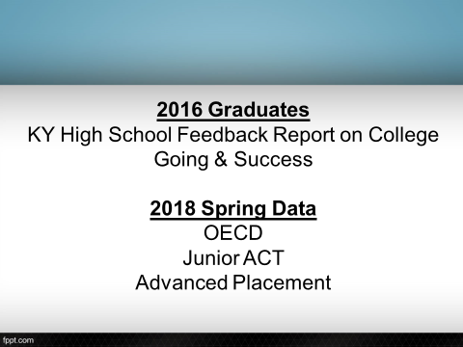

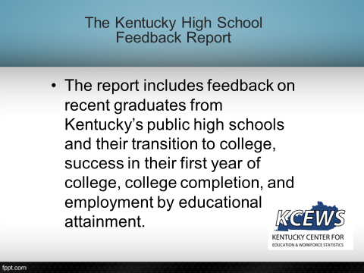

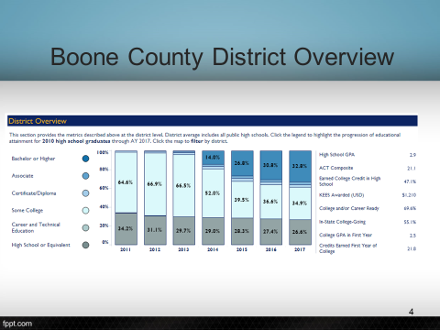

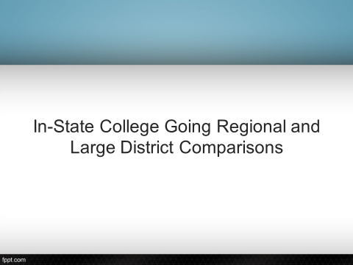

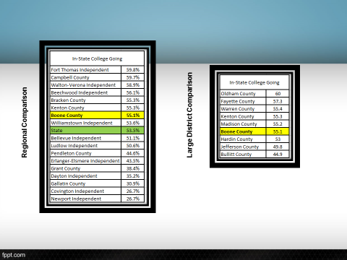

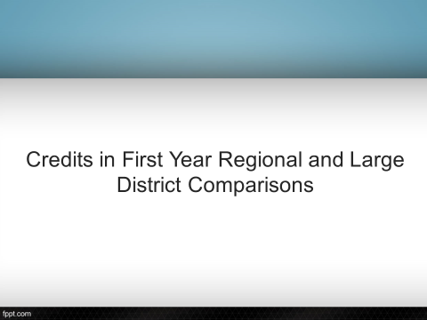

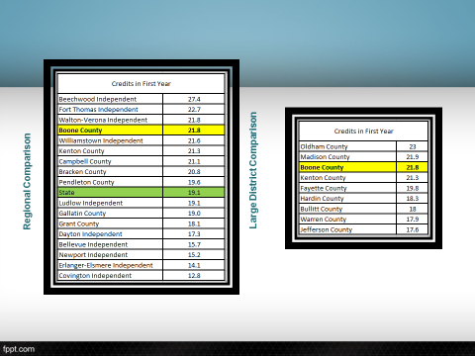

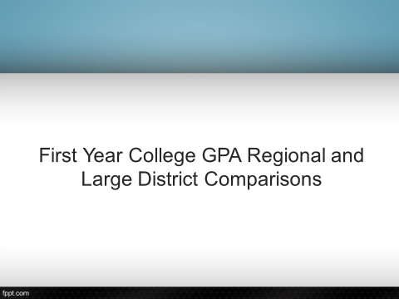

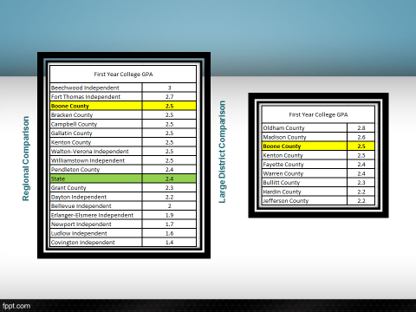
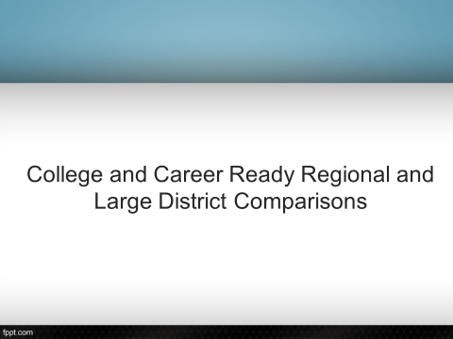

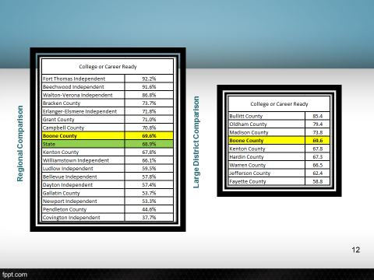

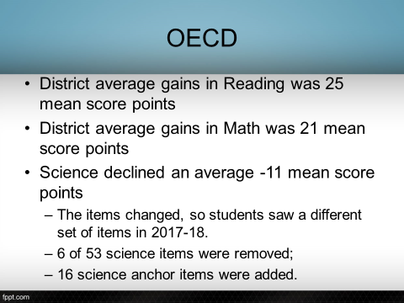

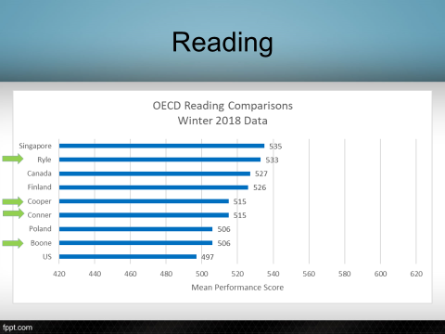

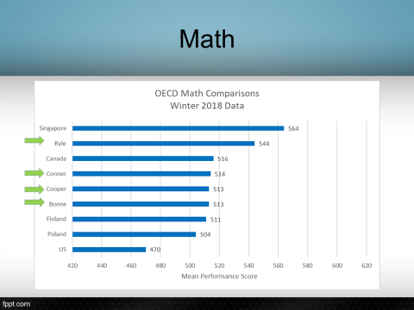

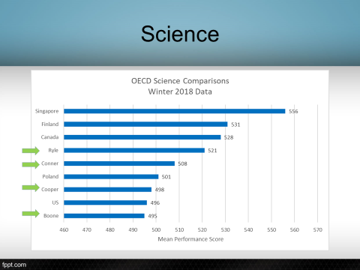

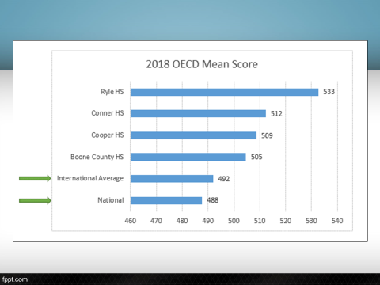
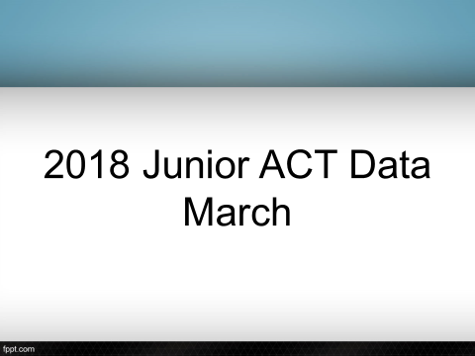

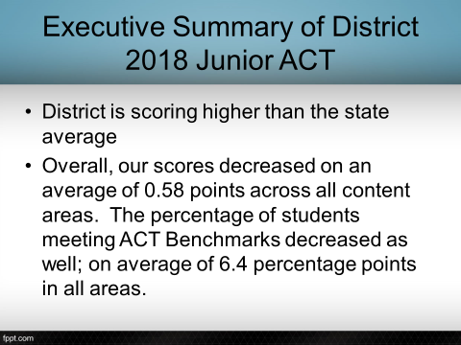

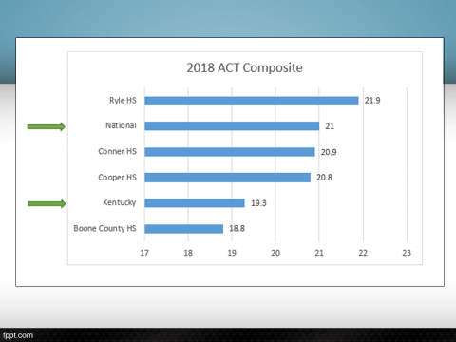

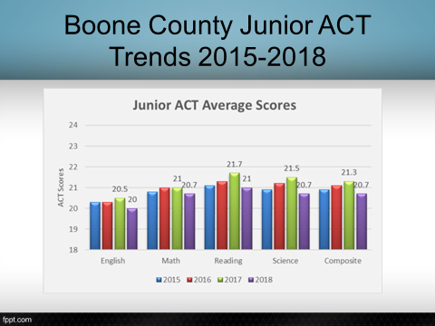

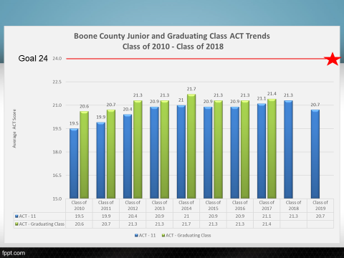

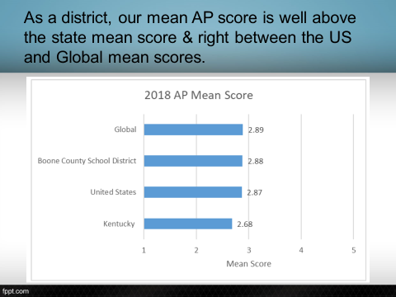

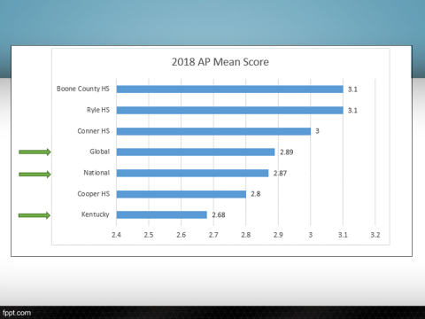

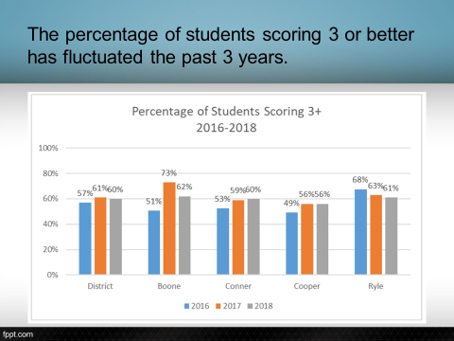

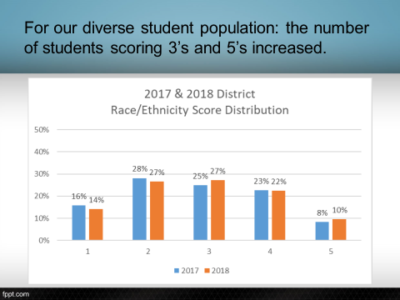

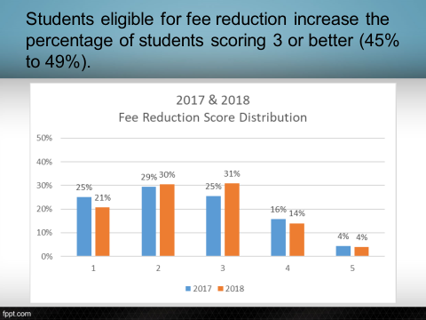
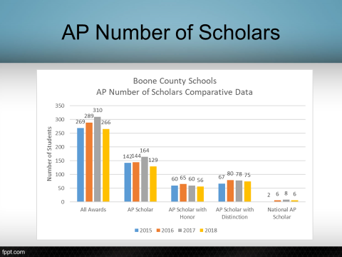

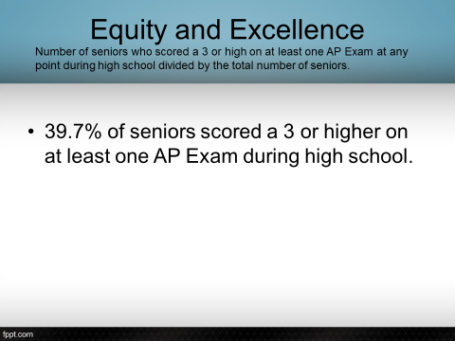

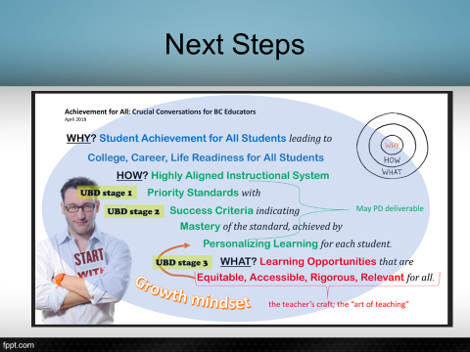

- Dr. Poe announced the board workshop book study on Unlocking Student Talent, by Gean Kearns. The workshop will be held on Thursday, October 18th at 6:30 to 7:30 pm at the LSS building.
- Dr. Poe announced members of the board will be attending the KSBA NKY Regional Dinner on Sept. 24, 2018.
- Dr. Poe announced the Ballyshannon Ribbon Cutting Ceremony – Tuesday, Sept. 18th, 2018.

X. INFORMATION, PROPOSALS, COMMUNICATIONS
X.A. Human Resource Actions
X.B. Worker's Compensation Claims
X.C. Overtime Report
X.D. Construction Status Report
X.E. Energy Management Report
X.F. Certification Constitutionally Protected Prayer In School
X.G. Goals and Objectives 2018-2019 Superintendent Randy Poe

XI. AUDIENCE OF CITIZENS
Visiting NKU College Students: Alexa Soucy and Evan Hodges

XII. CLOSED EXECUTIVE SESSION PER KRS 61.810
XII.A. No closed session

XIII. ADJOURN

5. A motion was made by Matt McIntire, seconded by Ed Massey, to adjourn the meeting. Maria Brown, Bonnie Rickert, Ed Massey and Matt McIntire voted, “aye” MOTION: The motion passed 4-0.

Meeting was adjourned at approximately 8:24pm

_____________________________________
Bonnie Rickert/Chairperson

_____________________________________
Karen Evans/Secretary

