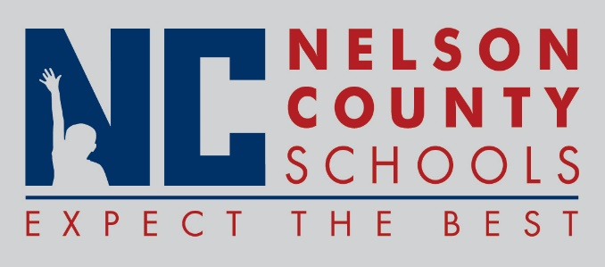

Information Paper
To: | Nelson County Board of Education
From: | Kimberly Brown
cc: | Mr. Tom Brown, Superintendent
Date: | March 20, 2018
Re: | Discussion of Sigma Flex Pilot for Nelson County Schools

INFORMATION: The Nelson County Schools must look at alternative ways to lead all students to proficiency and to attain their high school diploma.

704 KAR 3:303 Required Program of Studies
A high school graduation credit may be awarded in either of two ways: Carnegie Units (defined as at least 120 hours of instructional time in one subject/) OR performance-based credits, defined at the local level regardless of the number of instructional hours. Districts and schools are accountable for making sure that each student’s educational program includes the minimum content standards as specified in Kentucky’s Program of Studies and provides the student with the opportunity to learn the standards including appropriate supports based on the individual learning needs of a student.

The Kentucky Board of Education identifies the minimum credits required for graduation (704 KAR 3:305) and the local district sets the local requirements in its district graduation policy.

Performance-Based Credits
Performance-based credits refer to credits earned by a student outside of the traditional structure of a 120-hour instructional course. In order to award such credits, districts must establish a policy for a performance-based system that:
- Provides procedures for developing performance-based credit courses;
- Identifies related performance descriptors and assessments;
- Establishes grading and reporting procedures, specifies content standards as addressed in Kentucky’s Academic Standards;
- Identifies the extent to which end-of-course assessments will be used;
- Allows for students to demonstrate proficiency and earn credit for learning acquired outside of school or in prior learning experiences;
- Allows students to pursue internships, cooperative learning experiences and other learning experiences in the school and community.

Performance-Based Credit may be awarded for these types of courses:
- Course work that allows satisfactory demonstration of learning;
- Course work that constitutes satisfactory demonstration of learning in a course for which the student failed to earn credit when the course was previously taken;
- Standards-based portfolios, including senior year or capstone projects;
- Standards-based online or other technology-mandated courses;
- Standards-based dual credit or other equivalency courses;
- Standards-based internship, cooperative-learning experience or other supervised learning experiences in the school and in the community.

Director of Pupil Personnel and Director of Secondary Education will present the proposed Sigma Flex Program Pilot to ensure that all students are engaged in teaching and learning experiences with the Nelson County Public Schools.

The purpose of the Sigma Flex Program Pilot is to gather data in an effort to build an alternative teaching and learning environment for students who do not flourish in the traditional school setting.

