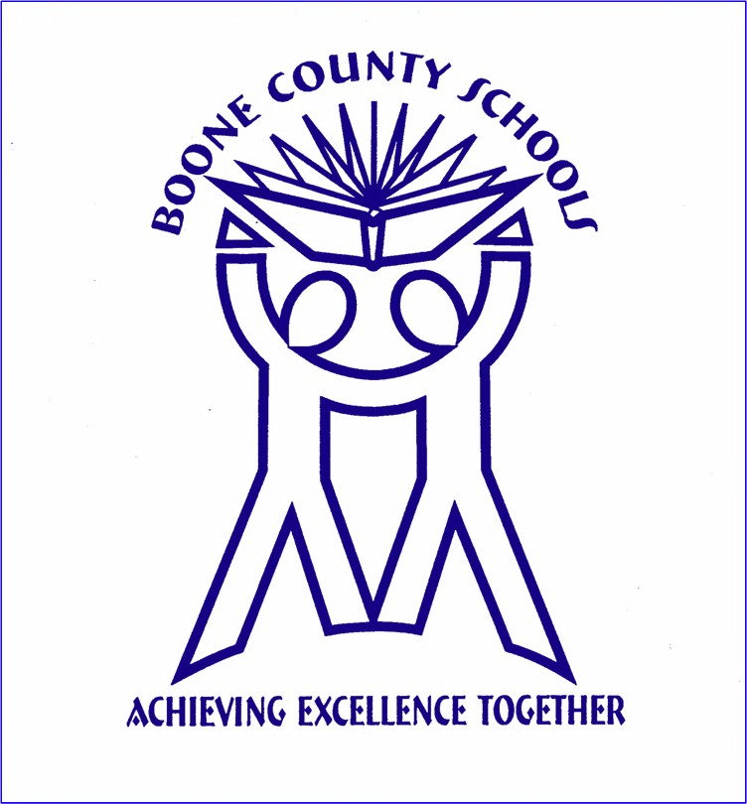

GOALS AND OBJECTIVES
SUPERINTENDENT, RANDY POE

BOONE COUNTY SCHOOLS – 2017-18

Submitted to the Board of Education
September, 2017

STANDARD 1: Strategic Leadership
The superintendent creates conditions that result in strategically reimaging the district’s vision, mission and goals to ensure that every student who graduates from high school is globally competitive in postsecondary education and the workforce, and is prepared for life in the 21st century.
Goal 1: Develop innovative pathways, processes, and practices for students to be prepared for the future workplace.

Objectives:
- 1.1 Create innovative methods of instruction, such as virtual/ online classes, additional career pathways, etc. at schools and through the Imagineering Academy.

- 1.2 Develop specific strategies across levels to instill passion and direction for career areas, especially those that are projected to be high pay/ high growth occupations for the region. Utilize College/ Career Pathways Coaches and the NaviGo teacher-coach model to develop plans for all high school and 8th grade students.

- 1.3 Use the results of the Student Resiliency Poll, as well as tools such as the VIA, to build students’ career skills (soft skills) such as grit, perseverance, leadership, resiliency, and independence.

- 1.4 Ensure all schools provide cultural and global competence learning along with a quality world language program utilizing both blended learning and teacher instruction.

STANDARD 2: Instructional Leadership
The superintendent supports and builds a system committed to shared values and beliefs focused on teaching and learning where performance gaps are systematically eliminated over time and every student graduates from high school college- and career-ready.

Goal 1: Deepen, refine, and extend the district’s and schools’ processes to inform, measure and monitor daily classroom learning system-wide in order to increase the achievement of all students.

Objectives:
- 1.1 Develop specific strategies/plans to address student skill deficits as indicated on EPAS and STAR assessment data. Focus on novice reduction/ RtI strategies, including strategies to impact achievement of EL’s and students with disabilities, as well as students in poverty.

- 1.2 Provide additional training and support to all teachers on the effective use of formative assessment on a frequent basis to monitor student progress and adjust instruction, including role of grading within formative assessment.

- 1.3 Address the achievement & opportunity gap by restructuring RTI practices to be in line with a mastery learning philosophy.

Goal 2: Provide leadership and support in the ongoing development and alignment of curriculum in all content areas.

Objectives:
- 2.1 Develop science, ELA and math curriculum and instructional practices within an Understanding by Design Framework.

- 2.2 Provide training and support for schools to build students’ 21st century skills (district’s 10 c’s), including the use of 4 c’s rubrics and blended learning strategies.

- 2.3 Provide training and support for PBL (project/ problem/ passion-based learning) and service learning.

- 2.4 Develop a system for vetting and monitoring the implementation of PBL units across schools and content areas.

STANDARD 3: CULTURAL LEADERSHIP
The superintendent understands and acts on the important role a system’s culture has in the exemplary performance of all schools.

Goal 1: Analyze and address 2017 TELL survey results.

Objectives:
- 1.1 Provide analysis of TELL survey results to stakeholders and develop comprehensive plan to address prioritized needs at all schools.

Goal 2: Strengthen a culture for learning that meets the needs of ALL students.

Objectives:
- 1.1 Develop strategies for embracing student diversity and ensuring equitable learning access for ALL students.

- 1.2. Employ the seven principals of the Happiness Advantage to build positive school cultures that fuel teacher performance and student success.

STANDARD 4: Human Resource Leadership
The superintendent ensures the district is a professional learning community with processes and systems in place that result in recruitment, induction, support, evaluation, development and retention of a highly effective, diverse staff.

Goal 1: Continue to support building leadership in implementing the teaching practices identified in the KY Teacher Effectiveness Framework (TEF)

Objectives:
- 1.1 Provide training and support for all principals and teachers in understanding and practice of the Danielson Framework. Develop professional development based on results of personnel evaluation.

- 1.2 Emphasize and support the role of the instructional coach in assisting teachers in the implementation of strategies in the TEF.

STANDARD 5: Managerial Leadership
The superintendent ensures that the district has processes and systems in place for budgeting, staffing, problem solving, communicating expectations and scheduling that organize the work of the district and give priority to student learning and safety. The superintendent must solicit resources (both operating and capital), monitor their use and assure the inclusion of all stakeholders in decisions about resources so as to meet the 21st century needs of the district.

Goal 1: Monitor and expand the use of the APQC process and other tools to increase efficiency in the district.

Objectives:
- 1.1 Support new and ongoing APQC projects and provide reports to the Board of Education on progress and savings.

- 1.2 Use APQC practices throughout the district’s departments.

- 1.3 Utilize the Achieve It project management tool to monitor and report progress toward meeting the Strategic Plan goals.

Goal 2: Utilize collaborative and transparent processes to ensure resources are allocated and expended to best meet student needs. (survey results, committee minutes and agendas, assessment results).

Objectives
- 2.1 Budget committee will continue to utilize TELL survey results as well as an extensive book study (Odden’s Improving Student Learning when Budgets are Tight) to develop plans for use of fiscal resources.

STANDARD 6: Collaborative Leadership
The superintendent, in concert with the local board of education, designs structures and processes that result in broad community engagement with support for and ownership of the district vision.

Goal 1: Engage the community through expanded marketing and branding efforts as well as expanded opportunities for students.

Objectives:
- 1.1 Develop enhanced learning opportunities for students involving community resources/ organizations, such as the NKY MakerSpace.

- 1.2 Create partnerships with community agencies to achieve goals in the Strategic Plan.

- 1.3 Utilize the advocacy committee to develop and implement marketing/ branding plans for the district.

Goal 2: Utilize distributive leadership strategies within the district to strengthen ownership among teachers and staff for achieving the goals articulated in the district strategic plan.

Objectives:
1.1 Develop teacher leader cohorts as described in the Kentucky Teacher Leader Framework to be change leadership guiding coalitions. Examples of teacher leader cohorts include those for blended learning, district programs, world language, curriculum design, etc.

STANDARD 7: Influential Leadership
The superintendent promotes the success of teaching and learning by understanding, responding to, and influencing the larger political, social, economic, legal, ethical, and cultural context. From this knowledge, the superintendent works with the board of education to define mutual expectations, policies and goals to ensure the academic success for all students.

Goal 1: Enhance Board of Education/ SBDM Council relationships and understanding.

Objectives:
- 1.1. Work with school SBDM Councils to promote increased understanding of schools’ implementation of district policies and practices.

- 1.2 Continue to hold board workshops on topics within the strategic plan to encourage understanding and collaboration among all stakeholders

