John Hardin SBDM Council
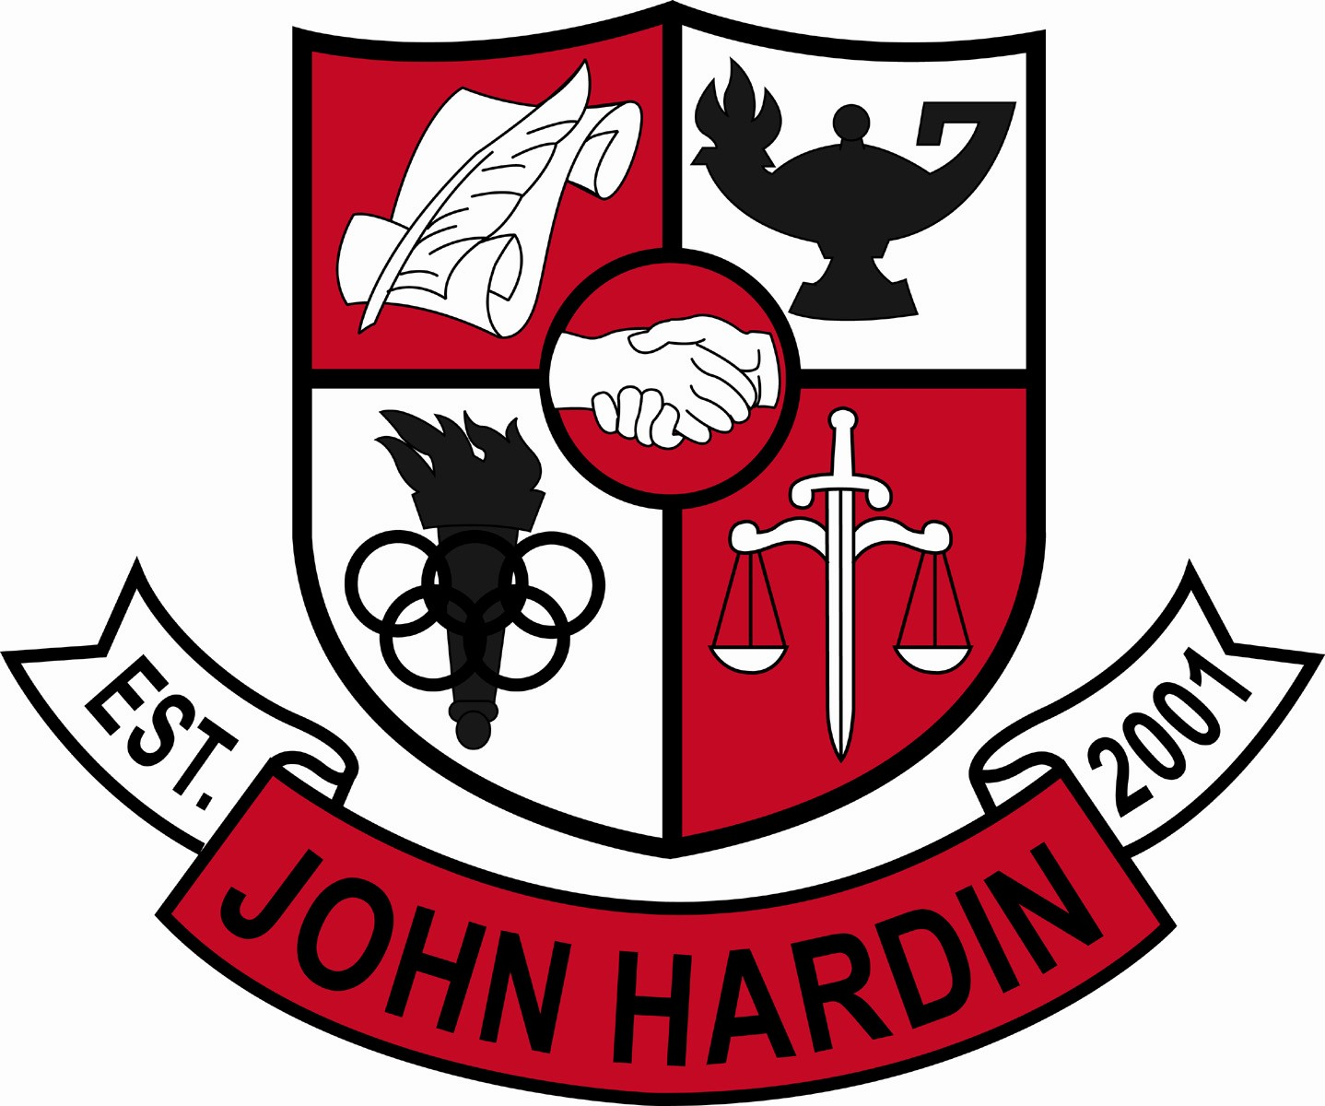
Meeting Minutes

December 12, 2013
4:00 p.m.

- Call to Order at 4:00 p.m.
Members present: Patrick Avery, Jana Haws, Stacey Moore, Alex Shearer and Lynne Gibson
Absent: Pauline Crittenden
Visitors present: Bobby Lewis
- Approval of Agenda ORDER #13-14/0024
The council approved the agenda as written.
Motion: Avery Second: Shearer
Avery - Yes
Crittenden – Absent
Gibson – Yes
Haws – Yes
Moore – Yes
Shearer - Yes
- Approval of Minutes ORDER #13-14/0025
The council approved the minutes as written.
Motion: Moore Second: Shearer
Avery - Yes
Crittenden – Absent
Gibson – Yes
Haws – Yes
Moore – Yes
Shearer - Yes
- PLC Reports
Fine Arts – No one attended due to illness or family emergency
JROTC – No one attended
- Principal’s Update
- .5 PE Credit – Mr. Kopp, Mr Robbins, Mr. Dennis, Mr. Isaacs and Ms. Gibson discussed offering this credit. NH currently offers the credit for students in band or athletics. CH is agreeable with part of the proposal but not all; concerns is for transferring students and how to track; and how some coaches would be able to meet all standards; when does the multiple credit offerings stop? John Hardin council does not support offering the .5 credit for PE in marching band or sports programs. No motion is necessary since this is not a change in current procedure.
- Handbook vs. Board Policy on Suspensions – Mr. Lewis addressed the council to say our currently policy of an automatic one day suspension for cursing a teacher out, is acceptable.
- EC³ Program Update – a concern was shared with the council that a small group of teachers are misinforming students about the center to keep students from wanting to attend. New classes are being offered next year that should help in quieting the chatter and benefit our students. We are offering more AP and Dual Credit also.
- Scheduling – schedule request forms have been reviewed and revised, now we just have to see what “makes”
- 2014 AMO Target – added program reviews to our score for a 66.5; 74.7 is our target for 2014
- Canadian Film Crew – Sportsnet wants to do a documentary on Stevie Delabar. They will be in town on the 18th and 19th of December and at JHHS on the 19th.
- Student Achievements – Elam receives the Paul Hornung Award next Tuesday at a luncheon; KYA State Convention recognized as Delegation of Excellence (top 5); Michael Kotarski and Lexi Legaspi both received awards; Ms. O’Daniel was recognized as Outstanding Advisor; 13 students were recognized at the WKU Luncheon for academic excellence (it was the most of any of the local schools)
- Financial Report ORDER #13-14/0026
The council reviewed and accepted the financial report for November.
Motion: Shearer Second: Moore
Avery - Yes
Crittenden – Absent
Gibson – Yes
Haws – Yes
Moore – Yes
Shearer – Yes
- CSIP Approval ORDER #13-14/0027
This year’s CSIP added a new goal (#5). Basically you enter requested scores/data and the document is generated for you. The council approved the CSIP as written.
Motion: Shearer Second: Avery
Avery - Yes
Crittenden – Absent
Gibson – Yes
Haws – Yes
Moore – Yes
Shearer – Yes
- Personnel
Vacancies: Asst. Tennis Coach; Freshmen Volleyball Coach; Girls Soccer Head Coach; 90% Freshmen Baseball Coach; 10% Asst. Baseball/10% Freshmen Baseball Coach
Hired: Amy Schwab for asst. swim coach and Maurice Green for .5 MS wrestling
- Questions and Concerns from Council
- Mr. Shearer has concerns about Zoom Math it has been purchased and downloaded on our calculators. He gave the council documents regarding ACT info prohibiting programmable calculators and showed practice tests with the percentage of questions that could be completed with no math knowledge and the use of Zoom Math. Ms. Gibson agrees with both sides of the issue but does not want our students to pay the price for our concerns with the use of Zoom Math Program. He feels like ACT will add it to the prohibited list, he just wanted to make the council aware of this issue in case something did come up.

- Agenda Items for Next Meeting
None
- Adjourn
The meeting was adjourned at 5:31 p.m. The motion was made by Ms. Moore and seconded by Ms. Haws

