Year to Date Attendance – 94.58%

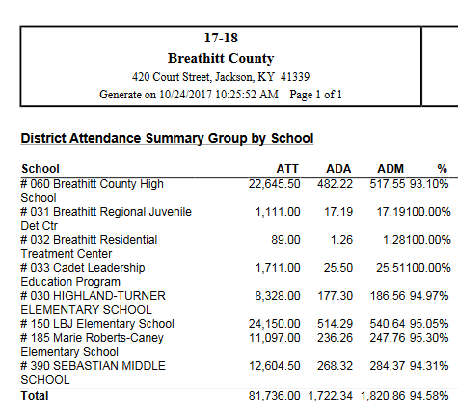

Month 2 showed a little drop but Month 3 is showing improvement.

Month 1: (7/31/17 – 8/30/2017) – 95.73%
Month 2: (8/31/17-9/28/17) - 94.47%
Month 3: (9/29/17 – 10/31/17) – 95.12% to date

