Director of District Support Services
Board Report - November 2020
Submitted by Katrina Rechtin

District Assessment Coordinator

MAP Assessment
- Students were assessed throughout the month of October. We are finishing up a few makeup assessments and assessments for virtual students before we close the assessment window.
- Ongoing conversations are focused around the MAP assessment timeline. The situation, virtual or in-person, will ultimately determine the future assessment dates and the frequency.

Brigance Screener (as of 11/17/20)
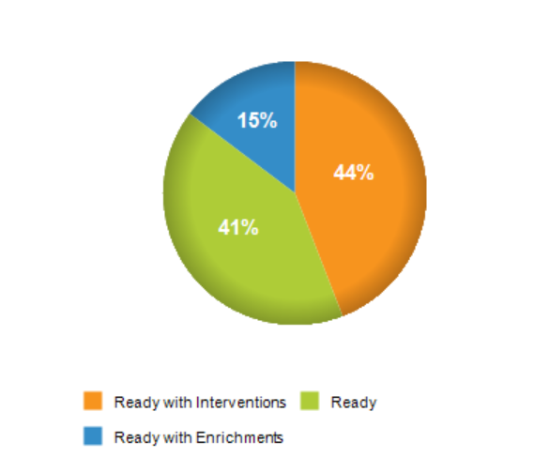

- 56% of Kindergarteners screened at this point are considered “Ready” or “Ready with Enrichments”
- 44% were considered “Ready with Interventions”. 11 of the 15 students in this category were within ten points or less of being considered “Ready”
- KDE has not confirmed a date for data collection completion or for formal reporting.

State Assessments
- The state is in the early stages updating the accountability system according to SB 158. This will focus on differentiation of all public schools using multiple measures. In this new system, performance is to be based on a combination of academic and school quality indicators. The big difference introduced by SB 158 is the idea of two terms: status and change.
  - Status: How a school performed in the current year
  - Change: How a school performed in the current year as compared to the previous year
- The U.S. Department of Education had expressed little interest in granting another waiver of testing this school year due to constraints placed upon schools because of COVID-19. However, with the election results being called, leadership at the U.S. Department of Education will change. Right now, KDE will explore options that are offered by the U.S. Department of Education and will keep districts informed.
- The ACT is scheduled in the spring for all Juniors. This year, we will administer the assessment online.
- ACCESS testing for our EL students will take place in January. The testing window for the Bellevue Independent School District is January 25th – 28th.
Infinite Campus Coordinator
- The instructional calendar in Infinite Campus is adjusted to match our transition to non-traditional instruction (NTI).
- Participation will be recorded for all students during NTI. Staff has been notified and reminded of the process in preparation for NTI.

Director of Pupil Personnel

BISD 2020-21 Enrollment Information
(Numbers pulled from Infinite Campus on November 17, 2020)
GES |  | BMS/BHS
Preschool | 38 | 6 | 43
K | 37 | 7 | 52
1 | 28 | 8 | 48
2 | 33 | 9 | 74
3 | 29 | 10 | 51
4 | 32 | 11 | 39
5 | 37 | 12 | 58
Total | 234 | Total | 365
BISD Total Enrollment Preschool – 12th Grade: 599

Attendance Data (10/12/20 – 11/17/20)
BISD Attendance Tracker
2020-21
Date | Temp/Cond | Notes | GES | BHS
10/12/20 | No School - Fall Break
10/13/20 | 72 - Sunny |  | 93% | B - 96%
10/14/20 | 77 - Sunny |  | 92% | Virtual
10/15/20 | 65 - Cloudy |  | 95% | A - 96%
10/16/20 | 58 - Sunny |  | 95% | B - 96%
10/19/20 | 59 - Rain |  | 90% | A - 97%
10/20/20 | 56 - Cloudy |  | 93% | B - 96%
10/21/20 | 71 - Partly Cloudy |  | 95% | Virtual
10/22/20 | 81 - Partly Cloudy |  | 98% | A - 96%
10/23/20 | 73 - Partly Cloudy |  | 98% | B - 95%
10/26/20 | 52 - Cloudy |  | 99% | A - 97%
10/27/20 | 52 - Rain |  | 95% | B - 97%
10/28/20 | 51 - Cloudy |  | 97% | Virtual
10/29/20 | 50 - Heavy Rain |  | 93% | A - 95%
10/30/20 | 43 - Cloudy |  | 95% | B -95%
11/2/20 | No School - Teacher Professional Development Day
11/3/20 | No School - Election Day
11/4/20 | 56 - Sunny |  | 94% | Virtual
11/5/20 | 60 - Sunny |  | 98% | A - 93%
11/6/20 | 61 - Sunny |  | 96% | B - 93%
11/9/20 | 70 - Sunny |  | 96% | A - 90%
11/10/20 | 68 - Sunny |  | 96% | B - 95%
11/11/20 | 60 - Cloudy |  | 96% | Virtual
11/12/20 | 37 - Sunny |  | 95% | A - 93%
11/13/20 | 42 - Sunny |  | 98% | B - 93%
11/16/20 | 45 - Sunny |  | 91% | A - 90%
11/17/20 | 42 - Sunny |  | 95% | B - 87%
11/18/20 - 12/4/20 | NTI - All Virtual

