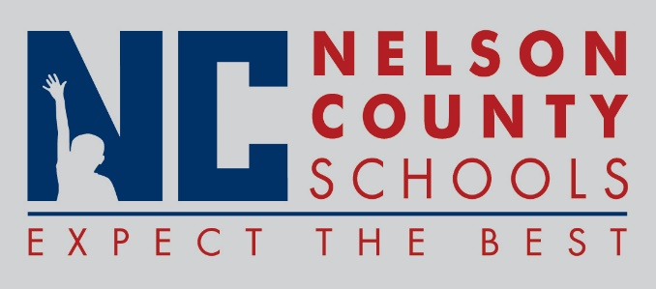

Decision Paper
To: | Nelson County Board of Education
From: | Ann Marie Williams
cc: | Dr. Anthony Orr, Superintendent
Date: | December 13, 2016
Re: | 2017 Comprehensive District Improvement Plan

RECOMMENDATION: Approve request for Comprehensive District Improvement Plan 2017.

RECOMMENDED MOTION: I move that the Nelson County Board of Education approve the Comprehensive District Improvement Plan (CDIP) for 2017 as completed as presented.

