Agreement for Services for Blind/Visually Impaired

This agreement made and executed on __________________ (date) by and between Katrina Berry, TBVI/COMS, (“provider”) and _____Todd______ County Schools.

Katrina Berry, TBVI/COMS is a certified teacher of the blind/visually impaired and certified orientation and mobility specialist. This school system has identified a need for blind/visually impaired and/or orientation and mobility services as documented on their Individual Education Plans (IEPS) or evaluation plan. The parties desire to collaborate to provide appropriate and needed services to students who are blind or visually impaired.

Duties of Provider:

Services: Katrina Berry, TBVI/COMS will provide one or more of the following services at the direction of the Director of Special Education or assigned liaison; assessment and evaluation with a written report when needed, consultation, direct instruction and training, staff training, progress reports, preparation of goals and objectives for student’s IEP.

Policies and Procedures: Provider shall provide the Board with reasonable access to such Provider policies, procedures, rules, and regulations as may apply to the provision of services to blind and visually impaired students. Provider maintains professional liability insurance.

Confidentiality of Records: Provider shall insure all educational and other records, either received from the Board or formulated during the school year will be confidential.

Payment: The provider shall invoice the Board when services are rendered. Direct services; conducting assessments, instruction, consultation, and travel time shall be invoiced at a rate of $75.00 per hour.

Duties of the Board

1. The Board shall designate a liaison between the provider and the Board as well as appropriate staff to deliver services delineated on the IEP.

2. The contracted amount for all services provided for __2017__ school year will be invoiced by the last day of each month as services are rendered. The provider will invoice only for services rendered and will receive payment no later than 30 days after receipt of invoice.

3. The Board shall provide a copy of a current school year calendar and each eligible student’s IEP to the Provider to insure appropriate educational programming.

General Terms:

Students will be assigned to Katrina Berry, TBVI/COMS solely for the purpose of blind/visually impaired or Orientation and Mobility services for the remainder of the __2017___school year.

No changes shall be made to this agreement without the consent of both parties, Provider and District.

Either party may terminate this Agreement upon Thirty (30) days written notice.

Both parties, are in consent of this written agreement for the remainder of the 2017 school year.

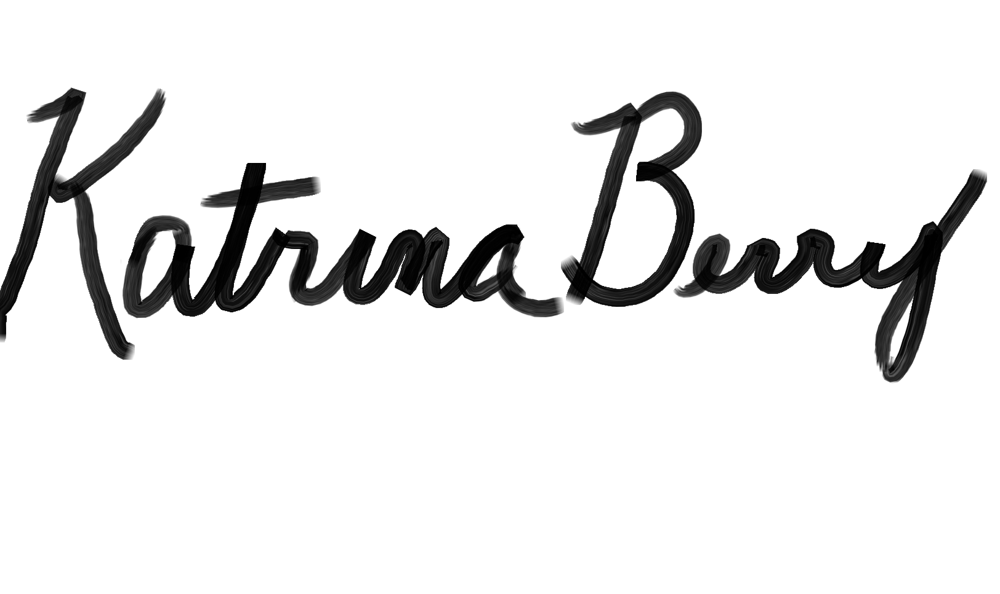________________01-19-2017______________________________
Provider Date Board (liaison) Date

