John Hardin SBDM Council
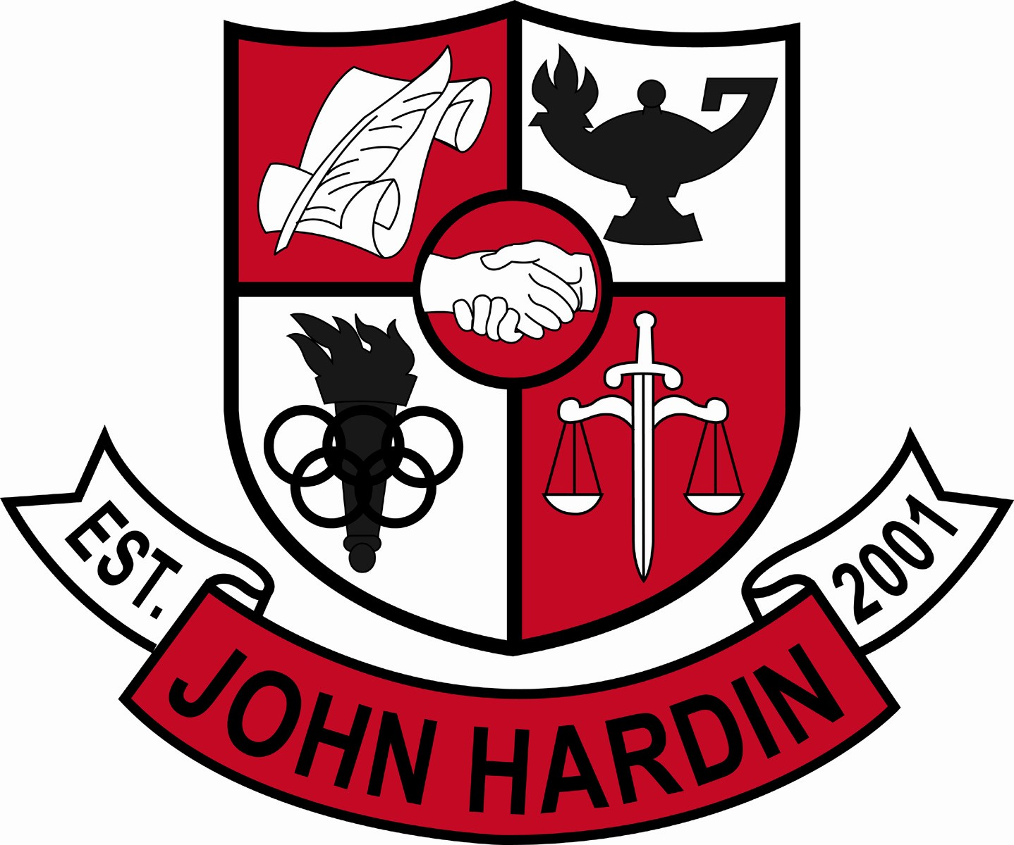
Meeting Minutes

May 12, 2016
4:00 p.m.

- Call to Order at 4:04pm
Members present: Mark Wells, Alex Shearer, Aurora Selbe, Kelly Smith, and Jan O’Daniel
Members absent: Stacey Moore
- Approval of Agenda ORDER #15-16/0066
The council approved the agenda as written.
Motion: Smith Second: Selbe
Selbe – Yes
O’Daniel – Yes
Shearer– Yes
Wells – Yes
Smith - Yes
- Approval of Minutes ORDER #15-16/0067
The council approved the minutes as written.
Motion: Shearer Second: O’Daniel
O’Daniel – Yes
Selbe– Yes
Wells – Yes
Shearer – Yes
Smith – Yes
- Approval of Special Called Meeting Minutes ORDER #15-16/0068
The council approved the minutes as written.
Motion: Selbe Second: Smith
O’Daniel – Yes
Selbe – Yes
Wells – Yes
Shearer – Yes
Smith - Yes
- Good News Report
  - Carson O’Daniel and Grace Vowels will attend the Governor’s Scholar Program during the summer.
  - Sierra Coachmen and Hunter Boucher were selected for the Governor’s School for the Arts.
  - Caleb Smith was named the Girls Basketball Coach of the Year by The News Enterprise.
- Public Comment
- No comment

- Principal’s Update
  - Day of Gratitude – Seniors spent the morning writing letters to parents, staff members and/or community members thanking them for guidance, support or other reasons. Seniors enjoyed an afternoon cookout and activities.
  - John Hardin Parade of Success – On May 24th, seniors will wear their cap and gowns and walk through New Highland Elementary, Bluegrass Middle School, and then John Hardin High School.
  - End of Course Exams –
May 18th – US History and Biology
May 19th – Algebra II
May 20th – English II
- Financial Report ORDER #15-16/0069
The Financial Report for April was reviewed and accepted.
Motion: Shearer Second:O’Daniel
O’Daniel – Yes
Shearer – Yes
Smith – Yes
Selbe – Yes
Wells – Yes
- Power Hour Committee – Heather Brown reported for the committee. Power Hour meets once a week for sixty minutes and is purposeful as well as valuable. This time is used to meet the needs of all students at all levels. Teachers complete a behavioral rubric for each student. If students receive two infractions, they will not be permitted to attend the celebration.
- Room Usage – No change
- Title I Extension Money ORDER #15-16/0070
The council approved the budget as written to fund teachers for homework help and instructional supplies.
Motion:Shearer Second: O’Daniel
O’Daniel – Yes
Shearer – Yes
Smith – Yes
Selbe – Yes
Wells – Yes
- Title I Budget ORDER#15-16/0071
The council approved the budget as written. The budget will be used to pay the salary of three teachers with any additional money coming from the PPA Budget.
Motion:Smith Second: Selbe
O’Daniel – Yes
Smith – Yes
Selbe – Yes
Shearer – Yes
Wells - Yes
- Personnel
Hired: No Hires
Vacancies: Math Teacher; Freshmen Volleyball Coach; Golf Coach; Tennis Coach 10% Stipend; Asst. to Head Girls Soccer Coach
- New Business
  - Work Ethic Certification – Students will be more informed about the certification.
  - Award’s Day – Students will be asked to dress for success.
  - Failing Students – Administrative staff talked to students who were in jeopardy of not walking or graduating. Students were encouraged to step up and finish their assignments. Some students will go to Hardin Co High School but will still be a part of our accountability.
- Agenda Items for Next Meeting
  - None at this time
- Adjorn
The meeting was adjourned at 5:02 p.m. The motion was made by Ms. Smith and seconded by Ms. Selbe.

