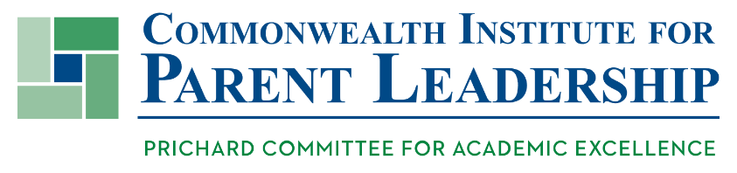
Fellowship Track

What is CIPL?
The Commonwealth Institute for Parent Leadership strives to equip and inspire parents as active participants in ensuring strong, high-quality public schools and community environments that support each and every learner to achieve their potential. The Institute includes: an annual Parent Leadership Summit, a Fellowship Track, programming supports for Fellows actively engaging other citizens at the local level (“Basecamp”), and resources for parents to gain knowledge about Kentucky’s education system, reforms, and progress over time.
Each year we bestow the Beverly Nickel Raimondo Award for Leadership on a parent leader at the Prichard Committee annual meeting and they are also recognized the following spring at the Parent Leadership Summit.
CIPL Fellows are citizen leaders actively working to realize excellence with equity in education.

Fellowship Track Objective
The Fellowship Track is designed to equip parents with the foundational information they need to understand the state of education in Kentucky; the system that supports education progress; successes and challenges over time; and current strategic areas of focus. It also equips parent leaders with knowledge about how to provide leadership in their local districts as a means to help increase outcomes for all students.

Process to Become a Fellow (2018-2020)
Becoming a Fellow requires commitment to and participation in the following:
- Kentucky Parent Leadership Summit: Attend the Kentucky Parent Leadership Summit in the spring of the year to learn and network with other parents and Fellows.
- Learning Webinars: Participate in a track of webinars that provide deep content to understand Kentucky’s education system and key topics relevant today to help increase student success.
  - Foundational Topics:
    - Education Reform & Accountability
    - Student Performance Over Time & Achievement Gaps
    - Adequate and Equitable Funding – Kentucky’s SEEK Formula
    - Community Leadership
  - Specific Topics:
    - Early Childhood and Early Literacy & Math
    - School/Community Climate & Culture
    - College & Career Readiness
    - Issues in Postsecondary
    - Social Determinants of Success
- Moving to Action: Take what you’ve learned into your community in a way that engages parents/citizens and helps deepen commitment to student success. This could be a dedicated community conversation with a goal of continuing the conversation over time, hosting a Basecamp, or designing a unique project.
- Final step: A written report that highlight’s what you learned, how you’ve grown as a parent leader, and what you hope to accomplish in your community as a result.
CIPL Fellows will be installed and recognized at the annual Kentucky Parent Leadership Summit.

