Tax Hearing Public Forum Meeting Boone County Board of Education
August 24, 2017 7:00 PM
Ralph Rush Professional Development Center
99 Center Street
Florence, Kentucky 41042

I. CALL TO ORDER

The Tax Hearing Public Forum meeting of the Boone County Schools Board of Education August 24, 2017 was called to order by Chairperson Ed Massey at the Ralph Rush Staff Development Center.
Attendance Taken at 7:00 PM:

Present Board Members:
Dr. Maria Brown
Ms. Karen Byrd
Mr. Ed Massey
Mr. Matt McIntire
Ms. Bonnie Rickert

Gerry Dusing attended as Board Attorney
Karen Evans, Board Secretary, recorded the minutes.

II. PLEDGE TO THE FLAG
The Pledge to the Flag was led by Mr. Ed Massey, Chairperson.

III. INFORMATION ON TAX RATE LEVY (Attachments On Emeeting for public view)

Mr. Eric McArtor, Deputy Superintendent COO and Budget Committee Member, presented to the board the following powerpoint presentation. Mr. McArtor discussed the need for the 4% tax rate revenue increase and the budget committee’s recommendation to ask the board to approve the rate increase. Mr. McArtor reviewed the growth of Boone County and the Per Pupil Expenditures from 2010 to 2016 comparing the State average with Boone County. The Boone County average per pupil expenditure is $10,072 well below the State average of $11,234.00. The Boone County Schools enrollment history from 2000 to 2016 has grown from 12653 to close to 20,800 in 2017 this growth has more than half of our Boone County schools exceeding their student level capacity according to KDE standards. Mr. McArtor reviewed the transportation funding issue Boone faces and the fact the state has not fully funded transportation costs since Fiscal Year 2004 and discussed the shortfall that is absorbed by the general fund in the last three years, in 2017 it is over 3 million dollars our district must come up with to cover. The transportation department keeps our fleet running and is great shape due to the mechanics that we have and being frugal and keep those 250 busses running, but we are in desperate need of extra funding. Mr. McArtor discussed the crisis in the Kentucky Teachers Retirement System and the state shifting the increasing cost of funding the system to school districts, which has cost the district an additional 2.6 million.
Mrs. Linda Schild, Finance Director, discussed the history of the shift of these expenses since 2011 to the district. Mrs. Schild spoke on the employees and employers picking up some of the cost of the retirement and this has graduated that burden up to about 3% over that period of time, those are additional cost for the district. We are now leveling out at 3%, 2. 7 million and that will continue to climb as we grow with new employees.

Dr. Poe clarified this is just the teacher retirement system and not the additional CERS retirement.

Mr. McArtor reviewed the SEEK funding and the decrease in SEEK.

Linda Schild explained how the property assessment effects the SEEK funding. The SEEK formula increases the calculation of local efforts and decrease the States portion that comes back to the district. The increase in property values result in a shift in operational funds to the restricting building fund in order to fund the 3 nickels. The property assessment increase this year will cause us to shift $633,000 over to the building fund and will not be able to use that for normal operations of the decrease. Mrs. Schild discussed the loss of 1.1 million plus $633,000 is how our SEEK formula will be impacted.

Mr. McArtor reviewed the districts increasing expenses with our growth of the new middle school Ballyshannon expense to open is 2. 8 million which is non construction expenses. The district will also have a 2.2 million expense of ongoing operating of the new middle school. Mr. McArtor discussed the other unmet needs of the district as the threat further hikes in retirement costs and the ability to financially support 21st Century personalized learning.

Dr. Jim Detwiler, Deputy Superintendent CAO, addressed the board on the needs world class teaching core and continue to strive to meet our strategic plan and move into personalized learning and world class education we must make sure we provide our students with the tools they need. There will be required expenses related to the Digital conversion providing those 21st Century learning spaces for our students.

Linda Schild, unfortunate the way the SEEK formula works and does put the board at a disadvantage and puts the board in a position to increase tax rates to try to make up the loss of funding.

Full presentation below:

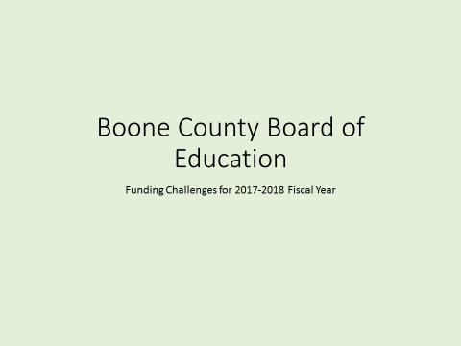

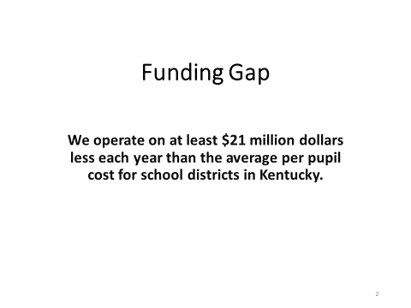

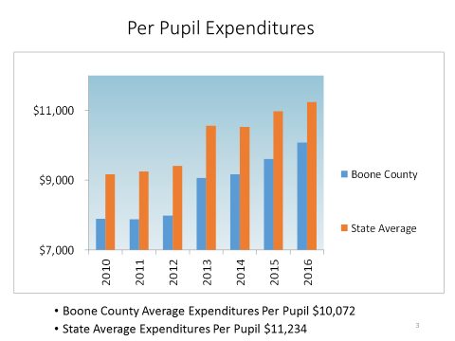

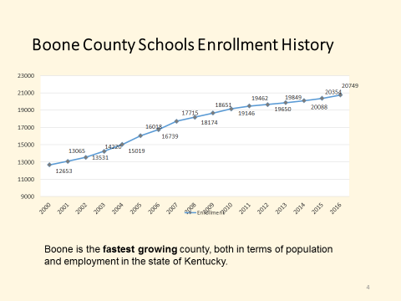

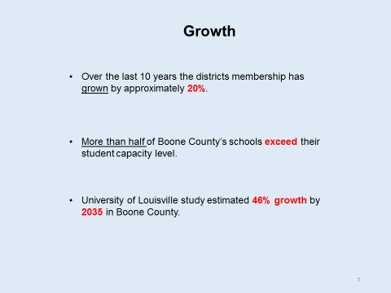

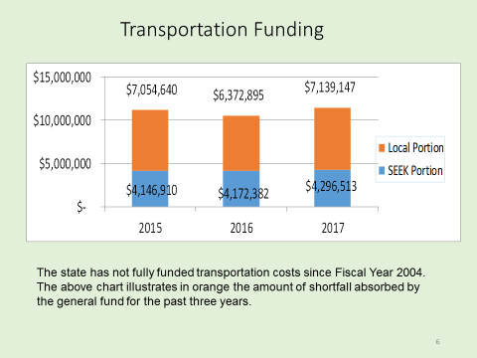

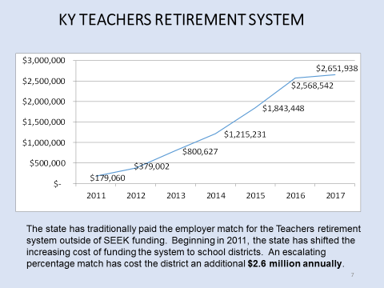

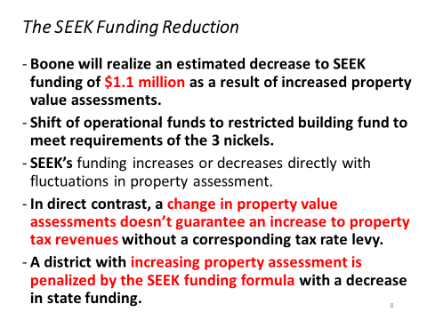

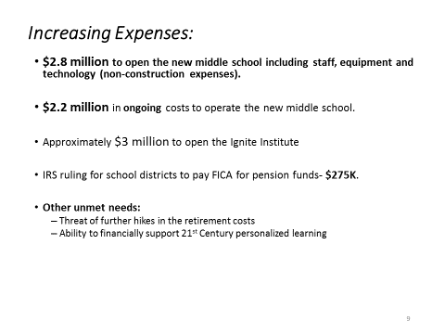

IV. PUBLIC HEARING

IV.A. To hear comments from the public on the Tax Rate Levy

Audience of Citizens – the following statements are summaries.

- Mr. Joe Hamelin, spoke for the classified employees as the BCCEA President, in support any endeavor the board make for the tax increase. Mr. Hamelin discussed the lack of funding from the Federal and State Government and we must make up the shortfall. We have done a terrific job in education for Boone County and support the tax increase.
- Mrs. Mary Wilson, represented the certified employees as the BCEA President, in support of the tax increase. Boone County’s goals for every student is to prepare every student for college, career and life readiness. Without the proper funding many of these goals and objectives cannot be accomplished. Mrs. Wilson spoke on the staff coming up with creative ways throughout the year to make sure students’ needs are continually met. Mrs. Wilson asked the board to notice the teachers that attended the meeting with the green shirts on in support of our student’s education and support of the increase.
- Mr. Greg Gaspard, past chair of Boone County Republican Party and active in Boone County in Northern Kentucky and Greater Cincinnati in a political sense and past part time employee of Boone. He spoke in the past that he has come and asked the board to not increase taxes and quit coming because it seems to be automatic to increase the taxes. Mr. Gaspard gave examples of government and businesses cutting across the board spending to meet their operational needs. He spoke on the challenges 25 years ago the Boone County School board faced on decisions to increase taxes or cut programs, programs were cut, it was hard but appropriate. Mr. Gaspard stated he would rather see programs cut than tax increases, he discussed the elderly on fixed incomes and asked the board to not increase the taxes and be as conservative as they could, asked to at least not increase them by the full amount, a lot of people would be grateful.
- Mrs. Mary Birkenhauer, Special Ed teacher in the Boone County School District, and addressed the board on her experience as a Special Ed teacher. She spoke on people moving to Boone County for the well-known Special Ed program and spoke on the Federal Governments lack of funding. Mrs. Birkenhauer stated Boone County spends the money to meet the needs of students and makes their lives more valuable and money well spent. As a district that services students with special needs and transitions them from high school to the adult world, which saves tax payers money, we have no other choice but to take this 4% for our programs. Mrs. Birkenhauer told the board we need this money and as an advocate for special education.

V. ADJOURN

- A motion was made by Matt McIntire, seconded by Bonnie Rickert to adjourn the meeting. Bonnie Rickert, Matt McIntire, Karen Byrd, Ed Massey, and Maria Brown voted, “aye.” MOTION: The motion passed 5-0.

The meeting was adjourned at approximately 7:21 p.m.

_____________________________________
Ed Massey/Chairperson

_____________________________________
Karen Evans/Secretary

