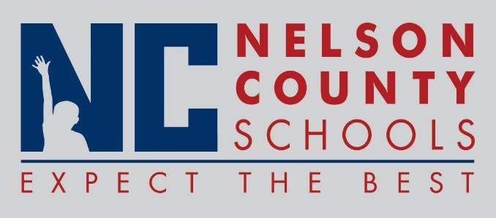

Decision Paper
To: | Nelson County Board of Education
From: | Bob Morris, Director of Student Support
cc: | Dr. Anthony Orr, Superintendent
Date: | June 1, 2017
Re: | Job Description: Director of State and Federal Programs

RECOMMENDATION: Approve Job Description as written.

RECOMMENDED MOTION: I move that the Nelson County Board of Education Approve the job description as presented.

Director of State and Federal Programs

