Special Board Meeting Boone County Board of Education
Discussion on Reopening of Schools to
Additional Days of In-Person Instruction
October 06, 2020 7:00 PM

Due to the Governor's directive of no more than 50 to gather for safety during the Covid-19 Pandemic, we were allowed to have 50 people in the room when the Board Meeting was broadcast. An additional overflow area was provided at Florence Elementary and was broadcast live to the room. Anyone that attended could sign up to speak during the audience of citizens portion of the meeting. The Board of Education will also broadcast the meeting on YouTube page.https://www.youtube.com/user/BooneCountySchools
Ralph Rush Prof. Dev. 99 Center St. Florence, KY 41042

I. CALL TO ORDER
The Special Called Meeting of the Boone County Schools Board of Education to Discuss Reopening of Schools to Additional Days of in-Person Instruction October 6, 2020 was called to order by Chairperson Matt McIntire at the Ralph Rush Staff Development Center.
Attendance Taken at : 7:00 PM
Present Board Members:
Dr. Maria Brown
Ms. Karen Byrd
Mr. Troy Fryman
Mr. Matt McIntire
Mrs. Julia Pile

Matthew L. Turner, Superintendent
Karen Evans, Board Secretary
II. PLEDGE TO THE FLAG
The Pledge to the Flag was led by Mr. McIntire, Chairperson.
III. DISCUSSION ON REOPENING OF SCHOOLS TO ADDITIONAL DAYS OF IN-PERSON INSTRUCTION
(Brief Summary)
Matt McIntire, chairperson, discussed the special meeting was called to discuss HOW and IF we might proceed to bring students back for additional days of instruction. The meeting is for the board to hear the information gathered to be able to move forward, no matter what that forward might look like. The board is listening to make an informed decision for our students, staff and community. Mr. McIntire discussed there are different perspective on bringing the students back and ask that everyone respect others opinions or thoughts no matter if you agree or not. Mr. McIntire asked that we all look at Boone’s challenges, circumstances and our needs, we have a different governor than Indiana and we must follow our safety guidelines of Kentucky. The board is doing their due-diligence from listening to many parents and teachers thru phone calls and emails, visiting schools in and out of our district. We must respect the argument of those who do not feel it is safe to return to the classroom, but most importantly, we must as a board plan to bring our students safely back to school, because COVID is not going away. Mr. Turner stated NO decision has been made, we are learning as we move forward and are listening to the two prevailing view points, both having valid opinions are returning our students to the classroom.

Mr. Turner stated the meeting was to gather information and listen on how to provide more instructional days, we all know in-person education is socially the best for our students; this is complex; significant challenges, safety protocols that must be followed, and providing appropriate staffing with many other concerns and issues that must be addressed. This all dependents on the COVID numbers in the county, things change quickly. Mr. Turner thanked all staff and students for all they can at this time and it is nothing short of heroic.

Mr. Turner introduced the T & L committee members attending the meeting, which is a principal representing and speaking for each level – elementary, middle and high. Kim Best, OMS Elementary Principal, Mary Goble, NPE Principal, Stephanie Hagerty, OMS Principal and Mike Wilson, RCHS Principal. The team gave a Powerpoint presentation, which is included below along with a handout to the board. The board asked several questions of the principals and had discussions on the content of the presentation after the last slide. The board asked questions of time-frame, when the principals felt the schools could be ready to bring the students back at a socially distanced space, questions on substitute teachers and having teachers in the class is a real concern, is there a stock of sanitizing products that we need or do we need more, have we thought of going to partial classes by grades, questions on internet access needed, special education student’s needs, and other discussions.

Presentation below:

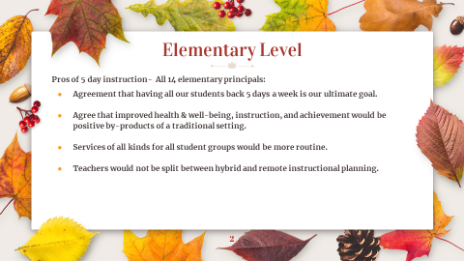

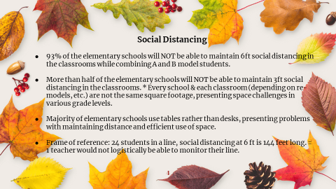

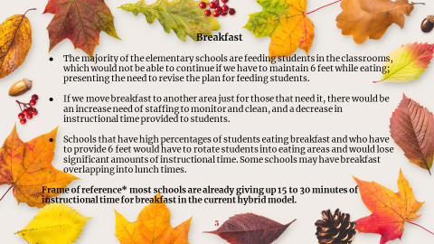

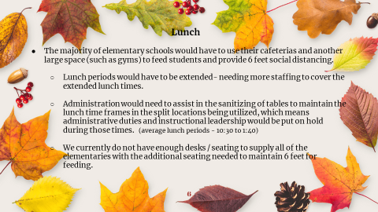

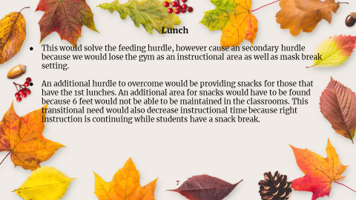

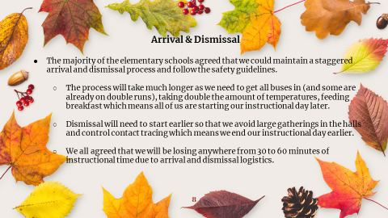

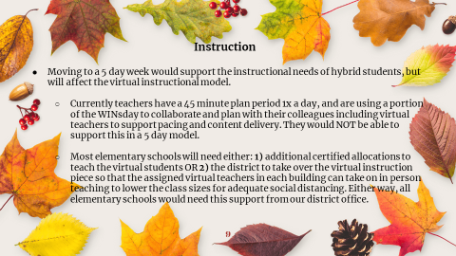

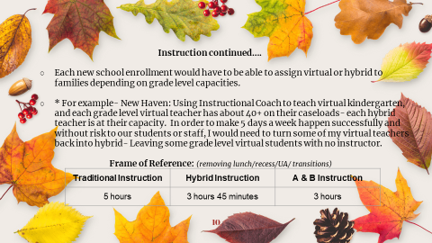

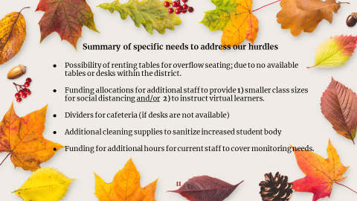

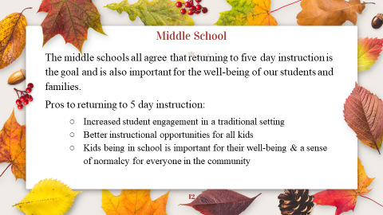

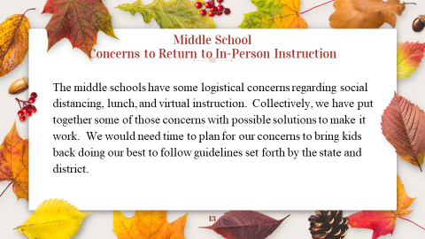

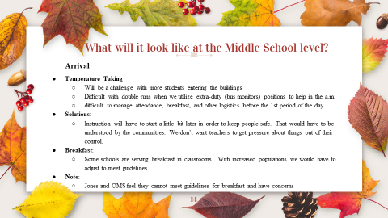

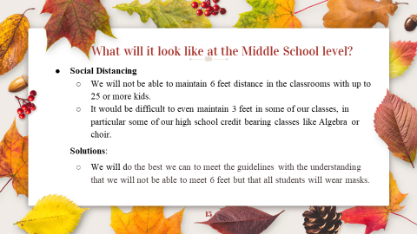

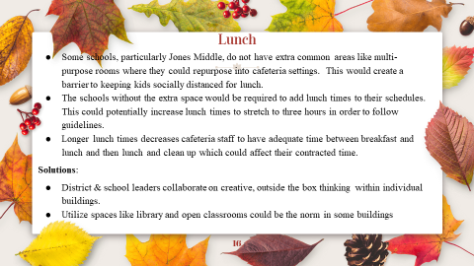

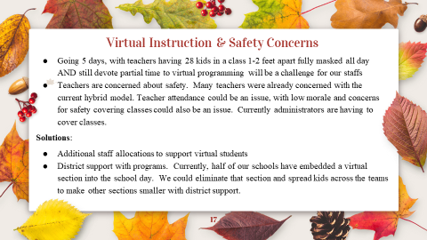
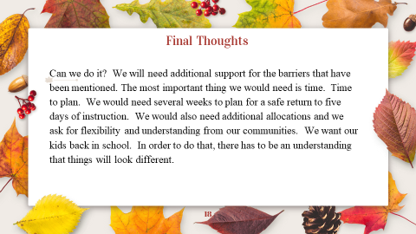

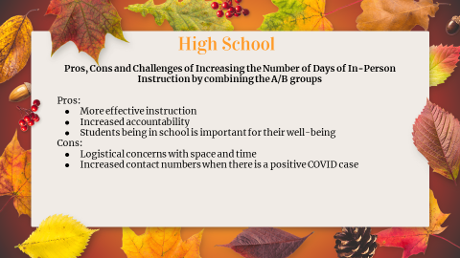

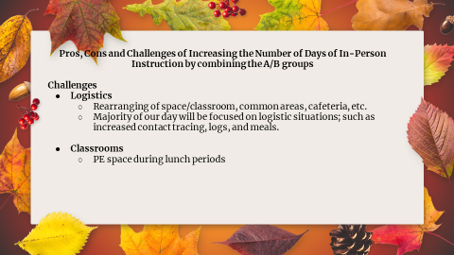

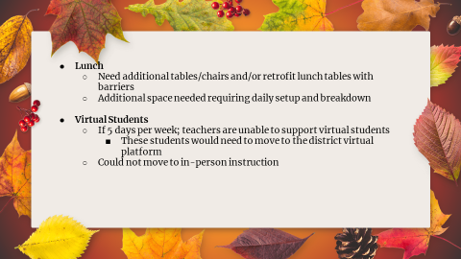

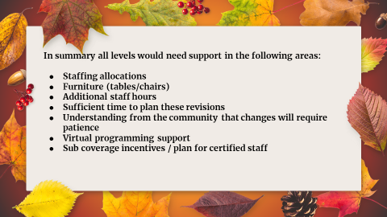

Mary Wilson, BCEA President, presented survey results from the teachers association and read a statement. Ms. Wilson guided the board thru a series of teacher concerns during this time in light of the COVID 19 pandemic. She reviewed a timeline of work that has been done since the start of the pandemic and teachers have continued to meet those request. Ms. Wilson described the survey of 650+ members completed a survey in and asked to gauge their needs with this current model and how they can transition to 5 day instruction. Reviewed the survey questions – would they file for FMLA or EMFLA if the board determines they could return to school - 7.46. agreed, 56.1% said they would disagree, 25.07% said it was a strong possibility. Teachers surveyed if the classroom has been supplied with adequate sanitizing points and hand sanitizers – 59.15% agreed, 41.2% disagreed. Discussion on PPE and what they would require, 61.78% would request protective plastic shield, -59.62% would request mask protection, and surveyed other safety precautions. The survey asked if the teachers could maintain the recommended CDC 6ft guidelines, the survey said No at 93.10%. 6.90% Yes. Ms. Wilson discussed the results of sick day utilization, if positive cases reported they would take leave, safety precautions being followed and compromised health categories. Discussion on concerns that need to be taken in to consideration for a safe return to school, Boone County returned to an orange level and the levels are on the rise again, to date we have 34 cases of staff and students with 6-days in-person hybrid instructions. Reviewed the teachers concern of maintaining social distancing in classroom, hallways and restrooms. Supplies of hand sanitizer and how long will it be there. The districts safety guidelines of mask wearing, following social distancing, cleaning and hand sanitizing – how is this possible with the concerns Ms. Wilson discussed. Concern there is not have adequate substitute teachers to cover even on a normal non-Covid day and always has been a problem in Boone County. Teachers once again are going to be asked to give up their coveted planning time, which would be a complete disservice to students, this is a time to contact parents, plan for the classwork etc. Ms. Wilson reiterated the teachers want to do their jobs, but teachers cannot keep up with the stress and strains of meeting the needs of our families, and the responsibilities, plus the needs for in-person and virtual instruction on top of that. Mental health is suffering and they are worried they will bring this home to their families with compromised system. Ms. Wilson explained the teachers only want the transition back to full instruction only when the time is right, let the hybrid model work for as long as possible, we need to see the impact of the hybrid students back, teachers fully understand we must prepare to go back to full instruction. Our teachers want to work collaboratively to work with the board and district leadership, but make the most responsible decision with voices to heard.

Charlie Bufano, BCCEA President, discussed talking to his members, asked the board keep it mind the custodian staff and classified staff have still been working they have not left or stayed home. At this time there is 11 opening of custodians right now, we have trouble getting these positions filled. Principals may be told, but the big concern of custodial staff is lack of communication and what they are supposed to do, what is the guidelines. Transportation issues from the bus drivers is the students are not doing what they are supposed to do – not wearing mask on the bus, switching seats and they can’t pay attention to this when they must keep their attention on driving. Custodial staff with all the internal cleaning duties are being asked to help with lunch duties and takes away from primary cleaning duty. Nurses concerned they are over worked and liability issues with their license. Membership of 435, normally the classified staff does not say anything but, this time there were many responses of concern. Mr. Bufano discussed the staff want the kids to come back but we want to be safe on the return, hope you all realize the staff is doing the best they can.

IV. AUDIENCE OF CITIZENS (brief summary)
- Tony Clevenger, Student Board Representative, spoke on the students she has talked to and they would love to go back to school, but there is a fear of bringing the virus back to their families and they are afraid for their teachers also. Go back when we can, but do it safely.
- Lauren Barnhill, parent and teacher, discussed the complete restructuring of her choral class to meet the hybrid and virtual models. Concerned with the guidelines and we will be forced to go back to all-virtual and the unknowns., spoke on the experiences of her children. Moving forward it is important to have a plan in place, the district zones do not specify, we need it based on something we can show people and be clear.
- Mr. Barnhill, parent and teacher, discussed the current guidelines and are we hoping this does not spread, he would like a clear plan for return to schools.
- Alisa West, student, discussed her wonderful experience at school and asked to return to 5-day instruction.
- John Warton, student, discussed that the decisions made are made for 21,000 students and many staff. He discussed the 6-days of hybrid has been a struggle for students, long hours in front of the computer is taking a toll.
- Karen Wills, teacher, discussed if the board has thought about what if a student of staff lose their life and has the health department been consulted, will COVID test be available for teachers.
- Shelly Price, stated the videos that are not safe with things being seen and heard from the parents of the students in the videos, very important to make contact with our students to see how they feel about going back and if we go back we need a virtual plan and teachers not responsible for both.
- Kelly Reed, teacher, discussed how the teachers have had to change their classroom instruction on a dime since March. Concerned for the surge in COVID cases, students handling on and off instruction, concerned with survey they were given and not being able to answer, as they would like to of answered.
- Andrea Leffler, teacher, discussed education 101 and the way a class operates with goals and plans. Concern we are failing with the plan and numbers are going up and we are moving away further from the green zone. Ask the board to give the teachers time with the hybrid plan.
- Krista Franks, teacher, concerned that the teachers need more time to get ready for full-time instruction.
- Mike Albret, parent, discussed the positive case counts in kids declined. Issues of student getting only one day in chemistry, no live stream on days at home, discussed some teachers not returning emails. He stated he couldn’t say that all education measures are being met.
- Jim Fiorelli, discussed number of COVID cases and asked that until we can guarantee safety we don’t go back.
- Holly Biss, teacher, discussed the importance of social interaction for students, no substitute for live teaching, we need a better plan, currently Edgeunity platform, develop a balanced plan for returning to school full time raise bar for hybrid learning.
- Tinna Schira, parent and nurse, discussed and urged the board to move to 5 day instruction, hybrid plan is flawed and not having a plan for parents who want 5 day instruction.
- Maggie Suttle, discussed people under the age of 24 are not getting the virus and you cannot spread it, students are not socially distancing nor are teachers when they still go out to restaurants, etc. Her child is not bringing the teachers any more risk than they have.
MOTIONS:

At approximately 7:50 pm a motion was made to extend the time of the meeting to hear from everyone that wished to speak. The meeting now would end at 9:30 pm. The meeting was advertised to end at 8:00 pm and by law the board must keep the schedule posted and advertised. The motions would allow the meeting to continue.

Mr. Matt McIntire, recommended the board extend the meeting time by 1.5 hours to be sure to hear from all that wishes to speak during the audience of citizens, as presented.
- A motion was made by Troy Fryman, seconded by Julia Pile, to approve to amend the agenda time by 1.5 hours to be sure to hear from all that wishes to speak during the audience of citizens, as presented. Matt McIntire, Karen Byrd, Dr. Maria Brown, Troy Fryman and Julia Pile voted, “aye” MOTION: The motion passed 5-0.

- Nikki Sinclair, teacher and parent, discussed her own child’s respiratory infection and how she tries in every way to socially distance. If someone gets the virus and you are around that person then the requirements to quarantine means time away from work. Discussed the safest instructional mode.
- Kim Delany, RN, concerned with the action to increase numbers in classrooms, events concerning COVID cases, not the time to decrease social distancing. Discussed the need for medical grade mask.
- Sarah Cheek, plan must be nimble, discussed in-action not the same in liability issues as action, shared she has a petition with 1,000 concerned parents that want their students in school. Asked the board to come up with a solution to come back to 5-day instruction.

MOTION

At approximately 9:20 pm a motion was made to extend the time of the meeting to hear from everyone that wished to speak.

Mr. Matt McIntire, recommended the board extend the meeting time be sure to hear from all that wishes to speak during the audience of citizens, as presented.
- A motion was made by Dr. Maria Brown, seconded by Karen Byrd, to approve to amend the agenda time to end after all have been heard during the audience of citizens, as presented. Matt McIntire, Karen Byrd, Dr. Maria Brown, Troy Fryman and Julia Pile voted, “aye” MOTION: The motion passed 5-0.

V. ADJOURN

- A motion was made by Dr. Maria Brown, seconded by Julia Pile, to adjourn the meeting. Karen Byrd, Maria Brown, Julia Pile, Troy Fyrman and Matt McIntire voted, “aye” MOTION: The motion passed 5-0.

Meeting was adjourned at approximately 9:31 pm.

____________________________________

Matt McIntire /Chairperson

_____________________________________
Karen Evans/Secretary

