John Hardin SBDM Council
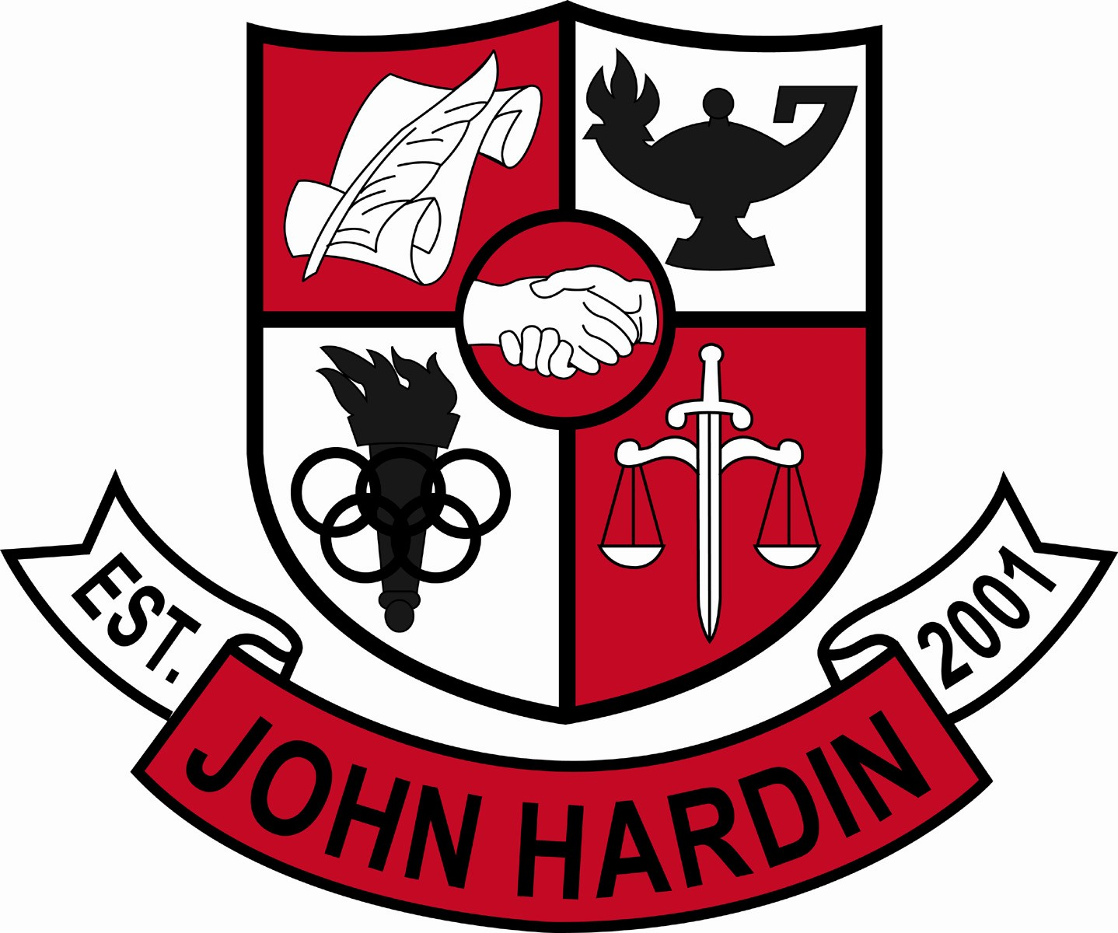
Meeting Minutes

September 8, 2016
4:00 p.m.

- Call to Order at 4:02
Members present: Mark Wells, Alex Shearer, Aurora Selbe, Jan O’Daniel and Michael Moritz.
Members absent: Kelly Smith
Visitors: Chris Reed
- Approval of Agenda ORDER #16-17/0015
The council approved the agenda as written.
Motion: Moritz Second: Selbe
Selbe – Yes
O’Daniel – Yes
Shearer– Yes
Wells – Yes
Moritz – Yes
- Approval of Minutes ORDER #16-17/0016
The council approved the minutes as written.
Motion: Shearer Second: Moritz
O’Daniel – Yes
Selbe– Yes
Wells – Yes
Shearer – Yes
Moritz – Yes
- Public Comment – No Comment
- Good News Report –
  - Student Recognition – Andrew Minnis named Kentucky Youth Soccer Player of the Year.
  - Mya Muschette placed as the Triple Jump 3A State Champion.
- Principal’s Update
  - Homework Help – The program has been very successful. Teachers were reminded that homework help can not be the only option to make up quizzes and tests since some students can not stay.
  - Student Athlete Social Media – Based on research, the Site Base Decision Making (SBDM) committee can create a policy addressing behavior on social media. Feedback from coaches will be requested before SBDM moves forward.
  - The Kentucky Open Records and Open Meeting Act “Your Duty under the Law” and Managing Government Records a Cooperative Undertaking – Information was given to each member of SBDM. The following forms will need to be completed and returned, SBDM Member Requirements, Special Meeting Written Notice, and Proof of Receipts .
- Financial Report
The Financial Report for August was not available at this time.
- Textbook Purchase Plan ORDER #16-17/0017
The council reviewed and approved the Textbook Purchase Plan as written.
Motion:Selbe Second: Shearer
O’Daniel – Yes
Shearer – Yes
Selbe – Yes
Wells – Yes
Moritz – Yes
- Committees ORDER # 16-17/0018
The council approved the committees as follows: Climate/Culture/School Spirit, CSIP, Governor’s Scholar, PBIS, Power Hour, Professional Development, Program Review, Project Graduation, Safety, SBDM and Title IX. Committees will be submitted to Mr. Wells and report to SBDM on a specific date.
Motion:Moritz Second:O’Daniel
O’Daniel – Yes
Shearer – Yes
Selbe – Yes
Wells – Yes
Moritz – Yes
- Personnel
Hired: Dwight Ashley for Custodian; Scott Holland for Girls Asst. Soccer Coach; Darrin Jacques for 50% Stipend Boys Assistant Soccer Coach.
Vacancies: Freshmen Volleyball Coach; Freshmen Baseball Coach; 9th Grade Girls Basketball Coach; 30% Stipend Boys Assistant Basketball Coach
- New Business - No new business
- Agenda Items for Next Meeting
- Adjorn
The meeting was adjourned at 4:40 p.m. The motion was made by Ms. Selbe and seconded by Mr. Moritz.

