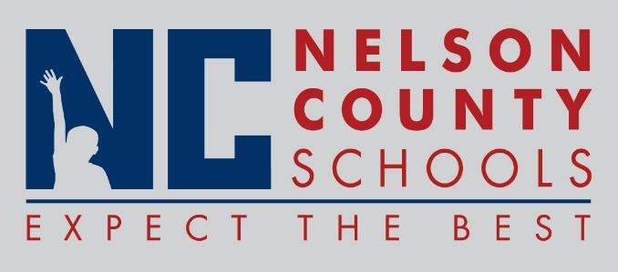

Decision Paper
To: | Nelson County Board of Education
From: | Bob Morris, Director of Student Support
cc: | Dr. Anthony Orr, Superintendent
Date: | August 15 , 2017
Re: | Policy Updates for 2017-2018

RECOMMENDATION: Approve the below listed policy updates for 2017-2018 as written for their second reading.

08.13452 English as a Second Language
08.14 Guidance
08.222 Assessment
08.232 Instructional Resources
08.3 School Calendar
08.4 Adult/Community Education
08.5 Program Evaluation
09.12 Admissions and Attendance
09.121 Entrance Age
09.122 Attendance Requirements
09.1223 Persons over Compulsory Attendance Age
09.1231 Dismissal from School
09.13 Equal Educational Opportunities
09.14 Student Records
09.2 Student Welfare and Wellness
09.227 Child Abuse
09.311 Safety (Athletics)
09.34 Student Publications and Speakers
09.425 Assault and Threats of Violence
09.4294 Driver’s License Revocation
09.4361 Police Officers in the School
10.5 Visitors to the Schools.
08.1114 Preschool Education
09.423 Alcohol, Drugs, and Other Prohibited Substances

RECOMMENDED MOTION: I move that the Nelson County Board of Education Approve the listed policy updates for 2017-2018.

