Project Construction Field Report
Project Name: Nelson County Schools – Guaranteed Energy Savings Contract – Bloomfield Middle, Bloomfield Elementary, and Nelson County High School.
Date: 04/27/2017
Contractor: Intertech Mechanical, Freedom Electric, ECT Controls, Blanton Electrical
Distribution: Kevin Mattingly; Vince Paul; Troy Blanton; Tony Humphrey; Adam Pierce; Jon Gasser
Work Completed (04/17 – 04/21):
Freedom- (Electrical)
Middle School:
- LED tube installations and ballast removals (4 lamp fixtures) were performed and completed for Science and Computer Classrooms, Library, Office Area, Cafeteria and Kitchen Areas.
- Repairs were made to broken football field scoreboard ciruit.
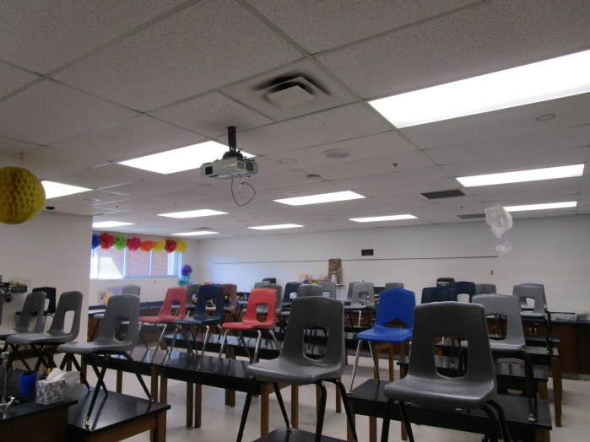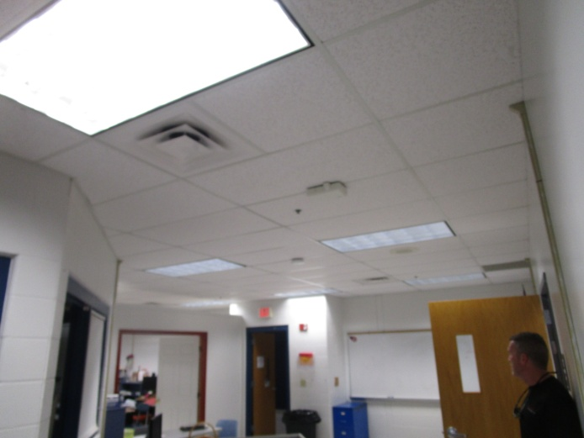
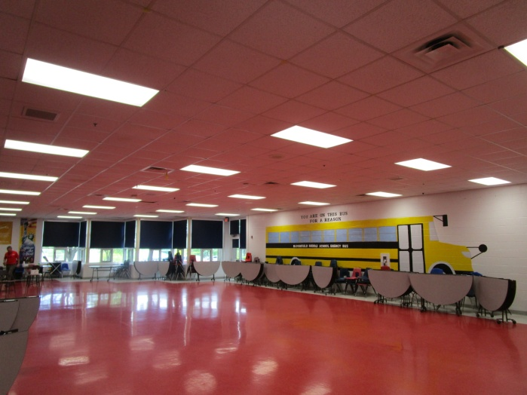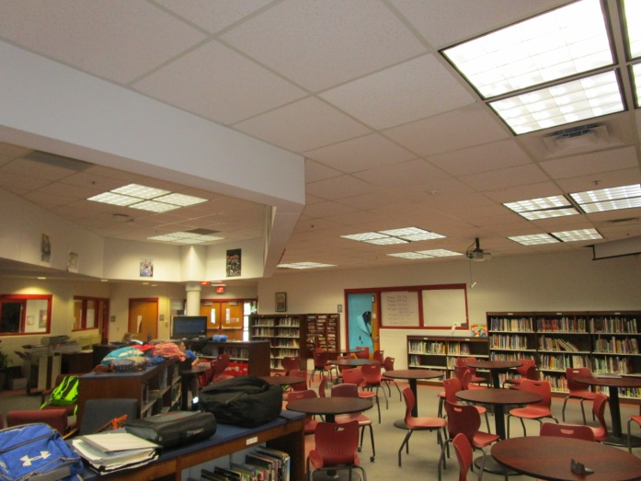
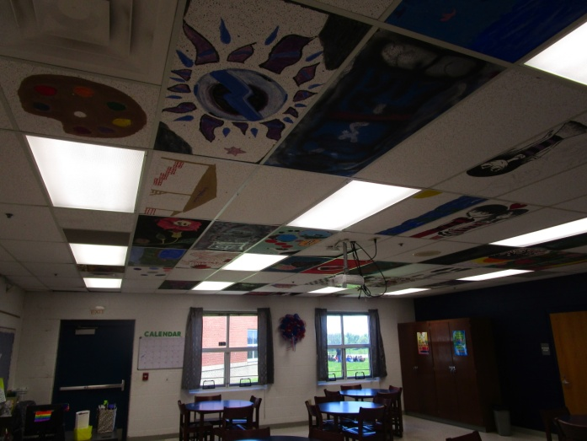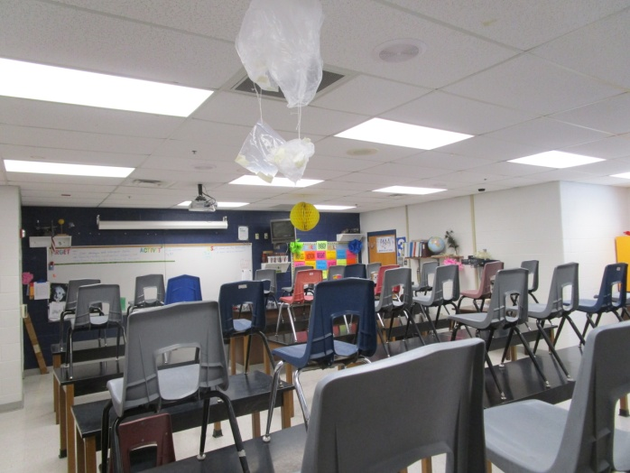
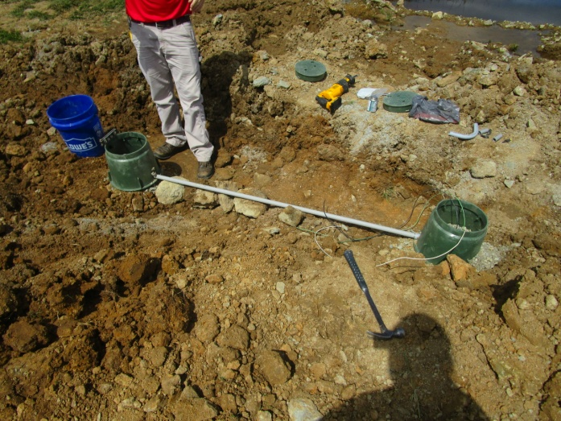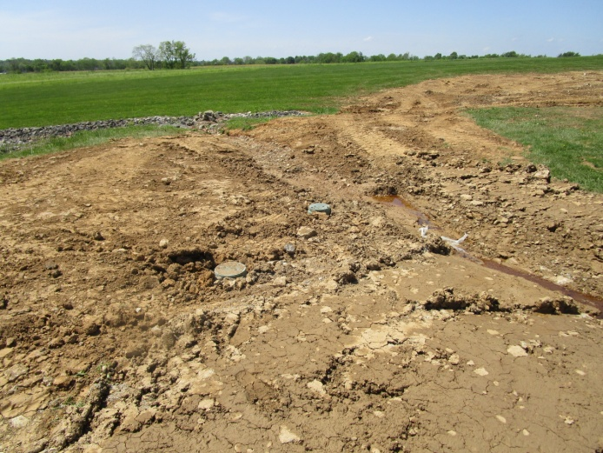
Intertech Mechanical:
Bloomfield Middle School:
- Installed geothermal piping tracer wire.
- Backfilled sand bedding.
- Installed caution tape on top of sand bedding.
- Completed back filling of geothermal lateral piping trench.
- Buried piping connection points were identified with wood post on each end of piping runs.
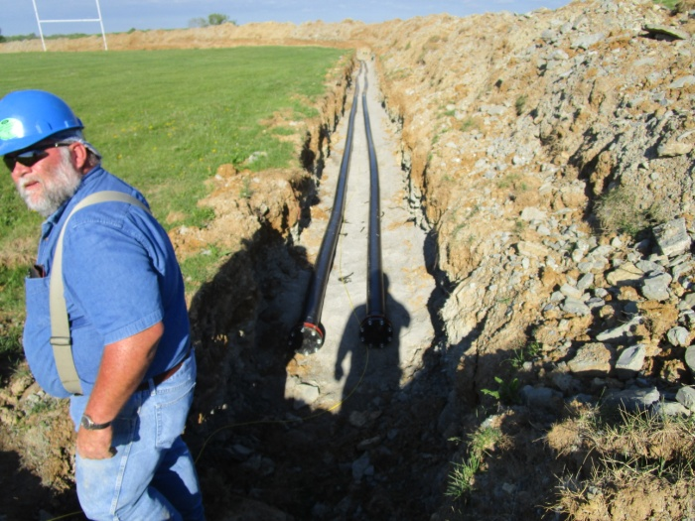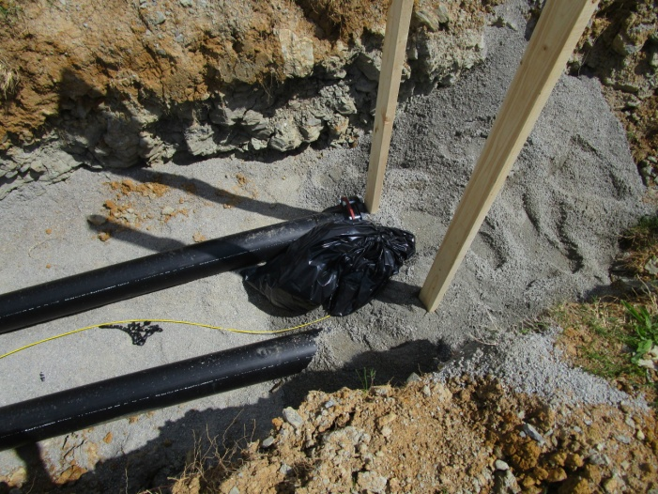
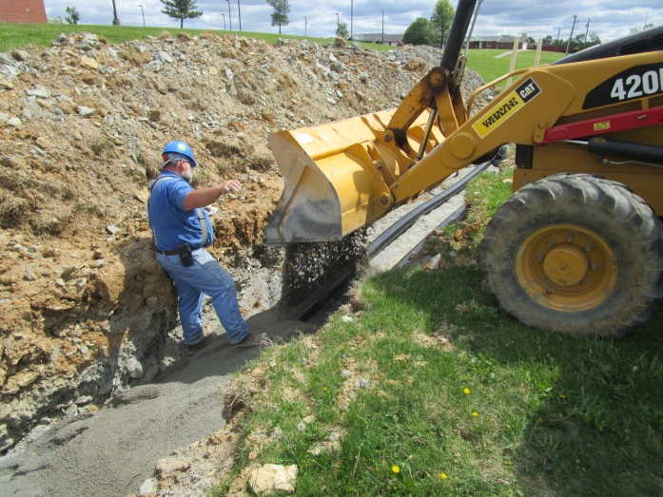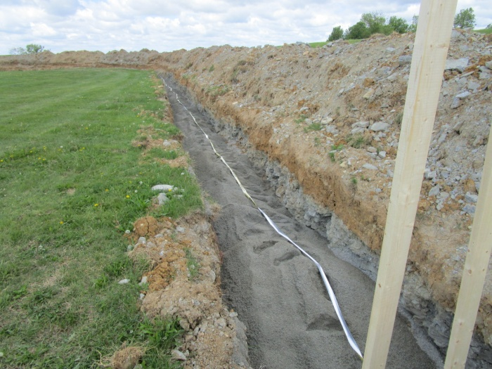
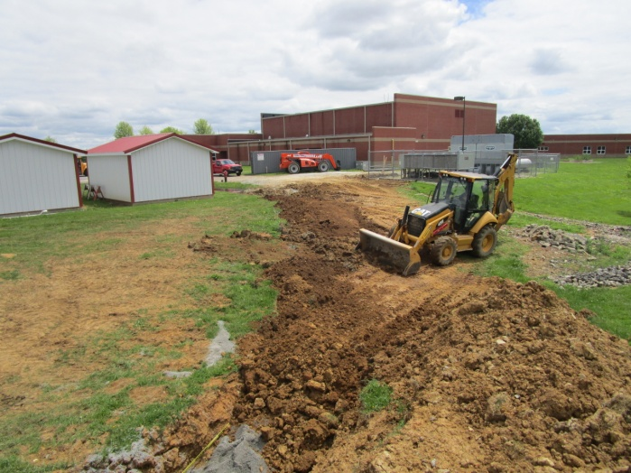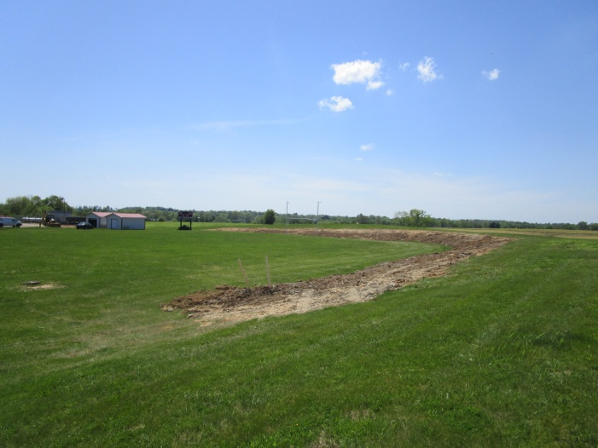
Work to be completed (05/01 – 05/04):
Freedom – (Electrical)
- To continue after hours work for Bloomfield Middle and Elementary Schools (lighting).
Blanton Electric:
- To begin lighting lamp change outs and ballast removal at Nelson County High School; Monday evening after hours (5/1).
Safety Items:
Site Review:
- Daily site review walk through were completed; no hazardous conditions to report.
- Contractors were wearing appropriate PPE for their assigned task, and hard hats were worn at all times.
Weekly Tool Box Safety Talks:
- Top Four Construction Hazards (OSHA Quick Card) was read to all onsite members for Freedom Electrical and Intertech Mechanical, and was documented to the Project Safety Manual.
Other items:
- Mike King Landscaping was onsite (04/27) at Middle School to provide a quote for final grading, seeding, and replacement of gravel area around mechanical fencing.
End of report.
Mike McNair
Construction Project Manager
CMTA Energy Solution

