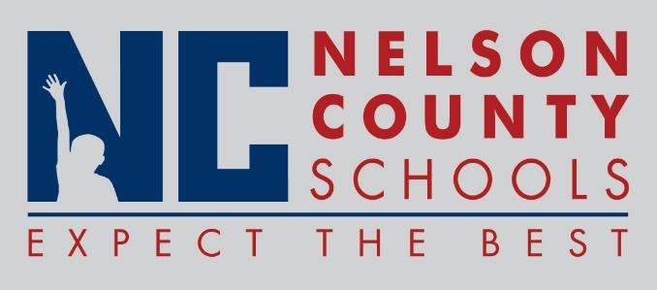

Information Paper
To: | Nelson County Board of Education
From: | Bob Morris, Director of Student Support
cc: | Dr. Anthony Orr, Superintendent
Date: | August 16, 2016
Re: | Personnel Notifications
Employment: Harry Van Why Teacher NCHS
Kenny Thornsberry Teacher NCHS
Alan Thomas Teacher FHES
Jennifer Craig Teacher BMS
John Martin Teacher TNHS
Marycatherine Stevens Teacher NCHS
Jaclyn Spaulding Teacher CCES
Kelly Justis Teacher OKH
Holly deRobles Teacher OKH
Suzan Sanders Teacher OKH
Mary Gomer Teacher FHES
Jenna Dillman Teacher CCES
Susan Dumais Teacher Horizons
Amy Duncan Teacher New Haven
Alex Edwards Teacher NCHS
Brittany Hahn Teacher NCHS
Katie Johnson Teacher TNHS
Kaitlin Mason Teacher NCHS
Trevor Mason Teacher NCHS
Scott Rouse Principal Horizons
Stephanie Smith Principal BES
Robert Tyler Lee Speech District
Judy Carmine IA I New Haven
Larry Dickerson IA I Title I
Lisa Gootee IA III FHES
Deja Jackson IA III NCHS
Kim Stumph IA III OKH
Shannon Wilkins IA I Boston
Kim Hogan Secretary FHES
Leslie Lutz Bus Driver Transportation
Robert Morris HR Director District

Transfers: NONE

Reinstatements: NONE

One Year Certificates: Donna Neal Family Consumer Science NCHS
Beth Crowe Library Media Specialist CCES

Classified Subs:

Certified Subs: Christina Durbin, Beverley McGarvey, Bobbi Nannery, Holly Smith, Tara Burkhead, Anne Kral, Emily Earley

Student Workers:

Non-Renewals:

Resignations: Amy Leasgang Teacher OKH
Holly Palumbo Teacher OKH
Andrew Farris Teacher OKH
C Matt Hicks Teacher NCHS
Carrie Chowning Teacher NCHS
Rhonda Horn Teacher TNHS
Misty Roller Secretary FHES
Tim Beck HR Director District
Christy Sias Sub District

