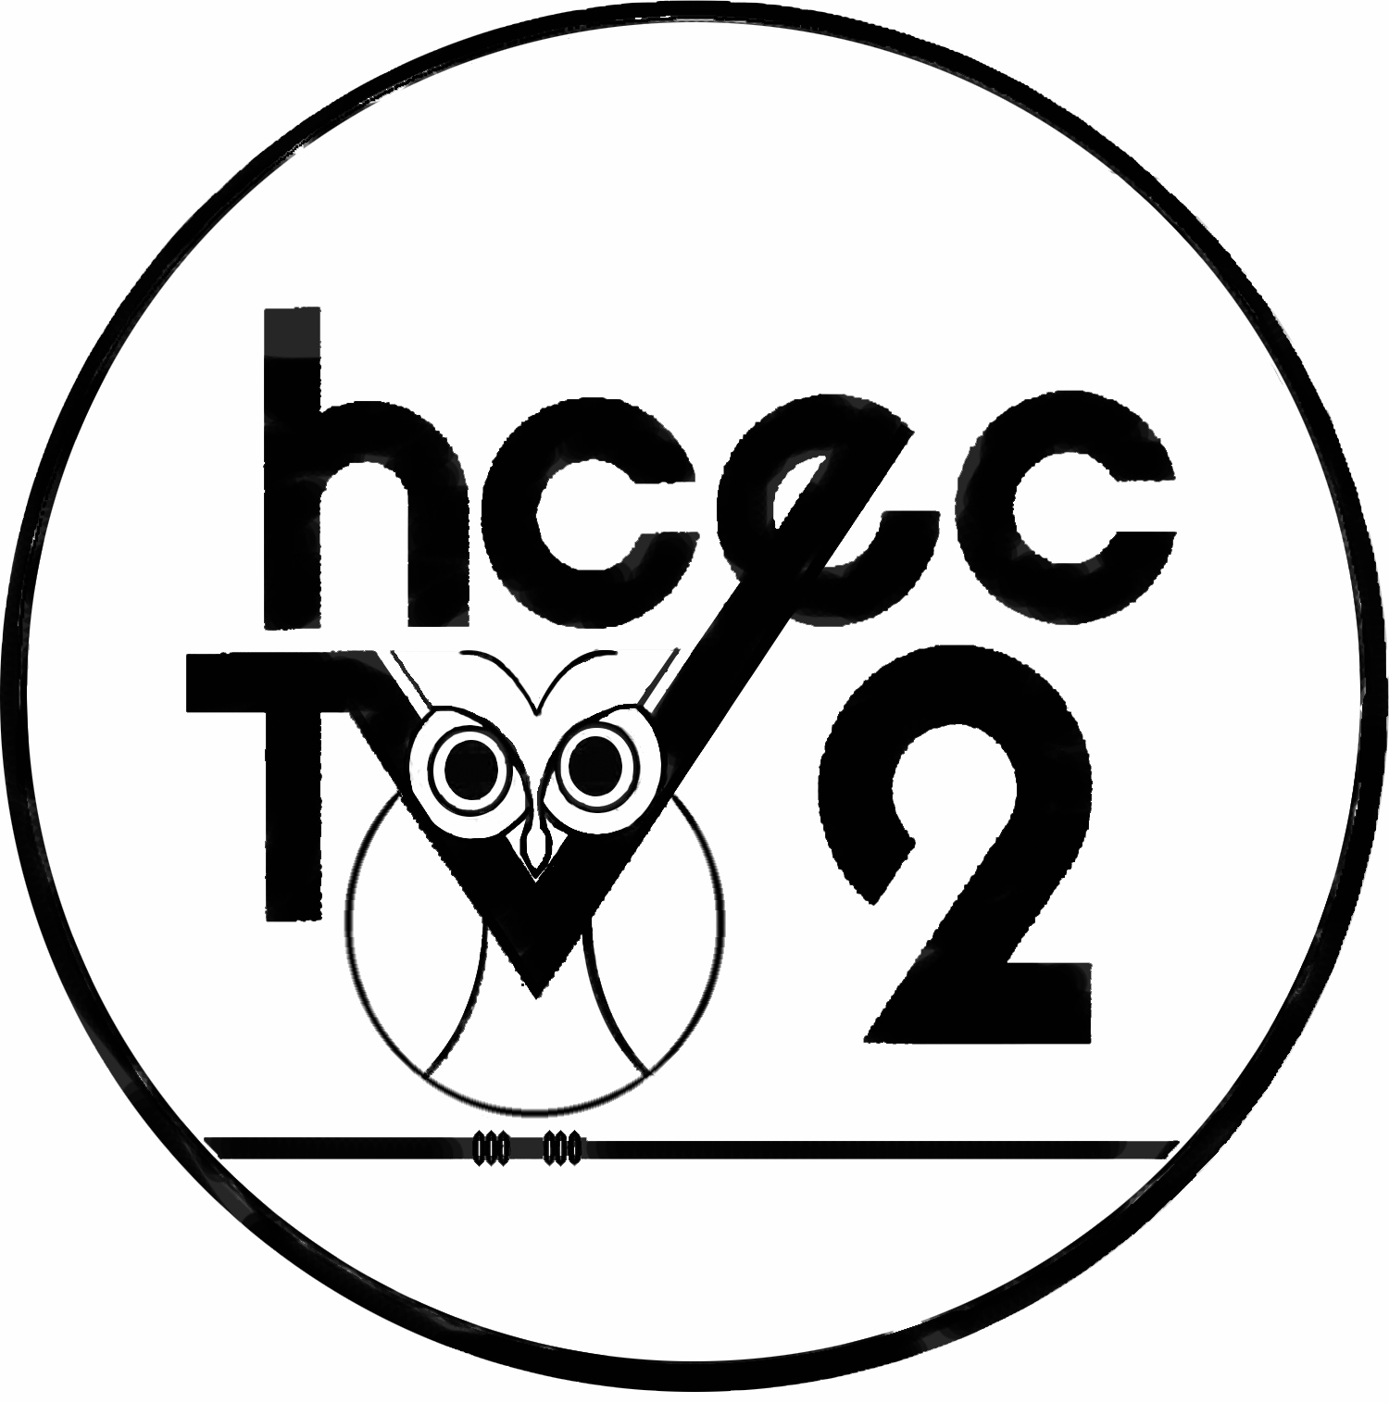
HARDIN COUNTY EDUCATIONAL
AND COMMUNITY TELEVISION
& EDUCATIONAL RESOURCE CENTER
209 Corporate Drive, Suite 102
Elizabethtown, Kentucky
Phone: (270) 769-8855
Fax: (270) 769-8961
Gina Ryan – Director
Nina Jones – Production Assistant
Jayne Shagool - Instructor
Kitty Wheeler
Academic Coordinator/HCEC-TV Secretary/Resource Center
Anna Bray – Production Specialist

Dale Mings
Japanese Language/Multicultural Teacher &
Educational Programming Facilitator

Hardin County Educational and Community Television
Production Service Agreement July 2014-June 2015

To: Edna Berger, Mayor of Elizabethtown
Date: May 22, 2014

This agreement addresses the July 2014- June 2015 production service cost Hardin County Educational and Community expends to videotape and facilitate the programming of Elizabethtown City Council regular voting meetings on the local government access cable channels.

Production and facilitation costs have slightly increased. Facilitation and administration of government programming and maintenance of equipment is not funded in part by any cable company. HCEC-TV is a division of the Hardin County Schools, and the school board provides funding for the Hardin County Schools’ educational programming and facilitation. Each county and city government agency utilizing HCEC-TV production services for meeting coverage is charged a fee for production, facilitation and administrative costs of its’ government agency coverage. Administration time, staffing costs, and transportation fees increase annually. Meetings are held after regular business hours, requiring staff to perform production and editing the evening of the meeting, causing overtime in staffing payment.

HCEC-TV is a non-profit organization, unlike other local media providers, and is therefore unable to solicit advertising dollars for this production service. Currently, Elizabethtown City Council, Hardin County Fiscal Court, Hardin Memorial Hospital Board and Radcliff City Council government agencies utilize HCEC-TV production services for meeting coverage.

The Elizabethtown City Council Meeting requires a single staff member, using a single camera, with pre and postproduction set up and equipment removal, editing with graphics, DVD fabrication, playback facilitation and administration of the schedule.

If you have any questions, please call Gina Ryan, Director of HCEC-TV at 769-8855.

HARDIN COUNTY EDUCATIONAL AND COMMUNITY TELEVISION
(A DIVISION OF THE HARDIN COUNTY SCHOOLS)
Production Service Fee Agreement for Elizabethtown City Council Regular Meetings July 2014-June 2015
(Based on not less than 12 showings per two week period)

Itemized Production Service Fee of Videotaping Regular Meetings:
Personnel (requires overtime), travel to and from meeting location
Equipment set up, videotaping, tear down (minimum 1.5 hours)
Editing (titles, ending graphics, credits, DVD fabrication-1 hour to edit)
Programming Facilitation (weekly publicizing/distribution scheduling)
Administration (master control playback facilitation)
Regular equipment repair and maintenance
$110.00 per hour pre/post production projected time (4:00 p.m.-6:30 p.m.)
(24 regular meetings per year/2.5 hour minimum per meeting-$275.00)
(Based on one DVD per 24 regular meetings-No cost for DVD) $6600.00

Projected cost for July 2014-June 2015 Total: $6600.00

Each meeting will air a minimum of twelve times on the following cable channels: Comcast, Brandenburg Telecom and Insight on Mondays, Wednesdays and Fridays at 11 a.m., M-9 p.m., W-7 p.m. and F-11 p.m. Airdates are published in The News-Enterprise newspaper weekly and posted on the Hardin County Schools Website www.hardin.k12.ky.us/tup/default.htm. A large number of the public receives the schedule via email, web site and local newspapers.
- Elizabethtown will also receive a complimentary DVD copy of “Issues and Insights” that features Elizabethtown each month.

Expenses not included/projected:
- Special City Council Meetings ($110.00 per hour/minimum 1 hour charge)
- Length of City Council Meeting extending after 6 p.m. ($110.00 per hour)
- DVD additional meeting copies requested ($10 DVD)

Approval Signatures:
____________________________ ________
(Hardin County Board of Education) (Date)

__________________________________ __________
(Mayor of the City of Elizabethtown) (Date)

