Regular Meeting Boone County Board of Education
August 10, 2017 7:30 PM
Ralph Rush Professional Development Center
99 Center Street
Florence, Kentucky 41042

I. CALL TO ORDER

The Regular meeting of the Boone County Schools Board of Education August 10, 2017 was called to order by Chairperson Ed Massey at the Ralph Rush Staff Development Center.
Attendance Taken at 7:30 PM:

Present Board Members:
Ms. Karen Byrd
Mr. Ed Massey
Mr. Matt McIntire
Ms. Bonnie Rickert

Absent Board Members:
Dr. Maria Brown

Karen Evans, Board Secretary, recorded the minutes.

II. PLEDGE TO THE FLAG
The Pledge to the Flag was led Mr. Ed Massey, Chairperson.

III. GOOD NEWS
III.A. Mr. Bryan Padilla, Student Board Representative elect, was sworn in by the Honorable Judge Schrand.
III.B. The board recognized and congratulated Mr. Jerry Gels, selected as the district-level Administrator of the Year by the Kentucky Association of School Administrators at the KASA Annual Leadership Institute in Louisville, Kentucky on July 26th, 2017.
III.C. The board recognized Boone County School New Administrators.

- Ms. Karen Byrd reported on the successful Boone County Business Association Annual Golf Outing which supports the Alternative Center and gives winter cloths to a many students in need every year. Ms. Byrd thanked all that took the time to support this amazing charity golf outing and thanked all the sponsors and the Business Association for their support of Boone County Schools.
- Ed Massey reported that he was honored to visit the bus garage and have a chance to speak to the bus drivers and transportation employees and thanked them for all they do every year to keep the students safe.
- Mr. Massey invited the new Student Board Representative, Brad Padilla, to address the audience. Mr. Padilla thanked everyone for their support in this position and he looks forward to the 17-18 Student Advisory Council and hopes to leave a positive impact.

IV. AUDIENCE OF CITIZENS
No one spoke.

V. RECOMMENDED ACTION - CONSENT AGENDA
Dr. Randy Poe, Superintendent, recommended the following Consent Agenda Items A-BB approval.

- A motion was made by Karen Byrd, seconded by Matt McIntire, to approve the consent agenda items A-BB, as presented. Matt McIntire, Karen Byrd, Bonnie Rickert and Ed Massey voted, “aye” MOTION: The motion passed 4-0.

V.A. Minutes of the regular board meeting of July 20, 2017
The board approved the minutes of the regular board meeting of July 20, 2017, as presented.
V.B. Bill List
V.C. Treasurer's Report was given by Mrs. Linda Schild.
V.D. Leaves of Absence
The board approved the following persons submitted leave of absence requests:
The following persons have submitted unpaid leave of absence requests for Board approval:
Recommended by Principal/Supervisor for approval:
Armstrong, Paula, Nurse @ Mann Elem, 9/15/2017 – 10/20/2017
Aylor, Rebecca, Staff Support @ Conner High School, 8/14/2017 – 11/3/2017
Blum Ficke, Melanie, Teacher @ Boone County School, 8/14/2017 – EOY
Bryant, Kathleen, Teacher @ Ockerman Elem, 8/14/2017 – EOY
Emmons Shumate, Amanda, Teacher @ Mann Elem, 8/14/2017 – 10/12/2017
Hicks, Jennifer, Teacher @ Yealey Elem, 9/5/2017 – 12/19/2017
Isaacs, Brittany, Teacher @ Ockerman Elem, 8/16/2017 – 9/15/2017
Klare, Emily, Teacher @ Collins Elem, 8/14/2017 - EOY
Kuertz, Danielle, Teacher @ Collins Elem, 8/14/2017 – 12/14/2017
Lamore, Sarah, Teacher @ Yealey Elem, 9/6/2017 - EOY
Lutz, Susan, Teacher @ Camp Ernst Middle, 9/20/2017 - EOY
McCarthy, Stephanie, Teacher @ Burlington Elem, 8/14/2017 – 9/29/2017
Ottesen-Price, Afton, Teacher @ Longbranch Elem, 8/14/2017 – EOY
Patton, Devinn, Teacher @ Ockerman Elem, 10/17/2017 – 11/14/2017
Scott, Mary, Teacher @ Mann Elem, 8/14/2017 – 11/10/2017
Zembrodt, Taylor, Teacher @ Collins Elem, 8/14/2017 – EOY
Not Recommended by Principal/Supervisor for approval:
Nothing to Report
Amended Leaves:
Frederick, Bobby, Custodian @ Camp Ernst Middle, 5/30/2017 – 8/4/2017
Cancelled Leaves:

V.E. Textbook Purchases Stephens Elementary
The board approved the Textbook purchases for Stephens Elementary - Math EnVisions, as presented.
V.F. Kentucky Association of School Superintendents Membership 17-18
The board approved the Kentucky Association of School Superintendents Membership 17-18 for Randy Poe, as presented.
V.G. Schlechty Superintendent Leadership Network Membership 17-18
The board approved the Schlechty Superintendent Leadership Network Membership 17-18 for Dr. Randy Poe in the amount of $5000.00, as presented.
V.H. APQC Membership Agreement
The board approved the APQC membership agreement for 2017-2018 in the amount of $1000.00, as presented.
V.I. Approval of Contract Closeout BG-4 Boone County High School MEP Improvements BG#14-014
The board approved the Contract Closeout BG-4 Boone County High School MEP Improvements BG#14-014, as presented.
V.J. Approval of Contract Closeout BG-4 Paving 2016 BG#17-061
The board approved the Contract Closeout BG-4 Paving 2016 BG#17-061, as presented.
V.K. Approval of Contract Closeout BG-4 Florence Elementary Site Expansion, Phase 1 and 2 BG#15-304
The board approved the Contract Closeout BG-4 Florence Elementary Site Expansion, Phase 1 and 2 BG#15-304, as presented.
V.L. Change Order #7 Ryle High School BG#15-281
The board approved the Change Order #7 Ryle High School BG#15-281, additional amount of $17,407.00, as presented.
V.M. Change Order #4 Ballyshannon Middle School BG# 15-279
The board approved the Change Order #4 Ballyshannon Middle School BG# 15-279, additional amount of $11,629.00 as presented.
V.N. Approval of Contract Closeout BG-4 Gray Middle School Chiller Replacement BG#15-282
The board approved the Contract Closeout BG-4 Gray Middle School Chiller Replacement BG#15-282, as presented.
V.O. Change Order #2 Central Office Annex
The board approved the Change Order #2 Central Office Annex, addition of $3683.00, as presented.
V.P. Change Order #2 Conner Middle School HVAC Upgrades (Phase 2) BG# 16-172
The board approved the Change Order #2 Conner Middle School HVAC Upgrades (Phase 2) BG# 16-172, additional amount of $13,235.00 as presented.
V.Q. AASA Conference 2018 - Ed Massey
The board approved Ed Massey to attend the AASA Conference in Feb 2018, Nashville, TN, as presented.
V.R. AASA Conference 2018 Randy Poe
The board approved the Dr. Randy Poe to attend the AASA Conference in Feb 2018, Nashville TN, as presented.
V.S. Surplus Technology
The board approved the Surplus Technology items at the warehouse as surplus and dispose of according to board policy, as presented.
V.T. Surplus Vehicles
The board approved to declare listed vehicles as surplus and dispose of through auction, as presented.
V.U. Surplus Bus Sale
The board approved the surplus buses to awarded to the highest bidder on August, 4, 2017, as presented.
V.V. Field Trips
The board approved the field trips, as presented.
School | Date Of Trip | Location | Reason
Cooper High School | November 2-5, 2017 | Orlando, FL | National Student Leadership Conference

V.W. Boone County Imagineering Academy-Summit Learning Program Participation Agreement
The board approved the Boone County Imagineering Academy-Summit Learning Program Participation Agreement, as presented.
V.X. CEMS-Summit Learning Program Participation Agreement
The board approved the CEMS-Summit Learning Program Participation Agreement, as presented.
V.Y. OMS-Summit Learning Program Participation Agreement
The board approved the OMS-Summit Learning Program Participation Agreement, as presented.
V.Z. CMS- Summit Learning Program Participation Agreement
The board approved the CMS- Summit Learning Program Participation Agreement, as presented.
V.AA. SES- Summit Learning Program Participation Agreement
The board approved the SES- Summit Learning Program Participation Agreement, as presented.
V.BB. Indirect Cost Rates
The board approved the Indirect Cost Rates, as presented.

VI. RECOMMENDED ACTION - OLD BUSINESS
VI.A. Annual Board Policy Update- Second Reading

Dr. Randy Poe, Superintendent, recommended the board approve the Annual Board Policy Update- Second Reading, as presented.

- A motion was made by Bonnie Rickert, seconded by Karen Byrd, to approve the Annual Board Policy Update Second Reading, as presented. Matt McIntire, Karen Byrd, Bonnie Rickert and Ed Massey voted, “aye” MOTION: The motion passed 4-0.

VII. RECOMMENDED ACTION - NEW BUSINESS
VII.A. Updated Classified Substitute Hourly Pay Rates
Dr. Randy Poe, Superintendent, recommended the board to approve the Updated Classified Substitute Hourly Pay Rates Chart, as presented.

- A motion was made by Matt McIntire, seconded by Karen Byrd, to approve the Updated Classified Substitute Hourly Pay Rates Chart, as presented. Matt McIntire, Karen Byrd, Bonnie Rickert and Ed Massey voted, “aye” MOTION: The motion passed 4-0.

- Ed Massey, who serves on the Budget committee discussed the budget committee has formed a task force to review some of the classified salaries.

VII.B. Paid Sick and Personal Leave for Four(4) Hour Classified Workers
Dr. Randy Poe, Superintendent, recommended the board to approve the Paid Sick and Personal Leave for Four(4) Hour Classified Workers, as presented.

- A motion was made by Karen Byrd, seconded by Bonnie Rickert, to approve the Paid Sick and Personal Leave for Four (4) Hour Classified Workers, as presented. Matt McIntire, Karen Byrd, Bonnie Rickert and Ed Massey voted, “aye” MOTION: The motion passed 4-0.

- Dr. Poe discussed the certified employees have received this pay in the past and in order to have a steady workforce this needed changed for classified as the Holiday Pay in VII. C will be presented. The majority of employees are covered, but this will make consistency across the district. The APQC process that we have done in the past revealed this was a concern and needed addressed.

VII.C. Holiday Pay for Four(4) Hour Classified Workers
Dr. Randy Poe, Superintendent, recommended the board to approve the Holiday Pay for Four(4) Hour Classified Workers, as presented.

- A motion was made by Matt McIntire, seconded by Karen Byrd, to approve the Holiday Pay for Four (4) Hour Classified Workers, as presented. Matt McIntire, Karen Byrd, Bonnie Rickert and Ed Massey voted, “aye” MOTION: The motion passed 4-0.

VIII. SUPERINTENDENT'S REPORT

- Krista Decker, LSS Director of Assessment, reported on the 2017 District Jr ACT and AP data. The following powerpoint was presented and reviewed with the board.

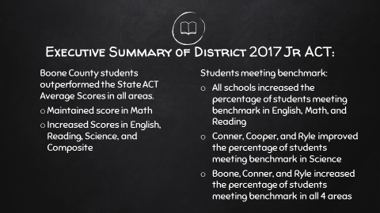

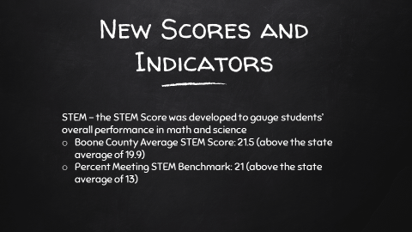

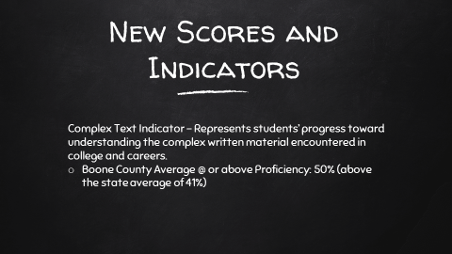

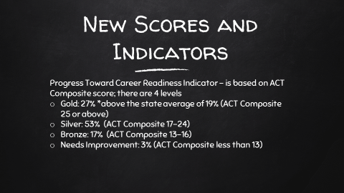

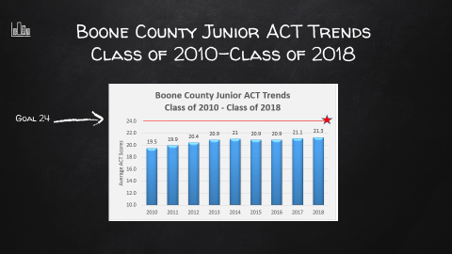

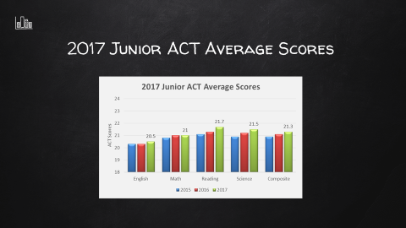

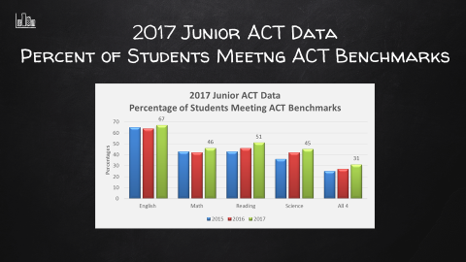

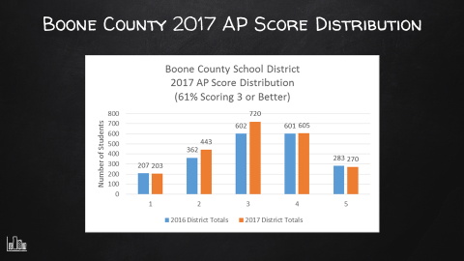

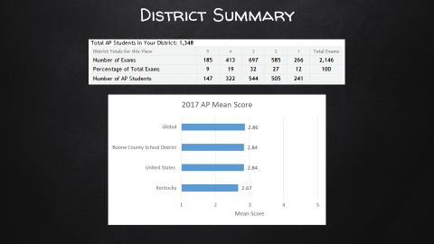

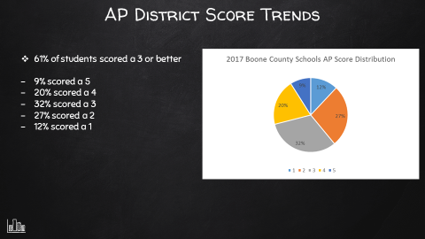

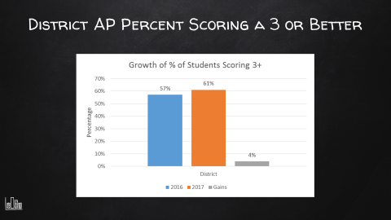

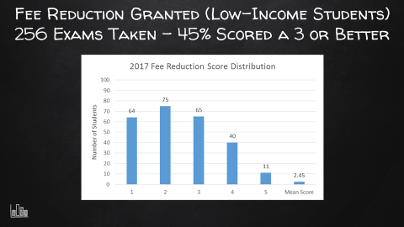

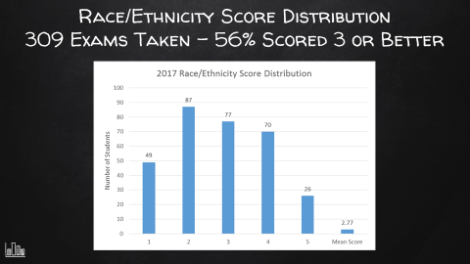

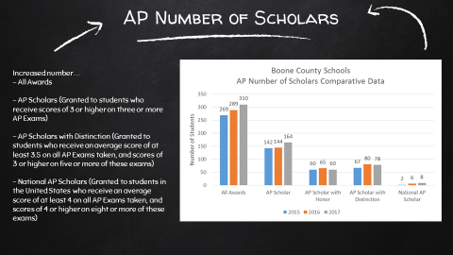

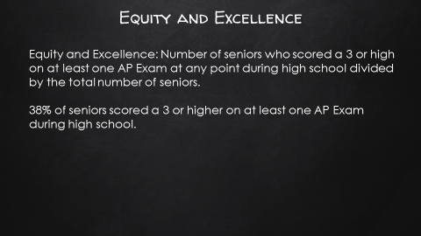

- Jerry Gels, Director of Innovative Programs, reported on the recent professional development which he took part of at the Freedom Writers Event.

- Dr. Poe discussed the upcoming Redistricting Workshop for the redistricting committee to present several scenarios for the Ballyshannon Middle School proposals. The Board Workshop will be held on August 28, 2017 at 6:30 pm at Ralph Rush Professional Development Center.

- Dr. Poe announced the committee will be asking the board for a 4.0% rate increase and the Tax Hearing Public Forum will be held at 7:00 pm on August 24th, 2017 with the Special Board Meeting regarding the vote on the Tax Rate will held at 7:30 pm on August 24, 2017.

- Dr. Poe discussed various options for the board relating to the Solar Eclipse and the timing of the Eclipse on August 21st. The board agreed the educational experience for the students would be beneficial and school would not close for this event. The eclipse will take place at approximately 2:30 pm and the schools will have a letter explaining the options for parents and this will also be on the website. Education Opportunity forms were discussed for parents that choose and those can be obtained at the individual schools.

IX. INFORMATION, PROPOSALS, COMMUNICATIONS
IX.A. Human Resource Actions
IX.B. Worker's Compensation Claims
IX.C. Overtime Report
IX.D. Construction Status Report
IX.E. Energy Management Report

X. AUDIENCE OF CITIZENS
No one spoke.

XI. CLOSED EXECUTIVE SESSION PER KRS 61.810 (1)(K)

XI.A. CLOSED EXECUTIVE SESSION PER KRS 61.810 (1)(k)Superintendent Evaluation

- On a motion by Karen Byrd and a second by Bonnie Rickert, the board went into closed session to have a preliminary discussion relating to the evaluation of the superintendent pursuant to KRS 61.810, Section (1)(k), meetings specified by law to be conducted in private which is pursuant to KRS 156.557, Section 4 preliminary discussions of superintendent's evaluation. Ed Massey, Bonnie Rickert, Karen Byrd, and Matt McIntire voted, “aye” MOTION: The motion passed 4-0.

The meeting was adjourned at approximately 8:43 pm.
The board returned from closed executive session at approximately 9:05 pm.

No action was taken in the closed session.

- After a thorough discussion a motion was made by Bonnie Rickert, seconded by Matt McIntire, for the board to approve the summative evaluation of the superintendent as Outstanding. Bonnie Rickert, Karen Byrd and Matt McIntire voted, “aye” MOTION: The motion passed 4-0.

Ed Massey read the comment from the evaluation – This board fully supports Dr. Poe and his vision for Boone County Schools. This shared vision is one of collaboration and engagement for the betterment of all students of Boone County. Dr. Poe thanked the board for their continued support and was honored to have the support of the board. Dr. Poe thanked all the staff for their work.

XII. ADJOURN

8. A motion was made by Maria Brown, seconded by Matt McIntire, to adjourn the meeting. Ed Massey, Bonnie Rickert, Karen Byrd and Matt McIntire voted, “aye” MOTION: The motion passed 4-0.

Meeting was adjourned at approximately 9:10 pm

_____________________________________
Ed Massey /Chairperson

_____________________________________
Karen Evans/Secretary

