John Hardin SBDM Council
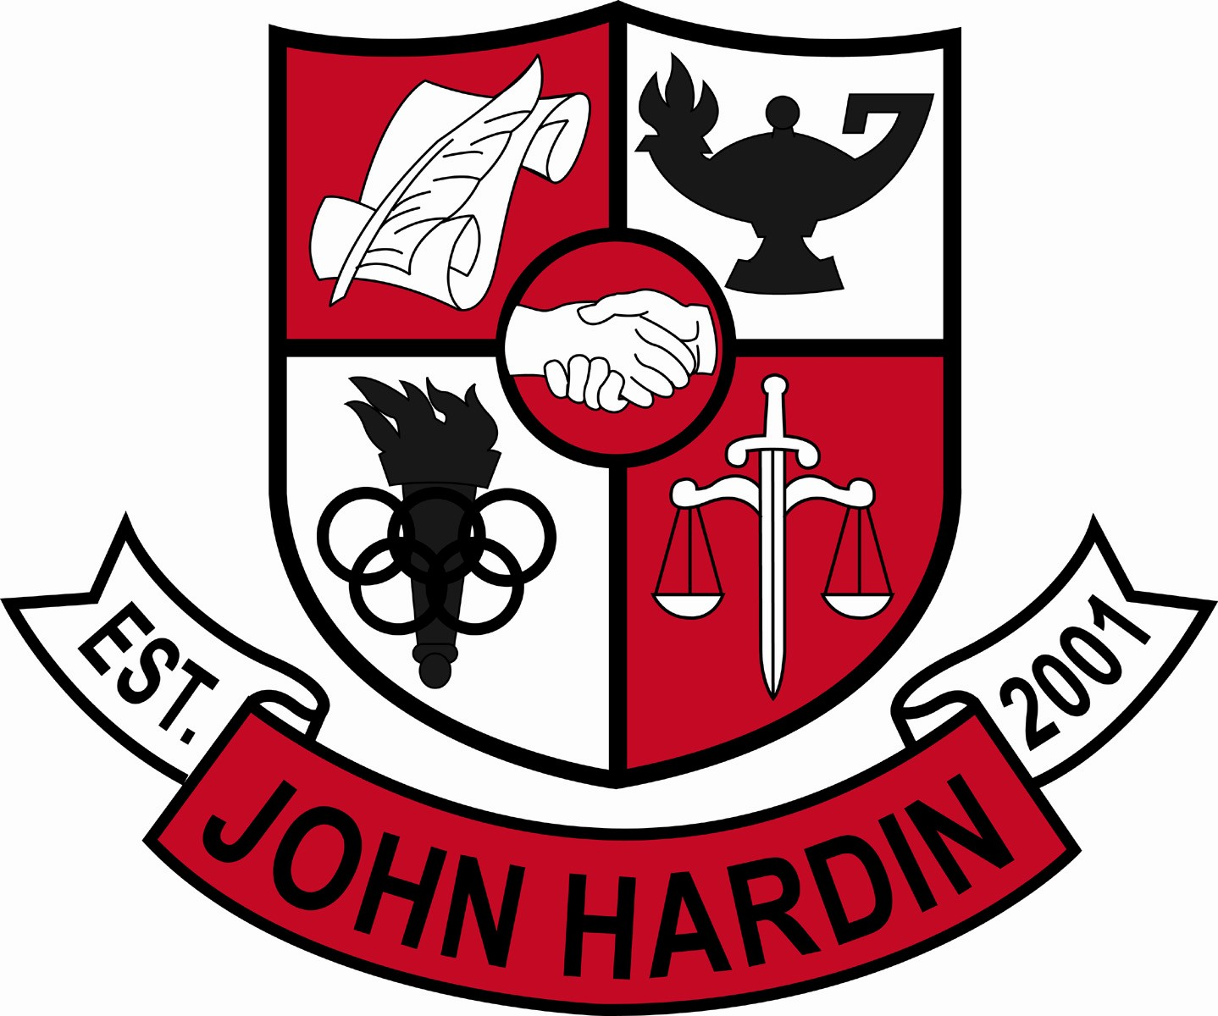
Meeting Minutes

April 14, 2016
4:00 p.m.

- Call to Order at 4:02 pm
Members present: Mark Wells, Alex Shearer, Aurora Selbe, Stacey Moore, Kelly Smith, and Jan O’Daniel
Visitors: Brahim Benmoussa
- Approval of Agenda ORDER #15-16/0061
The council approved the agenda as written.
Motion: Moore Second: O’Daniel
Selbe – Yes
O’Daniel – Yes
Shearer– Yes
Wells – Yes
Moore – Yes
Smith - Yes
- Approval of Minutes ORDER #15-16/0062
The council approved the minutes as written.
Motion: Selbe Second: Moore
O’Daniel – Yes
Selbe– Yes
Wells – Yes
Moore – Yes
Shearer – Yes
Smith - Yes
- Good News Report
  - Chorus – Chanelle Dau Pino, Hunter Boucher, Jessica Brandt, Noah Roby, and Sierra Coachman received distinguished ratings and will go to the State Solo and Ensemble Assessment in May.
  - FCCLA – Kait Humphrey, Madison Smith and Reyna Smith’s project, Cookies for Cops, placed 1st in Chapter Service Project Junior Division. These students qualified for Nationals in San Diego.
  - Band – The concert band and symphonic band recently attended the Kentucky Music Educators Association Large Ensemble Assessment. The band s received a distinguished rating in prepared music and a distinguished rating in sight reading.
  - HOSA – Kevin Young placed 2nd in state for Medical Math and Carson McCann placed 2nd in state for Medical Spelling. The students have the opportunity to compete at Nationals this summer.
  - Bark Strong Event was a success amongst both teachers and students. The program is catching on with our feeder schools.
  - The school website was used as a model for all of Hardin County Schools. The website is maintained by Ms. O’Daniel.
- Public Comment
  - No comments from visitors.
- Principal’s Update
  - ACT Preliminary Scores – Preliminary scores did not include 504 and special education students. These scores will be included one they are received.
  - Needs list – Revised to include the resurfacing of the tennis court and additional cameras inside the school.
  - Scheduling Update – Courses and class numbers for the teachers were shown.
- School Compact 2016-17 ORDER#15-16/0063
The council reviewed and approved the school compact plan for next year.
Motion: Shearer Second :O’Daniel
Selbe – Yes
Moore – Yes
Shearer – Yes
O’Daniel – Yes
Smith – Yes
Wells – Yes
- Parent Involvement Policy 2016-17 ORDER#15-16/0064
The council reviewed and approved the parent involvement policy for next school year.
Motion: Shearer Second: Selbe
O’Daniel – Yes
Selbe – Yes
Moore – Yes
Smith – Yes
Wells – Yes
Shearer - Yes
- Financial Report ORDER#15-16/0065
The Financial Report for March was reviewed and accepted
Motion: Shearer Second: Moore
Shearer – Yes
Wells – Yes
Moore – Yes
Selbe – Yes
O’Daniel – Yes
Smith - Yes
- Personnel
Hired; Scott Funderbunk, Custodian
Vacancies: Golf Coach; Tennis Coach 10 % Stipend, Asst to Head Girls Soccer Coach
- New Business
- Students representing the school on trips receive a zero from some teachers. The zeros are a reminder for the student to turn in the missing assignments and are updated when the assignments are graded.
- Belly dancers at Prom. The Arabian dancers will wear appropriate attire and will only be outside the front entrance.
- Agenda Items for Next Meeting
  - Master Schedule
  - Room Usage
- Adjourn
The meeting was adjourned at 5:15 p.m. The motion was made by Ms. Selbe and seconded by Ms. Smith

