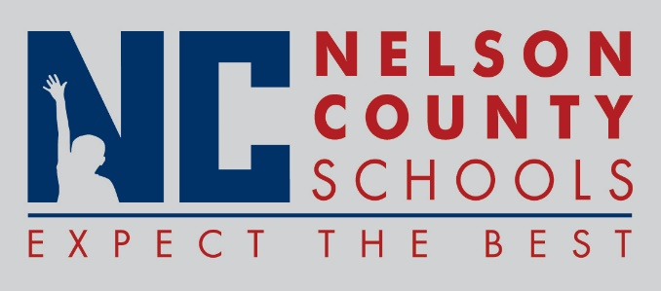

Decision Paper
To: | Nelson County Board of Education
From: | Ann Marie Williams
cc: | Dr. Anthony Orr, Superintendent
Date: | February 22, 2017
Re: | 17-18 FRYSC Continuation Plans

RECOMMENDATION: Approve the 17-18 FRYSC Continuation Plans. These plans provide a template for the Family Resource and Youth Service Centers in regard to site needs, program services, and budgeting. Each plan includes a needs assessment and action plan for each center and have been approved by FRYSC councils and local SBDMs.

RECOMMENDED MOTION: I move that the Nelson County Board of Education approve the 17-18 FRYSC Continuation Plans.

