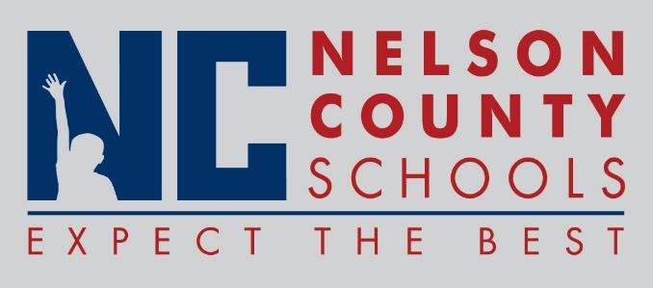

Information Paper
To: | Nelson County Board of Education
From: | Bob Morris Executive Director of Student Support
cc: | Tom Brown
Date: | April 17, 2018
Re: | Personnel Notifications

New Hires: Mary Faulker Monitor Trans

Transfers:None

Reinstatements: None

One Year Certification:

Classified Subs: Shelia Embry

Certified Substitute: Jessica Milby, Jeffery Neagle

Student Workers: Bailey Hicks, Eli Shewmaker

Non-Renewals: None

Resignation:

Retirements:

Reprimands/Terminations: None

