NEA’s Read Across America
Proclamation- A Nation of Diverse Readers
WHEREAS, the citizens of Hardin County stand firmly committed to promoting reading as the catalyst for our students’ future academic success, their preparation for America’s jobs of the future, and their ability to compete in a global economy; and WHEREAS,
Hardin County Education Association has provided significant leadership in the area of community involvement in the education of our youth, grounded in the principle that educational investment is key to the community’s well-being and long-term quality of life; and WHEREAS, “NEA’s Read Across America,” a national celebration of reading on March 1, 2019, sponsored
by the National Education Association, promotes reading and adult involvement in the education of our community’s students; THEREFORE,
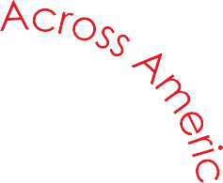
BE IT RESOLVED that the Hardin County Board of Education calls on the citizens of Hardin County Schools and the Community to assure that every child is in a safe place reading together with a caring adult on March 1, 2019; AND BE IT FURTHER RESOLVED that this
body enthusiastically endorses “NEA’s Read Across America”
and recommits our community to engage in programs
and activities to make America’s children the best
readers in the world.

Signed: Signed:

www.nea.org/readacross

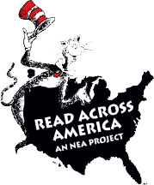
Signed:

Signed: ____________________________________________________

Signed:_____________________________________________________
Signed: ____________________________________________________

