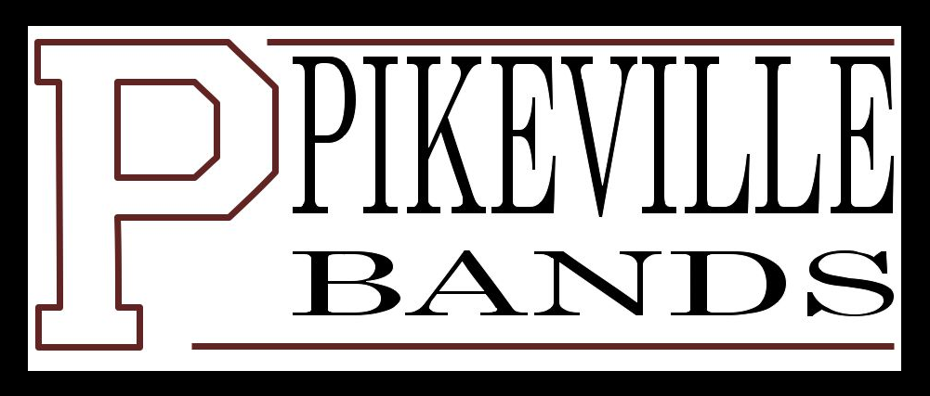

Pikeville Band Department

Instrument Policies

- The Pikeville Band Department supplies instruments on an as needed basis depending upon the inventory of the department. District-owned instruments will be not be issued to students until a completed contract is returned to the Director of Bands.

2. Members in need of reeds, lyres, cork grease, slide oil, and valve oil should see the Director of Bands.

3. Do not repair school instruments on your own. Speak with the Director if you believe your instrument is need of repair.

4. Any equipment that is loaned through the school district must be signed out and must be returned at the end of the academic year.

5. Only the case issued with each instrument is to be used for storing the instrument or packing the instrument for travel. Gig bags are not sufficient.

6. All instrumentalists are responsible for their music and other supplies.

7. While traveling, members are responsible for loading their own instrument. Anything left sitting on the ground will not be taken care of by the Director or staff members, but will remain where left.

8. Instruments are available for use during the off-season and should procured through the Director or Bands.

9. Instrument turn-in will be during the last week of class of the spring semester. A hold will be placed on the band member’s school account until the instrument is returned. If the instrument is not returned by the last calendar of school, a fee of $1000 will be charged to the student.

Pikeville Independent Schools
Band Department

INSTRUMENT CONTRACT
2013.- 2014 Academic Year

Please print clearly and return to Equipment Officers after instrument checkout.

First Name: __________________ MI: ____ Last Name: ___________________

E-mail: ______________________________ Student ID: ________

Cell phone number: ____________________

Mother’s phone number: ____________________

Father’s phone number: ____________________

Instrument type: ____________________
Serial number: ____________________ School number: _____________
School-owned mouthpiece: ___ yes ___ no
Other articles (ligature, mouthpiece cover, etc.): _______________________________
______________________________________________________________________
______________________________________________________________________

I have read and understand the instrument policies established by the Pikeville Band Department. Should I, for any reason, be unable to return my instrument (and additional articles) by the said deadline, I understand a hold will be placed on my student account until the requested article(s) is returned or replaced. In the circumstance that I withdraw from Pikeville Independent Schools, I am still responsible for returning or replacing said articles.

By signing, I signify that the listed equipment is in my possession and therefore my duty and responsibility to abide by the policies thereof. I understand that failure to do so will result with the penalties established in the aforementioned rules and regulations.

________________________________ ___________________________
Student’s signature Date Guardian’s Signature Date

________________________________ ___________________________
Director of Band’s Signature Date Principals’ Signature Date

Office Use Only
Issue Date: _______________________ Return Date: _________________

