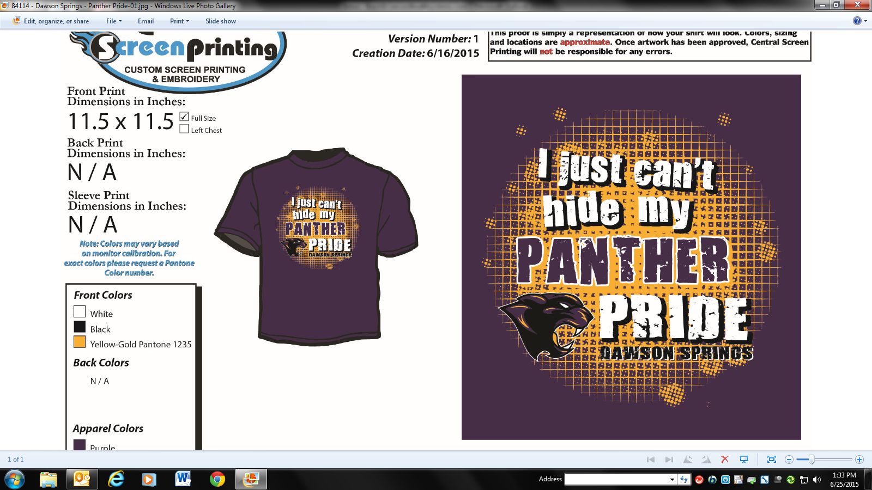

Panther Pride

T-Shirt Fundraiser

Sponsored by

DSCS

PTO

Only $10.00

Available in sizes

Youth Small – 3xl

Get yours at the annual BBQ festival

July 24th

