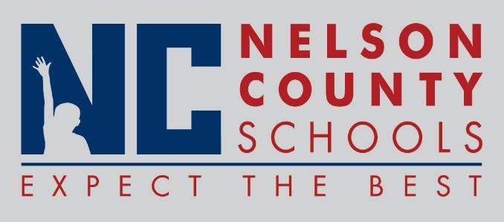

Information Paper
To: | Nelson County Board of Education
From: | Bob Morris Executive Director of Student Support
cc: | Dr. Anthony Orr, Superintendent
Date: | January 5, 2016
Re: | Personnel Notifications

New Hires: Derek Fields Math NH
Linda Parish Math/Science OKH
Maggie Whitfield Spec Ed TNHS
Madison Crowe Bus Monitor Trans

Transfers: Brandon Durbin teacher to BMS from NH.
J.P Williamson Teacher BMS to Assistant Principal interim BMS.
Chris Upton SPED from FHES to NCHS

Reinstatements: None

One Year Certification: None

Classified Subs: Terry McKenna, Cindy Feathers

Certified Substitute: Sheryl Figg, Ben Nally, Dawn Culver
Student Workers:
Non-Renewals: Wayne Hawkins Cust ELC

Resignation: Holly Derobles Teacher OKH
Carolyn Sanders Bus Monitor Trans
Dennis Dow Teacher NCHS
Kaitlin Mason Teacher NCHS
Jamie Mallard Cook/Baker TNHS

Retirements: None

Reprimands/Terminations: None

