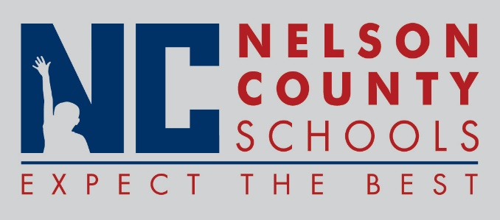

Decision Paper
To: | Nelson County Board of Education
From: | Tom Dekle, Grants
cc: | Dr. Anthony Orr, Superintendent
Date: | November 15, 2016
Re: | Grant application for Boston School

Boston School wishes to apply for a continuation grant under the 21st Century Community Learning Center program, in the amount of $100,000 per year for the first three years. This grant program is meant to provide students with a broad array of activities designed to help boost test scores and add depth to the curriculum while providing positive youth development activities during non-school hours. Boston has already hosted a successful 21st Century program in previous years and hopes to use continuation funds to further address school needs..
In particular, Boston School is focused on increasing achievement and reading; Increase access to high quality STEM programs; Improve non-cognitive indicators of success; Increase access to College and Career programming and Increase educational opportunities for parents and families to support academic achievement.
RECOMMENDATION: Approve Boston School request to apply for continuation grant funding through the 21st Century program.

RECOMMENDED MOTION: I move that the Nelson County Board of Education ___________ as presented.

