CONSENT ITEM E
October 14,2024
OLDHAM COUNTY BOARD OF EDUCATION

CONCERN
Consider approval of Bills and Claims.

DISCUSSION
The detailed listings of the bills and claims received since the last regularly scheduled monthly Board meeting are provided following this enclosure for your post-approval review. Below is a summary of each fund's check activity for October’s Board meeting.

Fund | # of invoices | Total amount
General Operating | 430 | $ 7,379,177.58
Exceptional Child Svcs/Dept of Instruction/Grant | 73 | 160,157.62
School Food Service | 32 | 319,798.78
Total | 535 | $7,859,133.98

RECOMMENDATION
Approve the bills and claims as presented.

On a motion by _______________, seconded by _______________, the Board approved the Bills & Claims as presented. ( - )

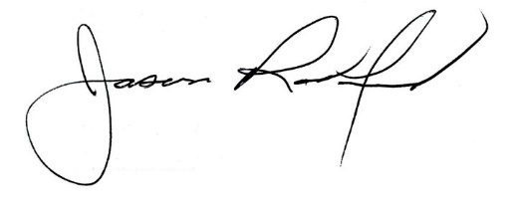
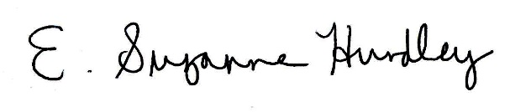

Suzanne Hundley, Board Chair Jason Radford, Superintendent/Secretary

