CONSENT ITEM D
October 14, 2024
OLDHAM COUNTY BOARD OF EDUCATION
CONCERN
Consider Approval of Contracts in excess of $40,000 and donations in excess of $1000.
DISCUSSION
Pursuant to Board Policy 04.32, the Superintendent can approve contracts for transactions of less than $40,000 in value. Below are listed the name of the contract vendor, the subject of the contract, and the amount of the contract for contracts less than $40,000 that were approved by the superintendent, and contracts in excess of $40,000 that must be approved by the Board. Donations over $1000 must be approved by the board.
School/Dept |  | Vendor | Subject | Amount
District |  | Campbellsville University | Student Teachers | Per agreement
District |  | KY Works | After the Tassel works program | $75,000.00
District |  | YMCA | Bus Rental | $1.70 per mile
District |  | Pitney Bowes | Annex Postage Meter Lease | 425.19/per quarter
NOHS |  | YMCA | Swim Team Pool Rental | $600.00
NOHS |  | Creasey Mahan | Facility Rental for Rumble | $17,216.00
NOHS |  | Jewish Community | Swim Team Rental | $165.00 per week
OCHS |  | Bluegrass Rental | Homecoming | $973.91.
OCHS |  | John Black | Golf Team Banquet | $95.00
SOMS |  | CityPlace | Football Banquet | $960.00
DONATIONS
Kenwood | KW PTO |  | Funds for Technology | $15,000.00
Kenwood | KW PTO |  | 5th Grade Committee | $1,000.00
Crestwood | PTA |  | FRC & literacy | $11,000.00
OCAC | Richwood Nursing Home |  | Student Activities | $2,500.00
NOHS | Athletic Booster Club |  | Boys Basketball | $4,000.00
OCHS | Athletic Booster Club |  | Girls Basketball Apparel | $2,000.00
OCHS | BYB Event Services |  | Cheer Team | $3,000.00
SOMS | Community Foundation |  | Cheer Uniforms | $2,000.00
SOHS | Athletic Boosters |  | Various Sports | $26,000.00
RECOMMENDATION
Approved the attached contracts and donations and authorized the Superintendent and Secretary of the Board, or his designee, to execute all the above contracts, and ratified any contracts of these contract signed prior to formal approval.

On motion by _______________, seconded by _______________, the Board approved the attached contracts and authorized the Superintendent and Secretary of the Board, or his designee, to execute all of the above contracts for formal approval. ( , )

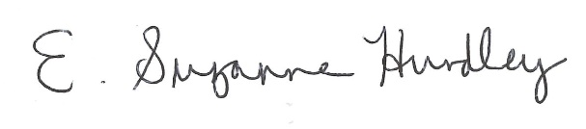
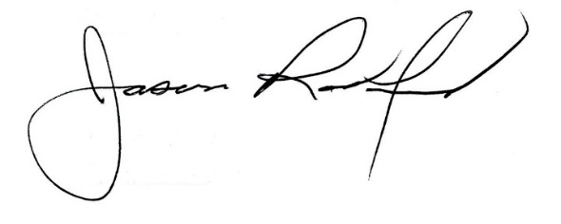

Suzanne Hundley, Board Chair Jason Radford, Ed.D, Superintendent

