MINUTES
September 23, 2024
OLDHAM COUNTY BOARD OF EDUCATION
CONCERN
Consider Approval of Meeting Minutes.
DISCUSSION
The draft minutes of the August 26, 2024, Regular Board Meeting, September 9, 2024-Special Called Meeting, and the September 19, 2024, Tax Hearing are available for review and approval.
RECOMMENDATION
Approve the minutes of the following meetings as presented.
August 26, 2024 – Regular Board Meeting
(1) Suzanne Hundley, Chairperson, (2) Larry Dodson, Board Vice Chair; and (3) Joe Dennis, Board Member, (4) Carly Clem, Board Member (5) Allison Sheffer, Board Member, and Dr. Jason Radford, Superintendent and Secretary to the Board were present.
September 9, 2024 – Special Called Board Meeting
(1) Suzanne Hundley, Chairperson, (2) Larry Dodson, Board Vice Chair; and (3) Joe Dennis, Board Member, (4) Carly Clem, Board Member (5) Allison Sheffer, Board Member, and Dr. Jason Radford, Superintendent and Secretary to the Board were present.
September 19, 2024 – Special Called Tax Hearing
(1) Suzanne Hundley, Chairperson, (2) Larry Dodson, Board Vice Chair; and (3) Joe Dennis, Board Member, (4) Carly Clem, Board Member (5) Allison Sheffer, Board Member, and Dr. Jason Radford, Superintendent and Secretary to the Board were present.

On a motion by _______________, seconded by _______________, the Board approved the minutes of the August 26, 2024, Regular Board Meeting. ( , )
On a motion by _______________, seconded by _______________, the Board approved the minutes of the September 9, 2024-Special Called Meeting. ( , )
On a motion by _______________, seconded by _______________, the Board approved the minutes of the September 19, 2024-Tax Hearing. ( , )
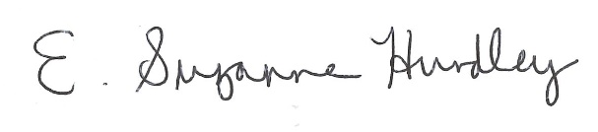
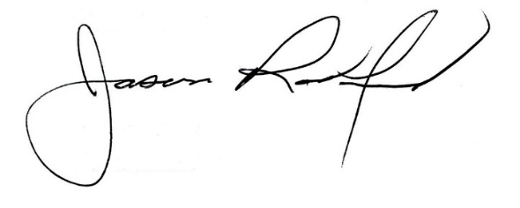

___________________________________ ______________________________
Suzanne Hundley, Board Chair Jason Radford, Superintendent/Secretary

