THIS IS AN INFORMATION PAPER

TO: Hardin County Board Of Education

FROM: The PAC

DATE: August 17, 2023

SUBJECT: PAC NEWS

BART’S BLOG – August 2023
Oncore presentation of

Planting Seeds for THE SECRET GARDEN – Casting
This past week, over one hundred local amateurs and professionals from seven years old to seventy auditioned for the musical THE SECRET GARDEN and the comedy CLUE, of which we cast only twenty-two.
When casting, there are never enough roles for all the talent presented at auditions.
Directors commonly wish that you could cast everyone who auditioned for your play. It is not easy to select the best actors from a pool of talented individuals who have put their heart and soul into their auditions.
However, casting everyone in the play is just not feasible. Each production has a limited number of roles and resources, and choosing the best fit for each character is essential. The decision-making process involves considering factors besides talent, such as availability and suitability for the role.
While it may be disappointing for those who did not make the final cut, it is crucial to remember that auditions are not just about getting cast in a particular production. They are also an opportunity for actors to showcase their skills and gain valuable experience.
As directors, Aaron Taylor and I find it essential to approach each audition with an open mind and fairness while making difficult decisions. Ultimately, casting the right actors will bring out the best in our production and create an unforgettable experience for both performers and audiences alike.
I’m pleased to announce our cast lists for THE SECRET GARDEN and CLUE.
THE SECRET GARDEN (9/15 through 9/24)
MARY LENNOX…..Lucy Melloan
ARCHIBALD CRAVEN…..Landon Sholar
LILY CRAVEN…..Heather Heim-Lawson
DR. NEVILLE CRAVEN…..Allen Brooks
MARTHA SOWERBY…..Addi Barnes
DICKON SOWERBY…..Corey Kieslich
COLIN CRAVEN…..Ethan Grose
ROSE LENNOX…..Mariah Lewis
CAPT. ALBERT LENNOX…..Matt McDougal
MAJ. HOLMES / BEN WEATHERSTAFF…..Mickey Anderson
MRS. MEDLOCK…..Ranelle Rigney
STAFF / MRS. WINTHROP…..April Reneau
LT. WRIGHT / STAFF…..Jamie Edlin
F. H. BURNETT / STAFF…..Kelsey Floyd
DANCERS…..Madeline Curtis, Alexis Hayes, Nicole Melloan, Kiris Ray, Kate Shirts, Harper Taylor
CLUE (1/19 through 1/21)
WADSWORTH…..Daniel Bannister
COLONEL MUSTARD…..Tim Isaacs
MRS. PEACOCK…..Kit Mills
PROFESSOR PLUM…..Jeremiah Shilling
MRS. WHITE…..Moira Taylor
MR. GREE …..Jared Eaton
MISS SCARLET…..Melissa Case
YVETTE…..Kathleen Lewis
ENSEMBLE…..Hannah Bowman, Gabby Butler, Mariah Lewis, Blake Ryan
Tickets for THE SECRET GARDEN are on sale now.
Tickets for CLUE will be on sale in August.

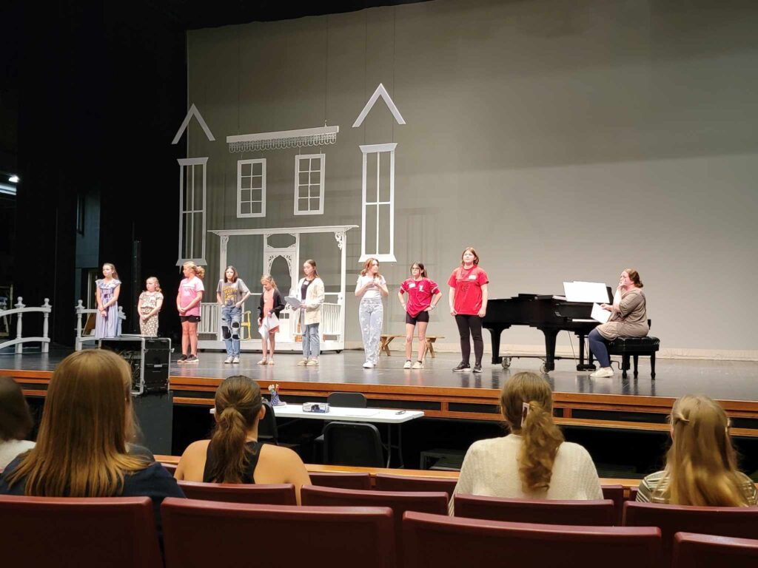
Video Links
The links below provide a video version of this month’s blog and a link to The Monthly Marquee, an interview program hosted by Bart focused on performing arts activities in our region.
BART’S BLOG – JUNE 2023
THE MONTHLY MARQUEE – JUNE 2023

Audience Survey Winners
Congratulations to CARLA DUNN, JO EXLER, SARAH HAYNES & EMILY MCCOMBS - each a lucky winner of a $20 PAC gift certificate for completing an Audience Survey last month.

Oncore presentation of PAC Spotlight:
PAC Spotlight – July 2023
This month, The PAC Spotlight shines on NHHS student, Reese Thompson, currently performing in YTHC’s Oklahoma! this summer.
What do you want to do when you grow up?
Go into education
What have you participated in at the PAC?
Beauty and The Beast (ensemble), Frozen JR. (Sven), Cinderella Youth Edition (Portia), and Oklahoma! (Ado Annie)
What have been your most rewarding PAC experiences?
The most rewarding PAC experiences for me come from all the people I meet along the way. I have made many lifelong friends from theater. They are people I can truly be myself around and go to for guidance. Everyone is so kind and welcoming; even if you’ve been surrounded by them for a short time, it feels like you’ve known them for years.
What did you learn from your PAC experiences?
I have learned how to be more confident in my work. Before being in productions at the PAC, I was too scared to try out anything new because of what people might think of me. Now I understand that you will never regret something, even if you fail, as long as you try. Every failure is a new experience to learn from.
Why is the PAC important to you?
The PAC is important to me because it provides an outlet for me to express myself. I love being able to come on stage and not be myself for once. Playing a character grants you the freedom to be creative. It teaches discipline and self-control. Also playing a major role in a play is fun, but it is not always easy.
Why should the PAC be important to others?
The PAC is a vital part of our community and provides endless opportunities for those in it. So many people have had life-changing experiences because of the PAC, and I believe others could experience the same. Live theater has been loved for years, and I’m so glad our community has local access to it.
Do you have any other comments you’d like to share?
I’m extremely honored to get this kind of recognition, and I would like to thank my family, friends, mentors, and, most importantly, God for always supporting my dreams and helping me get to where I am today.
Learn more about all the PAC Spotlight Ambassadors we’ve recognized over the years.
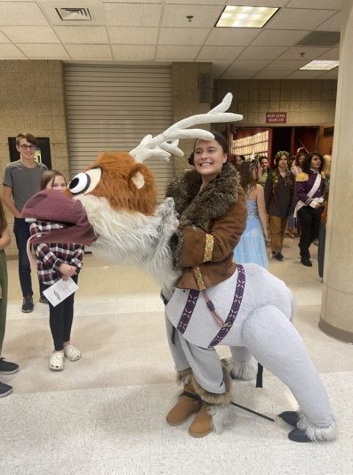
Now Showing – AUGUST 2023
August 1-Sept 15 PAC Season Event: The PAC will be in production for the PAC PRESENTS Fall ProAm musical THE SECRET GARDEN during the month of August. Performance dates are September 15 & 22 @ 7 PM for Abound Credit Union Members. September 16 & 23 @ 7 PM and September 17 & 24 @ 3 PM for general public. Tickets are on sale NOW. $11 - $27.25. Live Stream and On-Demand viewing will also be available.PAC.

August 7 HCS Event: John Hardin High School “Back to School” Bash. 6 PM. Freshman orientation will be held in the PAC.

Coming Soon – SEPTEMBER 2023
Sept 15 – 24 PAC Season Event: Fall ProAm musical THE SECRET GARDEN. The timeless tale of a special place where magic, hope, and love grow. The enchanting Tony Award-winning musical based on Frances Hodgson Burnett's novel is a compelling tale of forgiveness and renewal.
Run Time: 2 hours plus intermission.
Rated PG: Contains moments of mild peril and grief associated with death. Best for ages 9 and above.
Performances: September 16 & 23 @ 7 PM and September 17 & 24 @ 3 PM for the general public.
September 15 & 22 @ 7 PM - Free Fridays for Abound Credit Union Members. Tickets are only available with a code provided by email from Abound Credit Union.
School day performance: September 22, 9:30 AM. For students/teachers. Reservations required.
Tickets On Sale: NOW.
Tickets $: $11, $16, $22.25, & $27.25.
Partners: The Abound Credit Union

In Review – JUJY 2023
On July 1, a Celebration of Life for Patty Lirot was held before an audience of 205.
On July 14-16 and 21-23, 49 area youth with Youth Theatre of Hardin County presented 7 performances of OKLAHOMA before audiences totaling 1,764.

Total Served in JULY 1,446 HCS Students, 373 Non-HCS Students, 69 Adults, and 1,969 Audience Members.
Total Served Year to Date: 16,921 HCS Students, 5,324 Non-HCS Students, 5,454 Adults, 24,314 Public Audience Members, 114 LiveStreamed to 17 states and 2 countries.

