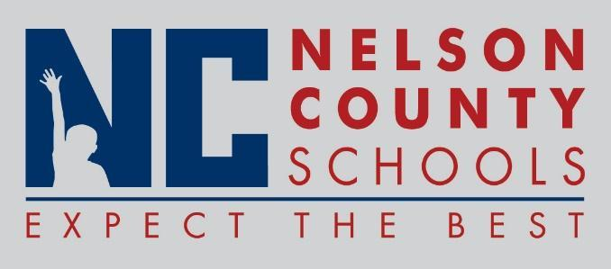

Decision Paper
To: | Nelson County Board of Education
From: | Carla McKay, Administrative Assistant to the Superintendent
cc: | Wes Bradley, Superintendent
Date: | June 19, 2018
Re: | Policy Updates for 2018-2019

RECOMMENDATION: Approve the below listed policy updates for 2018-2019 as written for their second reading.

- Definitions
01.11 General Powers and Duties of the Board
01.111 District Planning
01.42 Regular Meetings
01.43 Closed Sessions
01.83 In-Service Training
01.91 Authorization of Charter Schools
01.911 Charter School Application Process
01.9111 Charter School Contract
01.912 Charter School Monitoring Assessment and Annual Reports
01.913 Charter School Renewal, Non-Renewal, Revocation and Closure
01.914 Conversion to Charter Schools
02.421 Election of School Council Members (SBDM)
02.442 Comprehensive School Improvement Plan
03.11 Hiring
03.1161 Coaches and Assistant Coaches and Sponsors
03.121 Salaries
03.122 Holidays & Vacations
03.1232 Sick Leave (Certified)
03.1235 Educational/Professional Leave
03.18 Evaluation
03.21 Hiring
03.221 Salaries
03.222 Holidays & Vacations
03.2232 Sick Leave
03.27 Discipline, Suspension and Dismissal of Classified Employees
03.4 Substitute Teachers
03.6 Volunteers
04.1 Budget Planning and Adoption
04.3111 District Issuance of Checks
04.32 Bidding
4.91 Financial Statements
05.5 Security
06.33 Regular Bus Stops
06.34 Conduct on Bus
07.10 Alternative Meal
08.1341 Essential Workplace Programs
08.1345 Federal Programs
08.13451 Title 1-Parents and Family Engagement Policy
08.3 School Calendar
09.11 School Attendance Areas
09.12 Admissions and Attendance
09.123 Absences and Excuses
09.1231 Dismissal from School
09.211 Health Care Examination
09.22 Student Health & Safety
09.224 Emergency Medical Treatment
09.227 Child Abuse
09.313 Eligibility (Athletics)

RECOMMENDED MOTION: I move that the Nelson County Board of Education approve the listed policy updates for 2018-2019.

