CONSENT ITEM G
August 26, 2024
OLDHAM COUNTY BOARD OF EDUCATION
CONCERN
Consider approval of 504 Committee Chairperson Designees for FY25.
DISCUSSION
Each student suspected of having an impairment must be evaluated by a team of people knowledgeable about the student. The team members review the nature of the disability, how it affects the student’s access to the school environment or to school activities, determine whether related aids or services, or program modifications are needed and if so, determine the 504 services to be provided. The team must have a chairperson approved by the Board of Education upon recommendation by the Superintendent.
The following 504 team chairpersons are recommended to the Board for approval for FY25:
SCHOOL | 504 CHAIRPERSONS
Oldham County Preschool | Jessica Kasten
Buckner Elementary | Heather Dale
Camden Station Elementary | Catrisa Goodrich  Ashlynn Mahanes
Centerfield Elementary | Amy Pierce
Crestwood Elementary | Danielle Hardy
Goshen Elementary | Melinda Nevills  Heather Gossom
Harmony Elementary | Taylor Grimm
Kenwood Elementary | Kelli McMullen
LaGrange Elementary | Steve Mahoney
Locust Grove Elementary | Michelle Carter  Angie Annis
EOMS | Jen Tarbet  Jamie Reed
NOMS | Vicky Byrka
OCMS | Lydia Martin
SOMS | Corbin Feldhaus  Lucas Mattera  Brenna Cantrell
Arvin | Jamie Shiver
BAHS | Jamie Brown
NOHS | Gabi Cesarz
OCHS | Lynnette McGiffen
SOHS | Keith Blackburn
Central Office Personnel | Niki Brown  Jennifer Hallas  Bethony Keil
RECOMMENDATION
Approve the FY25 504 Chairpersons.

On a motion by _______________, seconded by _______________, the Board approved the FY25 504 Chairs.
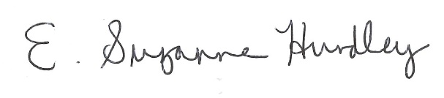
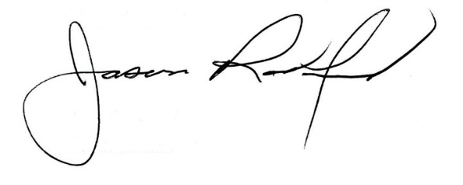

Suzanne Hundley, Board Chair Jason Radford, Superintendent/Secretary

