OCSDFC
ENCLOSURE 4
May 20. 2024
OLDHAM COUNTY SCHOOL DISTRICT FINANCE CORPORATION
CONCERN
Consider Approval of the OCSDFC Meeting Minutes.
DISCUSSION
The draft minutes of the March 13, 2023, Annual Board Meeting is available for review and approval.
RECOMMENDATION
Approve the minutes of the following meetings as presented.
March 13, 2023 – Annual Board Meeting
(1) Suzanne Hundley, Chairperson, (2) Larry Dodson, Board Vice Chair; and (3) Joe Dennis, Board Member, (4) Carly Clem, Board Member and Dr. Jason Radford, Superintendent and Secretary to the Board were present.

On a motion by _______________, seconded by _______________, and unanimously carried, the Board approved the minutes of the March 13, 2023, Annual Board Meeting. ( , )
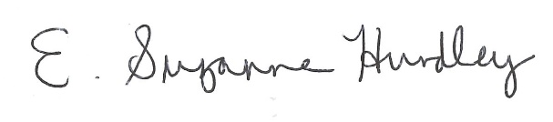
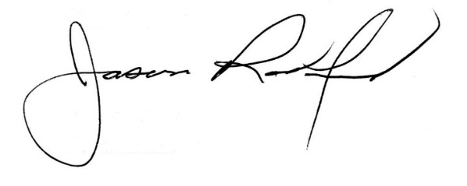

___________________________________ ______________________________
Suzanne Hundley, Board Chair Jason Radford, Superintendent/Secretary

