CONSENT ITEM F
January 22, 2024
OLDHAM COUNTY BOARD OF EDUCATION
CONCERN
Review Receipts and Expenditures (Draft Budget) for the year ending June 30, 2025 (FY25)
DISCUSSION
The Kentucky Department of Education requires each Local Board of Education to review receipts and expenditures toward preparation of a Draft Budget (excluding multi-year funds, i.e. grant funds and construction funds) for the next fiscal year no later than January 31 of the current fiscal year.
The Draft Budget is prepared mainly for compliance purposes and provides budget information based on current year operations and FY24 projected expenditures. As such, the Draft Budget should be viewed as a basis for beginning discussions related to the preparation of Tentative and Working Budgets for FY25.
See attached revenue projections from the discussion at the Board Work Session on January 10, 2024
RECOMMENDATION
Review the attached projections in preparation for discussions related to the completion of the FY25 Tentative Budget, and direct the Superintendent to continue to revise budget estimates as additional information becomes available.

On a motion by _______________, seconded by _______________, the Board approved the FY25 Tentative Budget, and direct the Superintendent to continue to revise budget estimates as additional information becomes available.. ( - )

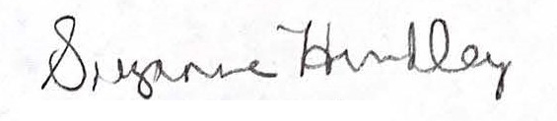
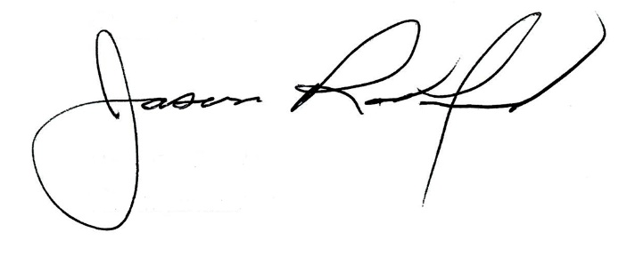

Suzanne Hundley, Board Chair Jason Radford, Superintendent/Secretary

