ACTION ITEM A
September 23, 2024
OLDHAM COUNTY BOARD OF EDUCATION
CONCERN
Consider approval of the Working Budget for the year ending June 30, 2025 (FY25)
DISCUSSION
The Oldham County Board of Education FY25 working budget includes estimated revenues and expenditures for all required funds. This working budget was prepared based on the following assumptions, among others:
- State funding of $49,893,194 consisting of:
    - General Fund SEEK $39,956,887
    - Capital Outlay 1,151,100
Plus State nickel equalization for:
    - Building Fund 8,785,207

These amounts are based on final property assessments and FY23-24 AADA. Changes to FY25 SEEK include an increase of $126 in the per-student guaranteed base.
- Real/Personal/PSC Property Tax gross revenue of $71,575,385 based on PVA property tax based assessed values of $9,858,902,739 at 79.7 cents per $100 of assessed value. Those taxes will be allocated between funds as follows:
    - General Fund $51,857,580
    - Building Fund $19,717,805
- FY25 expenditures are based on FY24 levels adjusted for planned increases that include:
    - Wage increases for step changes and step-related benefits and a 7% merit increase for all certified employees and a $2.00 per hour increase for all classified employees.
    - Overall inflation (diesel fuel, utilities, travel)
- Special Revenue (Fund 2 Grants) amounts will require additional adjustment per approved Federal / State awards and estimates, which will be available in early Fall.
Budgeted expenditures for FY25 include a General Fund contingency of $18.0 million.
As the District progresses through FY25, budgeted revenues and expenditures will be monitored, and any significant amendments will be made.
RECOMMENDATION
Approve the FY25 working budget for submission to KDE.

On a motion by _______________, seconded by _______________, the Board approved the FY25 working budget for submission to KDE. ( , )
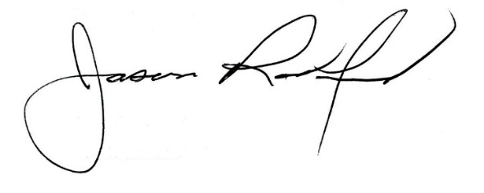
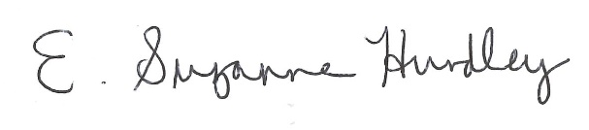

Suzanne Hundley, Board Chair Jason Radford, Superintendent/Secretary

