CONSENT ITEM J
October 14, 2024
OLDHAM COUNTY BOARD OF EDUCATION
CONCERN
Consider the proposed redistribution of the Deputy Superintendents duties and the reallocation of salary.
DISCUSSION
With the resignation of Sharla Six as the Deputy Superintendent (which we are all excited about her new position as Interim Superintendent or Anchorage Schools). We have decided not to fill the current opening until the 2025-2026 school year. The open position will be posted on February 1, 2025, the first day new posting for the upcoming year can be posted.
We are requesting a reallocation of the Deputy Superintendent salary. We have a need to hire two part-time positions at Oldham County Middle School. These two positions will continue to work with the staff and students in terms of being classified a TSI school. We are also requesting that several stipends be approved for staff who are taking on additional duties and responsibilities without the reduction of duties for the remainder of the 2024-2025 school year.
Proposal is to reassign the direct report for the following staff and departments:
- Brent Deaves will oversee Eric Davis and Jaclyn Green and their respective departments and staff
- Level Directors will oversee principal observations and evaluations
- Jason will oversee Brent Deaves and Dylan Smith
Task and Duties of Sharla’s that will be reassigned to Brent Deaves:
- Legal counsel connections and point person
- OEA complaints
- Open Records will fall under Brent Deaves but completed by Mark Robson and team.
- Executive session liaison with Jason.
- Directors and other Administrator 1:1 meetings with Jason
Task and Duties of Sharla’s that will be reassigned to Level Directors and Directors:
- All principal observations and data collection for evaluations – Level Directors
- G-map oversight for individual funds -
  - Liz Dant for all G-Map approval
  - Matt J for Perkins and other CTE
  - Niki for - IDEA
- FLOC will go to Liz Dant
- Learning walks and instructional rounds to Teaching and Learning Team
- MTSS - Jacyln Green and Eric Davis
- NTI to the Teaching and Learning Team
- Strategic Planning – Dylan Smith
- Special Projects workgroup – Liz Dant
- OCMS accountability - Jason and Jenna monthly
- Title IX and OCR concerns Matt Jacobson
Task and Duties of Sharla’s that will be reassigned to administrative staff:
- Touch points for staff across the district
- Social planning for central office and annex
- Recognitions
- Administrative task for legal needs and open recorders for confidentiality
- Departmental Budget Support for MTSS and Teaching and Learning
- MTSS administrative assistant duties
Stipends amounts as follows additional duties and responsibilities:
- Brent Deaves - $8,000
- Liz Dant - $4,000
- Matt Jacobson - $4,000
- Mark Robson - $2,000
- Teresa Gill - $2,000
- Jane Easton - $2,000
Two additional part-time staff at teacher daily rate not to exceed 187 days each.
Financial Breakdown:
- Stipends for deputy duties and task total $22,000
- 2 part-time instructional specialist OCMS $50,000
- Total savings of $48,028.34
RECOMMENDATION
Approve the reallocation of salary for the Deputy Superintendent position for the 2024-2025 school year with two part-time positions at Oldham County Middle School and stipends for additional duties and responsibilities for the 2004-2025 school year only.

On a motion by _______________, seconded by _______________, the Board Approve the reallocation of salary for the Deputy Superintendent position for the 2024-2025 school year with two part-time positions at Oldham County Middle School and stipends for additional duties and responsibilities for the 2004-2025 school year only. ( , )

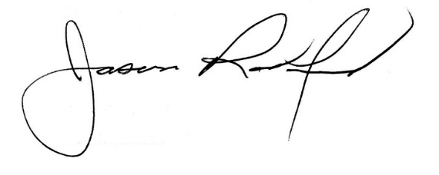
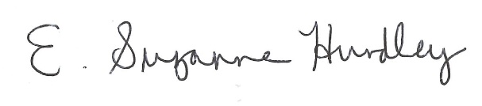

Suzanne Hundley, Board Chair Jason Radford, Superintendent/Secretary

