CONSENT ITEM K
January 22, 2024
OLDHAM COUNTY BOARD OF EDUCATION
CONCERN
Purchase of a new multipurpose Bobcat to be shared between four departments as needed.
DISCUSSION
Currently between the four departments we share one 2005 tractor with a front bucket loader/fork and one forklift only for deliveries and moving items within the annex building and transportation building. The purchase of a new Bobcat L65 will provide the district with the multiple opportunities we currently do not have. It will allow us to have an indoor salt storage facility on the same grounds as the Annex/transportation. It will also allow for easier and safer loading and unloading of large shipments. It will allow for lifting larger items in a tighter space. The L65 Bobcat is also a multipurpose piece of equipment, which will allow us the opportunity to do several other smaller projects with our own team of workers and not require us to have to rent pieces of equipment for smaller jobs. We are also seeing a large increase for the cost of rental equipment, when we want to perform some tasks with our own staff, our hope is that with this L65 bobcat we can cut down the cost in the long run.
The L65 can also be purchased from the general fund account and then the general fund account can be reimbursed through the capital project account, due to its functionality and classification as an asset piece of equipment.
Please refer to the attached spec sheet provided to give further detail. The price quoted is from the state procurement/bid sheets.
RECOMMENDATION
Approve the purchase of the L65 Bobcat for $78,059.64 with general funds, knowing that it will be part of the capital funds request at the end of the year, meaning we would be using restricted funds for this purchase.

On a motion by _______________, seconded by _______________, the Board approved the purchase of the L65 Bobcat for $78,059.64 with general funds, knowing that it will be part of the capital funds request at the end of the year, meaning we would be using restricted funds for this purchase..

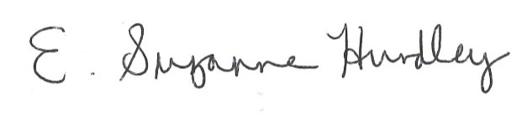
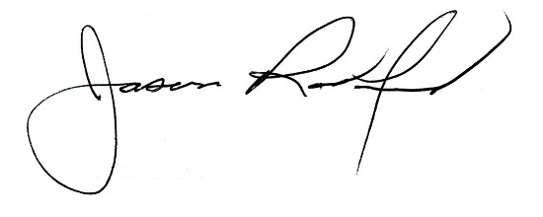

Suzanne Hundley, Board Chair Jason Radford, Superintendent/Secretary

