CONSENT ITEM G
October 14, 2024
OLDHAM COUNTY BOARD OF EDUCATION
CONCERN
Consider Shortened School Day request for OCS students.
DISCUSSION
The following students have requested a Shortened School Day. Details for each student follow this enclosure for your review.
STUDENT | SCHOOL
A.C. | Arvin - YATP
A.P. | LaGrange Elementary
E.C | SOHS
S.N. | NOMS
RECOMMENDATION
Post-approve the shortened school day request for these students.

On a motion by _______________, seconded by _______________, the Board post approved the Shortened School Day requests as submitted. ( - )

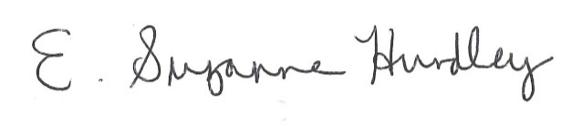
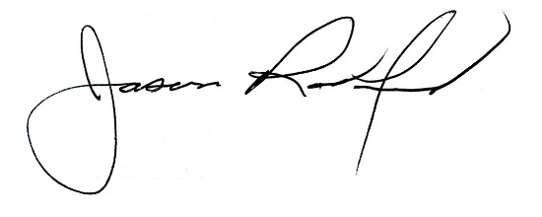

Suzanne Hundley, Board Chair Jason Radford, Superintendent/Secretary

