CONSENT ITEM A
September 23, 2024
OLDHAM COUNTY BOARD OF EDUCATION
CONCERN
Consider Approval of Field Trips Requesting Overnight Stay & Field Trips Requesting Use of Common Carrier.
DISCUSSION
The following are field trips requesting overnight stay and trips requesting use of a common carrier:
SCHOOL | GROUP | LOCATION/DATE | JUSTIFICATION | INSTR. DAYS LOST
NOHS | Student Y | Crowne Plaza  Nov 24-26, 2024 | Overnight: KYA  Parents | 2
OCHS | KUNA | Crowne Plaza  March 13-15, 2025 | Overnight: KUNA  Parents | 2
OCHS | KYA | Crowne Plaza  Dec 4-6, 2024 | Overnight: KYA  Parents | 2
SOHS | Marine Biology | Big Pine Key, FL  March 23-28. 2025 | Overnight: Study Trip  AIR | 5
SOHS | Cheer | Orlando, FL  Feb 5-11, 2025 | Overnight: National Competition  Charter Bus | 4
Approve the field trips as attached and described above, pursuant to the condition that students not traveling on school buses, with their parents, or with a Board employee whose insurance carrier has named OCBE as an additional named insured, will be transported to and from their destination on an approved charter bus(es) and school(s) shall obtain written evidence of liability.

On a motion by _______________, seconded by _______________, the Board approved the field trips as attached and described above, pursuant to the condition that students not traveling on school buses, with their parents, or with a Board employee whose insurance carrier has named OCBE as an additional named insured, will be transported to and from their destination on an approved charter bus(es) and school(s) shall obtain written evidence of liability. ( , )
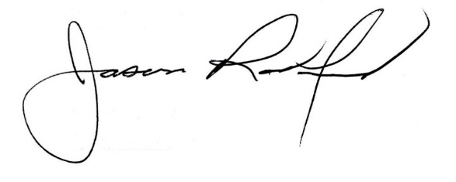
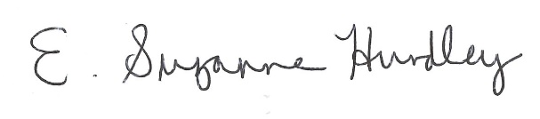

Suzanne Hundley, Board Chair Jason Radford, Superintendent/Secretary

