ACTION ITEM D
January 22, 2024
OLDHAM COUNTY BOARD OF EDUCATION
CONCERN
Redistricting of board member division boundaries (2024)
DISCUSSION
Every ten years districts are required to redistrict the board member division boundaries based on changes in population as reported by the census. KRS 117.055 and KRS 160.210 are the statutes that guide this process. Voter population in each division is to be equal as is insofar possible, with not a greater variation of five percent of the total population based on the number of divisions.
The prison population is calculated into the total population for the county which results in one division being larger than the specified amount, this is Division Five, though when the prison population is removed it is within the standard. Division One is smaller than the standard by approximately 500 residents based on its location and selecting the closest contiguous precinct could potentially remove other board members from their division.
In this new proposal the voter population is balanced within five percent of 1/5 of the population of the county in each division except for Division One as noted earlier. This plan is acceptable according to Board of Elections guidance.

Board Division | Population
Division One | 11,029
Division Two | 11,072
Division Three | 10,921
Division Four | 11,291
Division Five | 11,873

The DPP office will be available to answer any questions.
RECOMMENDATION
Consider approval of board member division boundaries. (2024)

On a motion by _______________, seconded by _______________, the Board approved the board member division boundaries. (2024) as presented. ( - ).
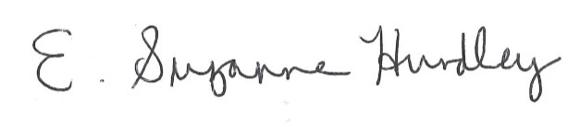
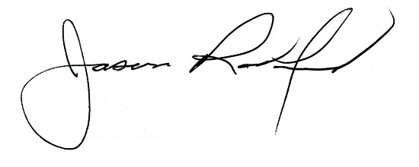

Suzanne Hundley, Board Chair Jason Radford, Superintendent/Secretary

