EXECUTIVE SESSION
October 14, 2024
OLDHAM COUNTY BOARD OF EDUCATION
CONCERN
Consider Executive Session pursuant to KRS 61.810(1)(c) to discuss litigation preparation or defense, the public disclosure of which would jeopardize the Board’s position, KRS 61.810(1)(b) deliberations on the future acquisition or sale of real property by a public agency, but only when publicity would be likely to affect the value of a specific piece of property to be acquired for public use or sold by a public agency and KRS 61.810(f).discussion of a Student Personnel Matter.
DISCUSSION
At this time, I need a motion to go into Executive Session pursuant to KRS 61.810(1)(c) to discuss litigation preparation or defense, the public disclosure of which would jeopardize the Board’s position, KRS 61.810(1)(b) deliberations on the future acquisition or sale of real property by a public agency, but only when publicity would be likely to affect the value of a specific piece of property to be acquired for public use or sold by a public agency and KRS 61.810(f).discussion of a Student Personnel Matter.
RECOMMENDATION
Conduct Executive Session.

On a motion by _______________, seconded by _______________, the Board entered into Executive Session pursuant to KRS 61.810(1)(c) to discuss litigation preparation or defense, the public disclosure of which would jeopardize the Board’s position, KRS 61.810(1)(b) deliberations on the future acquisition or sale of real property by a public agency, but only when publicity would be likely to affect the value of a specific piece of property to be acquired for public use or sold by a public agency and KRS 61.810(f).discussion of a Student Personnel Matter. ( - )

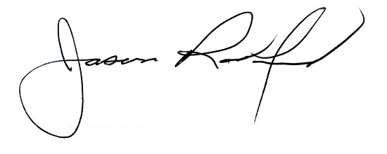
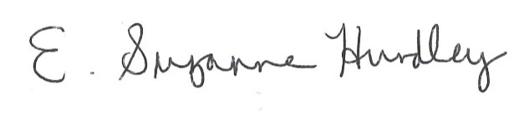

Suzanne Hundley, Board Chair Jason Radford, Superintendent/Secretary

