EXECUTIVE SESSION
October 8, 2024
OLDHAM COUNTY BOARD OF EDUCATION
CONCERN
Consider Executive Session on a Student Personnel Matter pursuant to KRS 61.810(f).
DISCUSSION
At this time, I need a motion to go into executive session to discuss a student personnel matter, pursuant to KRS 61.810(f).
RECOMMENDATION
Conduct executive session on a student personnel matter.

On a motion by _______________, seconded by _______________, the Board entered Executive Session to discuss a student personnel matter, pursuant to KRS 61.810(f). ( - )

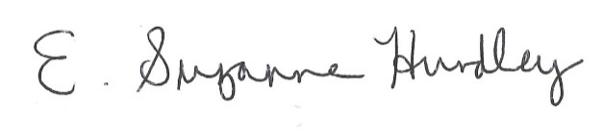
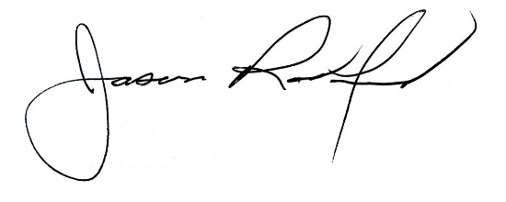

Suzanne Hundley, Board Chair Jason Radford, Superintendent/Secretary

