OCSDFC
ENCLOSURE 3
May 20. 2024
OLDHAM COUNTY SCHOOL DISTRICT FINANCE CORPORATION
CONCERN
Appoint the Secretary and Treasurer of the OCS District Finance Corporation.
DISCUSSION
The OCBE Treasurer is traditionally the OCSDFC Treasurer, and Superintendent serves as the OCSDFC Secretary. Dr. Tom Shelton would serve as treasurer and Dr. Jason Radford would serve as Secretary of the OCS District Finance Corporation.
RECOMMENDATION
Recommend the approval of Dr. Tom Shelton as treasurer and Dr. Jason Radford as Secretary of the OCS District Finance Corporation

On a motion made by _______________, seconded by _______________, the Board appointed Dr. Tom Shelton as treasurer and Dr. Jason Radford as Secretary of the OCS District Finance Corporation. ( - ).
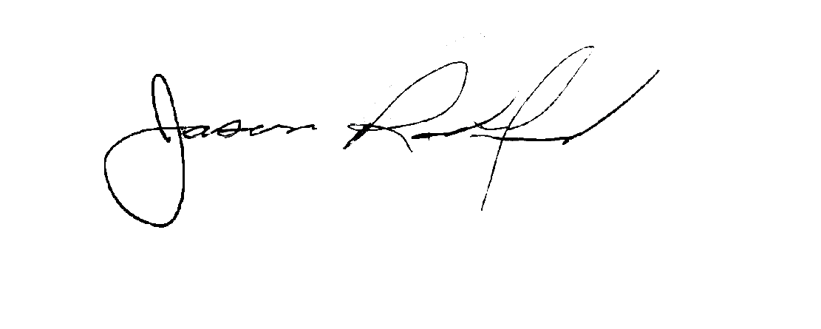


Suzanne Hundley, President Jason Radford, Superintendent

